

QUOTES FROM THE PAPER

“If we want a different AI future, we need to start considering alternative approaches to contemporary generative AI…”

“A multi-stage project is proposed to demonstrate how an artificial Xzistor agent could systematically develop basic language skills…”

“The model’s mathematical framework offers insight into the underpinning logic of the biological brain…could reignite the quest for human-inspired AI.”

“Building an artificial agent with the skills of an infant that can learn to use language to communicate with humans…will be much more than just a demonstrator of the principles of verbal behavior — it could be the start of a new era of Artificial Intelligence (AI).”

“The Xzistor Mathematical Model of Mind provides many of the missing pieces of the puzzle — and comes with a proven safeguard against ‘runaway-intelligence’ rooted in physics.”



CONTENTS

Part 1
Main Paper — Artificial Agent Language Development based on the Xzistor Mathematical Model of Mind
(Page 1)

Part 2
Appendix A — Mathematical Principles of the Xzistor Brain Model
(Page 58)

Part 3
Appendix B — Xzistor Brain Model Unification of Behaviorist and Structuralist Language Theories
(Page 134)

Artificial Agent Language Development based on the Xzistor Mathematical Model of Mind

Rocco Van Schalkwyk^{a, ∗}, Alireza Dehbozorgi^{b}
ªXzistor LAB, Bristol, United Kingdom.
^{b}Xzistor LAB, Bristol, United Kingdom.

∗Corresponding author
✉ rocco.vanschalkwyk@xzistor.com (R. Van Schalkwyk)
ORCID: 0009-0009-3933-3930

Abstract — The Xzistor Mathematical Model of Mind is a cognitive architecture that uses a functional model of emotions, based on biological homeostatic and allostatic control loops, to explain how an artificial agent can systematically learn to navigate to a reward source. The model also explains how subtasks required for the agent to access reward sources can be learnt through reinforcement learning. Simple virtual and physical agent implementations of the model have demonstrated how agents successfully learn to navigate to reward sources from anywhere in their environments. These implementations also showed how agents become motivated to perform subtasks to gain access to the reward sources. This paper describes how this demonstrated learning ability in agents, provided by the Xzistor brain model, could be used as a theoretical basis for implementing a human-like language learning skill in agents. This goes beyond Large Language Model approaches by incorporating computational equivalents of many human brain functions, including sensing, recognition, inference, and emotions. The study concludes that this cognitive architecture could provide a proof-of-concept implementation in agents of the principles of verbal behavior identified by B.F. Skinner (Skinner, 1957). A multi-stage project is proposed to demonstrate how an artificial Xzistor agent could systematically develop basic language skills using artificial emotions and reinforcement learning and, over time, refine this skill towards improved syntax and grammar use. The paper provides two appendices covering the mathematical principles underpinning the Xzistor brain model and an explanation of how it could potentially address the criticisms by Noam Chomsky of Skinner’s verbal behavior theory.
Keywords – verbal behavior, operant learning, emotion model, cognitive architecture, artificial speech.

Introduction

The origin of language and how the human brain learns to communicate has been debated since ancient times. As Plato wrote, “The power of speech…seems to me to be a nebulous thing, and by no means a safe basis…” (Plato, n.d., p. 97). In the 18th century, Jean-Jacques Rousseau argued that language derives from emotions, stating, “As man’s first motives for speaking were of the passions, his first progress was in metaphors…” (Rousseau, 1755, p. 53). Rousseau believed language developed naturally from emotional cries and exclamations, gradually developing into articulated speech.
In contrast, Immanuel Kant proposed that language is based on rational thought and logic, writing, “reason has insight only into that which it produces after a plan of its own…” (Kant, 1781/1787, p. 20). For Kant, language originates from innate mental structures and develops systematically, not just from emotional expression.
Twentieth-century philosopher Ludwig Wittgenstein revolutionized the field by arguing that philosophy is the study of how language constructs reality. As he famously stated, “…the meaning of words is their use…” (Wittgenstein, 1953, p. 20). Wittgenstein rejected traditional approaches, focusing instead on how language functions in real-world contexts.
In psychology, behaviorist B.F. Skinner saw language as a learnt behavior shaped by rewards and penalties (operant conditioning), stating, “Verbal behavior…is behavior reinforced through the mediation of other persons…” (Skinner, 1957, pp. 31−35). However, Noam Chomsky challenged radical behaviorism (a theory of learning that assumes environmental stimuli shape all behaviors) and proposed natural languages derive from a cognitive facility which contains innate rules for a universal grammar, syntax and semantics (Chomsky, 1957, pp. 15−20; Chomsky & Lasnik, 1993; Chomsky, 1995; Chomsky, 2005).
Today, many linguists believe that the approaches of Skinner and Chomsky are not mutually exclusive, that certain aspects of our ability to learn language, which is unique to humans, are innately provided by the neurophysiological structures of the brain (effectively preprogrammed) while other aspects require the brain to learn based on interaction with the environment.
Some linguists and philosophers have also proposed that learning a language and using speech to achieve goals is principally no different from learning to perform manual tasks using muscle manipulations and limb movements (elaborated on in the next section). This linguistic paradigm is specifically further explored here, to formalize a systematic set of tests that will prove its validity using a cognitive architecture embedded in an artificial agent.
This paper describes an investigation of a specific cognitive architecture, called the Xzistor Mathematical Model of Mind (Van Schalkwyk, 2022), to establish if it can explain language development in the human brain and further provide a way to develop language skills in intelligent agents. The Xzistor Mathematical Model of Mind (the ‘Xzistor brain model’) was developed by Rocco Van Schalkwyk, a robotics engineer, and uses a model of ‘subjective’ emotions in conjunction with reinforcement learning, to explain how the brain systematically learns to navigate to a reward source — fully described in the book Understanding Emotions (Van Schalkwyk, 2021),
This model not only explains how manual skills are learnt but also how an agent can acquire the skill of using words to gain access to a reward source. The discussion is extended to theorize how this language skill, when implemented and tested in an Xzistor artificial agent, will become increasingly more sophisticated and refined, as described in the book Understanding Intelligence (Van Schalkwyk, 2021, p.31).
The aim of this paper is not only to propose a systematic way to prove natural language acquisition by artificial agents which is akin to humans, but also to explain how a simple set of algorithms can, through a constant drive towards satisfying artificial emotions, lead an agent to cognize a computational correlate of semantic meaning and adhere to complex grammar rules. In support of this aim a project is proposed to show how this approach can be systematically tested and verified in proof-of-concept agent simulations and physical robots.

Related Research
The conception of oral language as a series of muscular movements of the speech-production organs dates back to the early 20th-century philosophies of Ludwig Wittgenstein. In his seminal 1921 work Tractatus Logico-Philosophicus, Wittgenstein theorized a picture theory of language, whereby spoken propositions serve as symbolic pictorial representations of states of affairs in the world (Wittgenstein, 1922, pp. 11−12). He stipulated that “In a proposition a thought finds an expression that can be perceived by the senses,” crediting the physiological speech apparatus for enabling this sensory expression, stating “Written signs are visual representatives of spoken sounds, which in turn are audible representatives of the ‘prop’ [proposition] which is in its turn a logical picture of the facts” (Wittgenstein, 1922, pp. 32−33). Thus, he characterized the vocal organs as an indispensable mechanism for formulating meaningful speech acts.
Expanding on the sensorimotor foundations of language, philosopher Gilbert Ryle in his 1949 work The Concept of Mind explicitly characterized language use as a learnt bodily skill and habit mediated by activation of muscular effectors. Ryle stated: “Speaking a language is a muscular habit, not an exercise in clairvoyance. It is a muscular habit dotingly elaborated, as are the exercises of acrobats and pianists” (Ryle, 1949, pp. 41−42). He emphasized the role of repeated motor training in forging neural connections, noting: “The rules which link sensations with utterances have to be practiced before they can be obeyed. There is nothing innate about them” (Ryle, 1949, p. 69). Thus, Ryle forwarded a perspective of verbal behaviors as routinized muscular acts.
Watson (1930) bluntly asserted that “Speech is nothing more nor less than a specialized musculature phenomenon” (p. 81) and “The speech muscles have been rigorously trained under environmental guidance to make certain complicated response patterns” (Watson, 1930, p. 82). Skinner (1957) echoed this sentiment in Verbal Behavior, stating speech is “behavior shaped and maintained by mediated consequences in the presence of discriminative stimuli” (Skinner, 1957, p. 14) and verbal utterances are simply “special cases of motor responses of the laryngeal musculature” (Skinner, 1957, p. 15).
Noted linguist Benjamin Lee Whorf also examined the integral motor aspects of language through the lens of linguistic relativity, asserting that engrained habitual modes of the nervous system and muscular articulators determine speech production patterns. As he described: “Articulatory patterns in speech are caused by almost identic excitation patterns in the central nervous system” (Whorf, 1956, p. 252) and “Language is culturally conditioned, speech is physiologically conditioned” (Whorf, 1956, p. 253).
Drawing together these various motor theories, cognitive scientist Jerry A. Fodor, in his 1983 work Modularity of Mind, proposed a neural network model whereby speech production emerges from interconnected sensorimotor brain systems that convert thoughts into muscle movement signals to control the vocal apparatus. As he noted, “Speech production seems to involve the activation of articulatory motor programs which are themselves organized in terms of linguistically appropriate phonological segments” (Fodor, 1983, p. 68). Thus, Fodor modeled language as a modular motoric system.
Most relevant today is Alvin Liberman’s motor theory of speech perception formulated in 1985, which emphasizes that the perception of speech is grounded in the neural decoding of intended phonetic gestures and motor commands underlying the speaker’s muscle movements. Liberman stated speech perception involves “the correct retrieval of intended gestures by the speakers from the systematic consequence of concomitant motor commands” (Liberman & Mattingly, 1985, p. 1).
In summary, these major schools of thought, from early philosophy of language through modern linguistics and cognitive science, have established a robust theoretical foundation elucidating spoken language as a volitional motor behavior grounded in the systematic activation of the speech musculature. This literature provides a pivotal backdrop for considering oral communication as a biosignal mediated by concerted contractions of the vocal apparatus.

The Xzistor Brain Model
The aim is not to provide a detailed description of the Xzistor Mathematical Model of Mind as a cognitive architecture in this paper. Instead, the reader is referred to Appendix A – Mathematical Principles of the Xzistor Brain Model.
Numerous academic papers provide general information on cognitive architectures (Kotseruba et al., 2020; Lieto, 2021). Information specific to the Xzistor brain model can be found on the Xzistor LAB website (https://www.xzistor.com/xzistor-concept-frequently-asked-questions/), where discussions on the theoretical aspects of the model are provided, as well as evidence of how the model was implemented in simulations and physical robots.
It will be important to understand the basic approach this cognitive architecture uses to model the brain and some of the key features and functions required to achieve language acquisition in artificial agents. A brief introduction is provided below, followed by dedicated sections covering those aspects for which a basic understanding will be required to allow for a more detailed discussion on artificial verbal behavior.
The Xzistor brain model is a functional (top-down) cognitive architecture that claims to offer a complete ‘principal’ model of the brain, explaining how it works functionally and how it can be expressed in mathematical terms through simplifying assumptions.
It formulates one of many computational theories of mind (CTMs) aimed at explaining and modeling the brain computationally (Miłkowski, 2018; Rescorla, 2020; Colombo et al., 2023). The model’s mathematical description has successfully been translated into computer programs to control intelligent agents. It has provided evidence that the theoretical approaches to emotions described in Understanding Emotions (Van Schalkwyk, 2021) and to cognition defined in Understanding Intelligence (Van Schalkwyk, 2021) work correctly under dynamic conditions.
The Xzistor brain model simplifies and serializes the main neurobiological functions of the brain into a single logic loop that is repeatedly executed:
- Sensing (obtain sensor inputs)
- Planning (translate sensor inputs into behavior commands)
- Behaviors (perform behavior commands using effectors)
- Go back to 1. Sensing
The model contains five basic algorithmic building blocks. By means of simplifying assumptions, all functions performed as part of these building blocks can be defined in mathematical terms and turned into executable computer code.
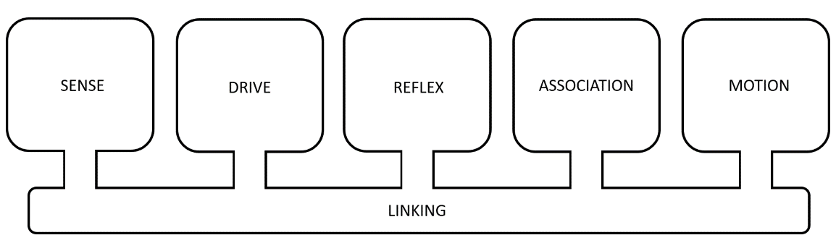
Figure 1. The Xzistor brain model comprises five functional building blocks connected by a linking function.
The model is means-agnostic, meaning it is not concerned with whether the substrate is biological or silicon-based; only that the correct functions are provided. It was developed to:
- Provide a principal understanding of the processes of the brain, specifically the mechanisms of cognition and emotion.
- Serve as a basis for a complete cognitive architecture, providing autonomous agents with the ability to develop human-like intelligence and emotions.
The Xzistor brain model can be instantiated in symbolic or neuro-symbolic (a hybrid synthesis of symbolic and connectionist) implementations (Gordana, 2023). Like the human brain, an instantiation of the model achieves increased functionality and a higher level of intelligence through ongoing learning, i.e., the forming of associations. This happens in the same way an infant would mentally mature into adulthood through learning.
Emotions, artificially generated by the model, play a crucial role in achieving learning and storing associations to solve future problems. By attaching sets of artificial emotions to newly stored associations in the agent’s association database, these associations can be contextualized and prioritized to solve future problems using past experience, including the use of inductive inference in novel environments.
Since this type of reinforcement learning can also theoretically lead to spoken words being memorized, recognized and repeated by an agent to solve problems (Van Schalkwyk, 2021, p.31), it is essential to understand how the Xzistor brain model is able to generate artificial emotions, as these underpin the approach to modeling verbal behavior proposed in this paper. The Xzistor brain model was initially defined in two provisional patent specifications (Van Schalkwyk, 2002; Van Schalkwyk, 2003).
Note: Key terms are capitalized in the rest of the text when they have specific meanings in terms of the Xzistor brain model, i.e., when they can be mathematically defined, as opposed to their more general meanings related to the biological body and brain. Mathematical definitions and descriptions are provided in Appendix A − Mathematical Principles of the Xzistor Brian Model.

Artificial Emotions
The Artificial Emotions generated by the Xzistor brain model are based on models of the homeostatic negative feedback control loops in the human body and brain. The biological homeostatic control loops aim to maintain setpoints for control variables in the body and/or brain. Some control variables are obtained from receptors measuring external states affecting the body (like ambient temperature, cutaneous pressure/pain, visual inputs, auditory inputs, olfaction, etc.) and some from receptors measuring states internal to the body (like internal organ temperatures/pressures/pain, muscle chemicals, and blood chemicals like glucose, ghrelin, H₂O, sodium, oxygen, carbon dioxide, etc.).

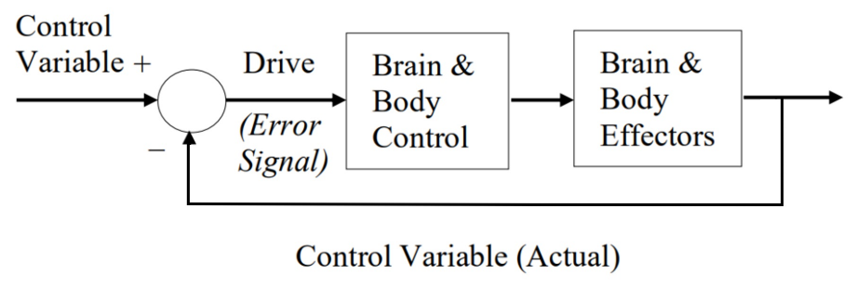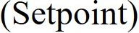
Figure 2. A homeostatic negative feedback closed-loop control system as modeled by the Xzistor brain model.
Figure 2 shows how the first part of the control loop, also called the drive (indicated by a circle), will compare the incoming control variable value with its setpoint and create an error signal. This is often achieved in the biological brain by the activation/inhibition of dedicated control centers (neural circuits) to represent and convey the error signal information to those areas of the brain that need to act on it. This neural representation of the error signal will then be communicated to the brain and body control part of the brain (middle block of the diagram) to decide what actions must be performed to reduce the error signal. This will include the rules for when to use preprogrammed (reflex) actions or learnt actions (i.e., from memory).
The brain and body control part will, therefore, include adaptive control rules that will constantly ensure learning within changing environments by reinforcing effector motions that reduce error signals successfully. The control actions are then passed to the brain and body effector part (last block of the diagram), where muscle sequences will be executed in an attempt to bring about changes that reduce the error signal. The drive part of the control loop will then read and compare the updated error signal again, and the loop will be repeated to keep reducing the error signal towards zero.
These naturally occurring control loops and their control variables in the human body and brain are simulated by the Xzistor brain model. For instance, a numerical blood glucose value can be defined which can gradually be lowered over time to create a growing deficit (Error Signal) in a modeled Hunger Homeostatic control loop. This numerical Error Signal can quickly be restored when the artificial agent uses its Motion Effectors to perform control actions that are deemed equivalent to ingesting food. The Xzistor artificial agent will also adaptively update control commands for its Motion Effectors based on learning within its environment.
In the human brain, the error signals of some control loops can also be altered during the recollection of learnt associations (memories) without any physical actions that could change control variables. For example, the human brain can regenerate a stress state via the fight-or-flight reflex by simply recalling a bad experience. In this case, the error signal can be represented by activating a neural area in the amygdala. This activation, which could have originated during a painful bite from a dog, will be regenerated in the amygdala during the recollection of this upsetting event. The Xzistor model refers to this subset of control loops where Error Signals can directly be influenced by the recollection of memories as Allostatic or memory-modifiable control loops.
The use of the term Allostasis here deviates in some respects from the classical definition of allostasis used in other fields of biology. However, it allows for the model to simulate two distinct types of negative feedback control loop mechanisms in the human body — Homeostatic and Allostatic:
- Homeostatic Control Loop — Those negative feedback control loops for which the Error Signal can only be altered by receptor signals, i.e. they cannot be changed by recalling memories. Examples are thirst, pain, fatigue, itching, urge to urinate, cold, hot, etc.
- Allostatic Control Loop — Those negative feedback control loops for which the Error Signal can both be changed by receptor signals and by recalling memories. Examples are anger, sexual arousal, acute fear, nausea, autonomic stress (fight-or-flight response), etc.
The Xzistor brain model deems innate fears and phobias in humans to be generated by allostatic control loops because these rely on the recognition of states preprogrammed into memory to trigger an autonomic nervous system (stress) response.
These two simple groupings of control loops (homeostatic and allostatic) as the basis for modeling all human emotions are a departure from the classifications offered by other researchers who have acknowledged homeostasis to be the origin of certain types of emotions, but not all emotions — researchers like Panksepp (Ellis et al., 2012), Denton (Denton, 2006), and Craig (Craig, 2008).
The Xzistor model does not allow for any Artificial Emotion to originate other than from a modeled Homeostatic or Allostatic control loop. The model deems all complex later-life (higher-order) emotions experienced by humans to be just different combinations of emotions based on a finite number of homeostatic and allostatic control loops linked by association to new objects, concepts and experiences in more sophisticated and socially evolved environments.
There is an important additional aspect that makes the way the Xzistor brain model generates Artificial Emotions different from other approaches. This relates to the autonomic nervous system, an allostatic control loop comprising the sympathetic, parasympathetic, and enteric nervous systems. There are four ways in which the autonomic nervous system can be activated:
- Standalone — A direct stimulus, such as a sudden loud sound, could send a signal from the eardrums to the amygdala, activating the sympathetic nervous system.
- From Instinct — Observing a threat object or state that might never have been experienced before (e.g., a snake or entering a claustrophobic tunnel) could send a signal to the amygdala to activate the sympathetic nervous system.
- Coupled to Control Loops — It is well-evidenced in the academic literature that all biological homeostatic and allostatic control loops, when activated/inhibited through changes in receptor signals, will also send activation/inhibition signals to the amygdala in unison with their own fluctuations, triggering the autonomic nervous system.
This coupling effect is due to physical connections between homeostatic and allostatic drive centers in the brain (where error signals are processed) and the amygdala (where the error signals for the autonomic nervous system are processed).
- From Memory — Homeostatic and allostatic control loops that have become part of associations during learning events will, from memory, activate/inhibit the autonomic nervous system to the same level as when they were activated/inhibited during the association-forming (learning) event.
When in future a memory related to a homeostatic drive event like hunger, thirst, pain, etc. is recalled based on recognition or recollection of an associated stimulus, the autonomic control loop will automatically be triggered. As mentioned before, homeostatic control loops like hunger, thirst, pain, etc. cannot be regenerated from memory by the brain during recognition or recollections events — only the autonomic nervous system will be re-evoked.
The same applies to allostatic control loops, except that when in future a memory related to an allostatic drive event e.g., anger, sexual arousal, nausea, etc., is recalled based on recognition or recollection of an associated stimulus — not only the autonomic nervous system will be triggered, but also the allostatic drive itself.
The autonomic nervous system (also simply referred to here as the autonomic stress loop) can simultaneously receive signals from all four of the above sources and thus be activated/inhibited collectively to form a resultant (net) activation level. For instance, if an activation signal is received from one source, and an inhibition signal is received from another source, the effects will be combined into a net level of autonomic stress generated.
Although it is important to note that the autonomic nervous system can be triggered on its own and from memory, it is the fact that it will always receive activation/inhibition signals from all other homeostatic or allostatic control loops that is important to the Xzistor brain model.
All mathematically modeled Homeostatic and Allostatic control loops will, therefore, always also send either activation or inhibition signals (numerical) to the modeled Autonomic Nervous System.
Note: Some allostatic control loops can also inversely be activated by the autonomic stress loop. These are discussed in Appendix A – Mathematical Principles of the Xzistor Brain Model.

As an example of the coupling between a homeostatic control loop and the autonomic stress loop in the biological brain, we see in Figure 3 below how the homeostatic control loop for hunger will also trigger the sympathetic nervous system. As hunger is sated, the parasympathetic nervous system will restore (inhibit) the autonomic stress level in unison with the hunger.
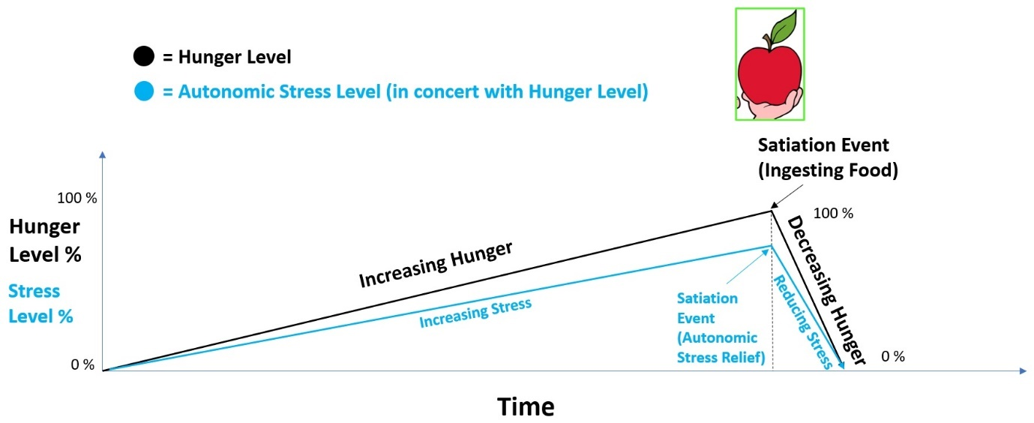
Figure 3. The rise and fall of the hunger level (black line) will trigger a coupled autonomic nervous system response (blue line).
Assuming that blood glucose will act as a control variable for a hunger control loop, Figure 3 shows how the hunger level as a percentage will rise as blood glucose is depleted over time (in this simplified example the increase is assumed to be linear). The drive part of the control loop (the circle shown in Figure 2) will thus register the decreasing glucose level as a departure from the setpoint and create the error signal. When, for example, an apple is now ingested, and the blood glucose suddenly starts to increase, the situation will instantly improve, meaning the error signal — and thus the hunger level — will immediately start to decrease (assumed to happen instantaneously and linearly).
The vertex point in the hunger curve (black line in Figure 3) is referred to as the satiation event — where the initial relief from hunger is experienced. Since the human brain always couples an autonomic stress response to all other control loops (including hunger), the autonomic stress level (blue line in Figure 3) will fall in concert with the hunger level and create its own satiation event, where sudden relief from autonomic stress is experienced.
The memories formed in the human brain during both these satiation events are of particular importance. As part of the hunger satiation event, through a process called reinforcement learning, the brain will causally link the actions of holding and eating the apple with a reduction in hunger level. These actions will become strongly reinforced in memory and come in handy in the future when hunger is experienced in that environment. This type of reinforcement learning, called operant learning, is modeled in Xzistor agents and key to how these agents learn reward-producing behaviors (including the use of words as will become evident later in this paper). How these agents start to form Associations and how these Associations support Operant Learning are discussed in the next Section 5 – Operant Learning.
While the operant learning triggered by the hunger satiation event can reinforce actions like holding and eating the apple, the autonomic stress satiation event can additionally teach the brain how to navigate towards the apple. With repeat approaches to the apple, the ability to bring autonomic stress relief (related to hunger) is gradually passed on to other objects along the routes to the apple in a process the model refers to as Reward-based Backpropagation. This unique ability of the Xzistor brain model to use Autonomic Stress Satiation to reinforce reward-preceding actions and turn objects in the environment into navigation cues will be essential for explaining how artificial agents can develop a Verbal Behavior capability and is further explained in Section 6 − Reward-based Backpropagation.
The hunger example above explains how homeostatic/allostatic control loops work and the importance of the coupled autonomic stress loop as another means of reinforcement learning. This basic understanding can now be used to explain how the Xzistor model creates Artificial Emotions.
The human brain is not just linked to sensory receptors for gathering information from outside the body, but there are also receptors distributed all over the inside of the body, keeping track of all the homeostatic and allostatic control variables. When these sensors detect changes in control variables leading to increased error signals, they activate various pathways throughout the body that alert the human brain that something is not right.
For hunger, sensing a drop in blood glucose level could, for instance, send activation signals to the neuronal populations in the brain where the hunger drive (based on the error signal) is represented. From there, the signals will be projected onwards to the areas of the brain where nerve inputs from the viscera (body) are represented, e.g., the somatosensory cortex, insula, etc.
These visceral representations, which will be experienced as if coming from inside the body, will convey important information to the brain about the status of the control loops. For example, certain characteristics of the representation might tell the brain the strength of the hunger control loop's error signal, its rate of change, and the direction in which it is changing. If the hunger error signal is decreasing (e.g., when the apple is being ingested) a different visceral representation will be created in the body map area of the brain that is not the same as when the error signal is increasing.
Through reinforcement rules, the brain will learn that the first visceral representation, where the error signal is decreasing, should trigger approach/pursual behaviors (and the brain will learn to call this bodily feeling ‘good’ or ‘positive’). The brain will learn that the second visceral representation, where the error signal is increasing, should trigger avoidance behaviors (and the brain will learn to call this bodily feeling ‘bad’ or ‘negative’). The Xzistor model argues that experiencing these ‘good’ or ‘bad’ visceral representations, derived from error signal status, as bodily feelings is what constitutes emotions in the human body and brain.
The above not only explains how these emotions will drive avoid/approach behaviors, but also how objects in the environment will become subjectively valued as ‘good’ or ‘bad’ by virtue of the emotions they become associated with.
Emotions are essential to the biological brain as these spatiotemporal activation patterns, residing in dedicated body map areas of the brain, are what the executive part of the brain will constantly be presented with (aware of) without the need to consider the complex underpinning mechanisms contributing to the final emotion representations. For instance, blood pressure and osmolality are actively factored in when generating a single thirst emotion, but no visceral representations of blood pressure or osmolality are subjectively experienced (self-reported) by humans.
This ensures the executive part of the brain only has to adjudicate between a finite set of consolidated emotions to identify the strongest (most salient and thus most urgent) emotion on which to base its next action selection.
If the executive part of the brain is already successfully acting on the strongest ‘prime’ emotion and thus experiencing satiation, it will simply keep executing the satiation actions. Nothing prevents the brain from simultaneously performing actions that will satiate other emotions at the same time as the ‘prime’ emotion, e.g., a hungry human can drive up to a drive-thru service point while at the same time turning up the car’s heater and canceling a mobile call from a confrontational landlord (all actions that will cause satiation, but with hunger remaining the most urgent emotion).
The Xzistor brain model creates simplified mathematical correlates of all the neural functions and spatiotemporal activation patterns found in the somatosensory areas of the brain as visceral representations. It achieves this by using a relational database to create its own numerical Body Map. The same basic information can be modeled as numerical values in this relational Body Map database where the simulated brain can process it. This includes information about where in the body the visceral Artificial Emotions will be experienced, the strength and changes in the Error Signals they represent and to what extent they will be felt in neighboring areas of the artificial agent’s body.
By locating an Artificial Emotion representation for increasing Hunger in the abdominal part of the Body Map of an Xzistor agent, the representation can effectively be ‘positioned’ so that it will feel like a somatic sensation originating from the abdominal part of the agent’s body. Since this representation will, however, not only be used to map sensory stimuli from within the body and environment, but also to drive behavior, Artificial Emotions are also called pseudo-somatosensory representations by the model.
Following the approach above also allows for the modeling of key aspects of the limbic system in the human body and brain — collectively referred to by the Xzistor brain model as the Body State Override Reflex. The model’s artificial limbic system can intensify Emotions when changes are important for learning, e.g., when Satiation or Deprivation Emotions are experienced, or when anticipated (predicted) Satiation or Deprivation Emotions are suddenly more or less than expected. The biological limbic system achieves this by overriding the error signals of numerous bioregulatory drives to temporarily create a boost in good or bad emotions that will also reinforce learning.
Dopamine has been implicated in this mechanism in the human brain, and cocaine is often used to explain how a temporary ‘false’ satiation state (euphoria) can be achieved. This happens through a dopamine build-up that interferes with the error signals of control loops so that it will subdue hunger, thirst, pain (anesthetic properties), nausea, fatigue, body thermal sensitivity as well as many types of fear (stress) to create a feeling of indefatigability, invincibility and euphoria.
Any Satiation source, or anticipated Satiation source that is replaced with either a stronger (better) or weaker (worse) Satiation source, will cause a ‘surprise’ effect in the agent — a change of state in the modeled Autonomic Stress Emotion which will trigger the Body State Override Reflex.
This will override the Error Signals of many Homeostatic and Allostatic control loops and create a temporary ‘false’ Satiation or Deprivation state (set of Emotions), which will enhance learning and adjust the Emotional salience associated with the Satiation or Deprivation source that caused the hedonic/aversive surprise, as well as the preceding actions and the preceding navigation cues.
If an expected Satiation source is suddenly missing, a temporary ‘false’ Deprivation state (negative Emotions) will be created that will enhance learning to devalue and lower the Emotional salience of the Associations containing the preceding actions and the preceding navigation cues (not of the actual missing Satiation source itself).
In addition to the effects of the Allostatic control loops (specifically the Autonomic Stress control loop), it is this Body State Override Reflex that leads to objects/concepts/situations in the agent’s environment to generate ‘good’ or ‘bad’ Emotions when observed or recalled — akin to the limbic system in the human brain. This also provides the agent with the equivalent of an intuition or ‘Gut Feel’ as a quick combined Emotion based on first impression.
Under Modeling the Limbic System in Appendix A, a more detailed discussion on the Body State Override Reflex is provided.
Recognizing how the autonomic stress loop is always triggered in unison with other homeostatic and allostatic control loops in the human brain and how the limbic system enhances emotions allows the Xzistor brain model to explain how all other emotions work. The modeled brain of the agent learns to act on these Artificial Emotions, which, according to the model, become the origin of all volitional behaviors.

Operant Learning
It is important to understand how Xzistor agents learn since the manner in which new words are learnt will basically be no different from how new actions and action sequences are learnt. A new instantiation of the Xzistor brain model, driving a virtual agent or physical robot, will immediately upon initiation start to store Associations as it begins to move around and engage with its environment.
These Associations are just entries into the Association Database — snapshots combining what is in the agent’s simulated brain at the time, moment by moment, and may include Sensory inputs, information reflecting the status of different Homeostatic and Allostatic control loops along with the Emotional representations these create (including the modeled Autonomic Stress control loop Emotions), and representations of the Effector Motions the agent was performing.
If there is already an Association in the agent’s brain for what is being experienced, the existing Association will be updated based on the model’s specific rules for combining past and present experiences. These rules include how current and recalled activation/inhibition signals from all other Emotions to the Autonomic Stress Emotion are consolidated into an average stress state.
In addition to the Association Database, the model maintains a buffer where the consolidated Associations for several previous logic loop cycles are maintained. This will allow reward-preceding actions/objects to be assigned Satiation-triggering qualities retrospectively during Satiation Events and will be based on the Allostatic effects of the Autonomic Stress Loop, as discussed in the next section on Reward-based Backpropagation.
In the previously discussed example of Hunger, the importance of the Satiation Event was explained when suddenly Hunger is Satiated, accompanied by Autonomic Stress relief. This return to Homeostasis is turned into a Reinforcement Learning event by the model by storing and linking all environmental cues with strong Satiation-related Emotions (positive) and the Effector Motions that correctly led to the reward. This is called Operant Learning or Operant Conditioning (Skinner, 1957).
Due to how the model describes subjective Emotions, Operant Learning becomes easy. As Artificial Emotions must, by definition, provide information on whether Homeostatic and/or Allostatic control loops are moving towards (good) or away (bad) from their setpoints — it is also a good way to decide when Effector Motions should be reinforced (causally linked to a reduction in control loop Error Signal). The greater (faster) the improvement in Homeostasis and/or Allostasis is, the stronger the Association containing the Effector Motions will be reinforced.
As the discussion in this paper moves towards how Xzistor agents can demonstrate Verbal Behavior, reference will be made to reward sources. The model defines a reward source as any object/concept/situation that will provide Satiation. As mentioned before, the Xzistor agent will experience this Satiation Emotion as a visceral body feeling because it is located in its Body Map, and it will learn to pursue it and call it ‘good’.
An apple is a good example of a reward source when Hunger is experienced. Hunger Satiation will also generate Autonomic Stress relief, and navigation cues, like objects in the environment leading to the apple, can become Autonomic Stress ‘relief’ reward sources through Association.
The green door to the kitchen could become a reward source for when an agent is feeling Hungry — not because observing the green door will relieve Hunger, but because it will relieve Autonomic Stress linked to Hunger and because the Body State Override Reflex will create positive Emotions. The model will naturally allow such objects in the environment capable of relieving Autonomic Stress to become secondary reinforcers. Eventually, the agent could even feel Satiation when seeing a wallet on the table if it has learnt that money (as a proxy) can be exchanged for apples at the grocery store.
Important when moving towards a discussion on Verbal Behavior is the fact that for an Xzistor agent, just like for humans, a human caretaker will become an important reward source able to cause intense Autonomic Stress relief and able to trigger enhanced positive Emotions via the Body State Override Reflex. In this way, behaviors can be strongly reinforced by such a caretaker to teach the agent specific tasks that the agent will perform simply in return for an emotional reward. This powerful effect of human emotional manipulation is accounted for by the Xzistor brain model and explored in more detail later in this paper.
The Operant Learning mechanism mentioned above closely correlates with what is observed in the human brain when food is ingested, and the brain now needs to encourage the individual to repeat that action when next feeling hungry. Neurochemicals are released by the limbic system to ensure plasticity (learning). At the same time, a body sensation is generated that will represent relief from the unwanted hunger state (dopamine is positively correlated here) as well as relief from the autonomic stress state (acetylcholine is implicated here).
The neurophysiological structures of the brain suggest that the logical algorithms of the Xzistor brain model are also followed by the biological brain, i.e., there are no logical operations prescribed by the model that do not seem to have correlates in the biological brain. Equally, there are no structures in the biological brain that would suggest that additional functionality is required over and above what is provided by the Xzistor brain model as a simplified model of the human brain.
To maintain psychological plausibility and to align with what is seen in the biological brain, the model assigns an attribute to a stored Association referred to as an Impact Factor. This represents the Association’s Emotional salience (good or bad), how often it has been recalled (updated) and how recently it has been recalled. This Impact Factor plays an important role in aiding the executive part of the modeled brain in deciding which Associations from the Association Database could be used with a high level of certainty to select the next (subsequent) behavior e.g., to navigate to a Satiation source or to move away from a Deprivation source. The Impact Factor is described in more detail in Appendix A – Mathematical Principles of the Xzistor Brain Model.
The model’s ability to include Artificial Emotion representations as part of Associations and rank these Associations based on Impact Factors, not only enables agents to have preferences for memorized reward sources based on Emotional saliency but also provides a means for the modeled brain to link environmental cues with the correct Effector Motions. This allows for navigational routes to these reward sources to be created through Reward-based Backpropagation, which, as a supplementary learning mechanism, will be important in explaining how Xzistor agents can achieve Verbal Behavior.

Reward-based Backpropagation
Reward-based Backpropagation is based on how certain states in the human brain will linger while new ones are introduced. This can happen when one stimulus state temporally precedes another (e.g., the view of an open cupboard door preceding the image of an apple as a reward source). This is referred to as ‘persistent activity’ by neuroscientists (Curtis, 2021). This can also happen when two or more stimulus states are simultaneously present in the brain (e.g., the tutor’s face is viewed at the same time as the apple is viewed). This is referred to as ‘perceptual binding’ (Colzato, 2007).
When a new state (neural activation pattern) enters the human brain and triggers a satiation event, indicating that access to a reward source has been secured, preceding states that are still lingering in the brain can ‘inherit’ some of the positive emotions generated by the autonomic stress loop and its effect on the limbic system.
The Xzistor brain model exploits this effect in a unique way. With repeated learning, environmental cues that are progressively further away from the reward source can now be tagged, as part of Association-forming, with the positive Emotions using Reward-based Backpropagation. Navigating towards and recognizing the tutor’s face will trigger a Satiation Event — not because this will solve Hunger, but because it will solve the Autonomic Stress linked to Hunger (blue line in Figure 4 below) as well as triggering the Body State Override Reflex.

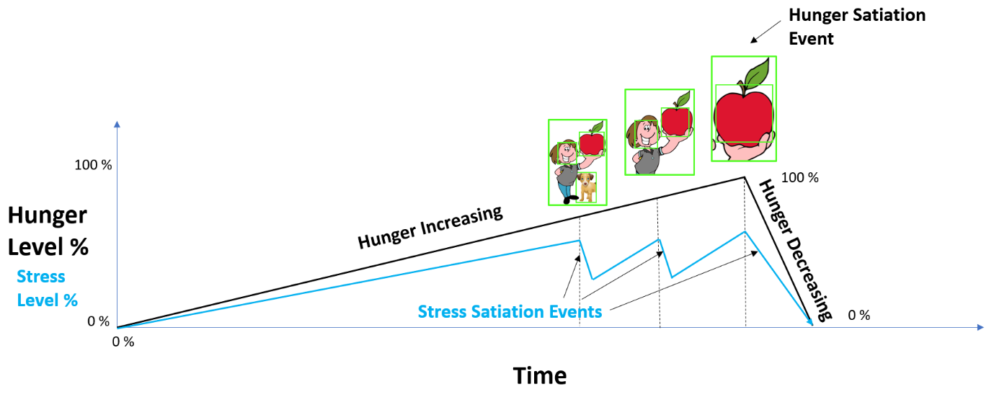
Figure 4. With every approach to the Hunger reward source (red apple) another preceding ‘green frame’ Sensory state is turned into a positive Autonomic Stress Satiation Event. This causes positive Emotions and reinforces Effector Motions towards the Hunger reward source from further and further away. The model calls this Reward-based Backpropagation.

In this manner, environmental cues further and further away from the Hunger reward source (apple) will gradually be turned into Autonomic Stress relief sources, capable of triggering positive Emotions and causing Satiation Events by mere recognition, when the agent is experiencing Hunger.
As shown in Figure 4 above (blue line), Operant Learning caused by these Autonomic Stress relief reward sources in the environment will reinforce and match the correct actions the agent was performing while navigating past the tutor and the dog towards the apple.
This means the agent will learn all the correct Effector Motions to steer it through the environment towards the Hunger reward source based on what is observed in the environment. As these environmental cues will hardly be identical every time (light, shadows, angles, etc.), the Xzistor agent will use a level of inductive inference (guessing). If a dog is suddenly missing from a scene, it will simply use the other objects in the scene to guess it is still on the correct navigational route to the apple.
To prove this mechanism under dynamic conditions, Xzistor simulations and robots were developed, demonstrating how these agents gradually learn to navigate from increasingly further locations in their Learning Confines towards Hunger reward sources when getting Hungry. The facial expressions of these agents also reflected the Hunger and Autonomic Stress Emotions with intermediate moments of Autonomic Stress relief, as well as the effects of the Body State Override Reflex, clearly displayed when recognizing a positive environmental cue i.e., an object in the environment guiding the agent towards the Hunger reward source.
The model does not consider facial expressions part of Emotions, as these are just Learn-modifiable Reflexes triggered by subjective Emotions. These expressive Reflexes like smiling, frowning, laughing, crying, etc. can be modified through learning to become volitional (often manipulative) behaviors in time.
The model also explains how executing navigational behaviors will become less interrupted by periods of searching the Association Database, and increasingly coordinated and ‘automatic’ with continued practice. This means the blue line in Figure 4 will start to move down and flatten, as more cues in the environment become instantaneously recognizable as pointers to the reward source.
As the Autonomic Stress (blue line) drops lower and the agent’s confidence increases in its ability to find food when Hungry, the agent will need to pause and infer less about what actions to take, and it will be able to confidently execute the learnt Effector Motions to follow the well-practiced navigational route. There is no unresolved Autonomic Stress or delays to finding Autonomic Stress Satiation, meaning the agent’s brain will not have to resort to Thinking.
The Xzistor model proposes an unconventional mathematical correlate of what humans refer to as thinking — a mechanism derived from the human mind’s natural tendency to wander, as explained in the following Section 8 – Mind Wandering.
The blue line in Figure 4 also helps to explain what happens if the anticipated reward source is replaced by a less impressive (lower Impact Factor) or more impressive (higher Impact Factor) reward source. Every time the blue line drops downwards, as a familiar environmental cue is recognized, Autonomic Stress will momentarily be relieved, and the Body State Override Reflex will help create positive Emotions.
If an individual is expecting a tasty hamburger, which is known to cause strong hunger and autonomic stress satiation (along with additional strong positive emotions generated by the limbic system), finding a slice of dry toast instead (weaker positive emotions) will trigger surprise i.e., the sudden drop from the strong autonomic stress relief generated by the anticipated (imagined) reward source to the weaker autonomic stress relief generated by the observed (found) reward source, will cause a depression of the reward system (limbic system) that will generate negative emotions (shock with disappointment).
Similarly, if an individual who is expecting a tasty hamburger, which has caused strong hunger and autonomic stress satiation in the past, finds instead a large chocolate cake, the person will also experience a surprise, i.e., the sudden rise in anticipated autonomic stress relief will trigger the limbic system causing enhanced positive emotions (shock with pleasure).
This effect is sometimes called ‘prediction error’ in psychology (Den Ouden et al., 2012). Catecholamines like noradrenaline and dopamine have been implicated in the reinforcement learning processes in the human brain during emotional events involving surprise. Implementing Reward-based Backpropagation in agents resulted in human-like ‘Satiation-seeking’ behaviors and highly authentic facial expressions.
In Figure 5 below, we can see an Xzistor simulated agent, ‘Simmy’, having learnt to navigate from anywhere in its Learning Confine to the food source (purple liquid) with a visible smile.

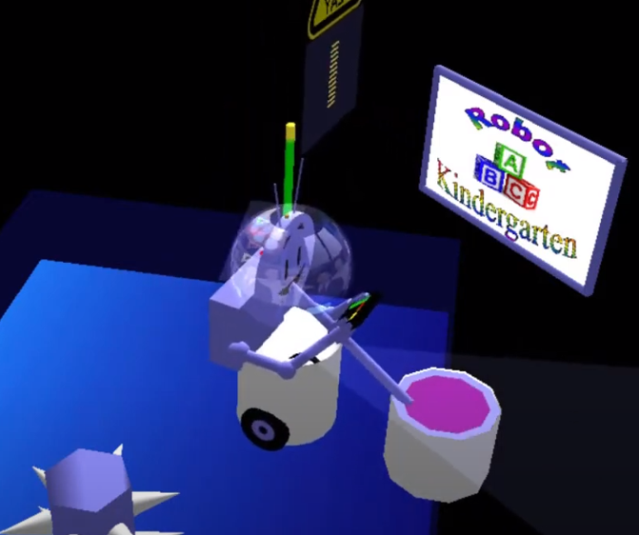
Figure 5. An Xzistor simulated agent, ‘Simmy’, has learnt to navigate to the food source (purple liquid) using Reward-based Backpropagation.
Video available: https://youtu.be/8HTjBucudrI?si=BjdtvoJuUPsNpoz8

In Figure 6 below, we can see a simple physical Xzistor robot called ‘Troopy’ that has learnt to navigate to the food source (miniature buffet table outside its Learning Confine). The graphical interface (dashboard) used by the tutor to interact and teach this elementary robot shows the robot’s video camera field of view as well as time traces of Homeostatic and Allostatic Emotions (including the coupled Autonomic Stress Emotions) as they are experienced in real-time.
The model’s ability to replace the visceral emotion representations experienced by the biological brain with numerical representations means that these can be digitally processed and displayed as graphs. By allowing any Artificial Emotion to vary between a maximum positive value of +1 and a maximum negative value of −1, an aggregate (normalized) Emotion strength value can be calculated representing the agent’s consolidated mood (net positive or net negative) and displayed as what is referred to as a real-time ‘General Happiness Curve’.
It further allows these agents to display facial expressions, varying moment to moment from wide smiles to anxious frowns, reflecting their average internal emotional states — making them appear very lifelike. Troopy’s facial expression is displayed on the tutor’s screen rather than under the Stormtrooper helmet.

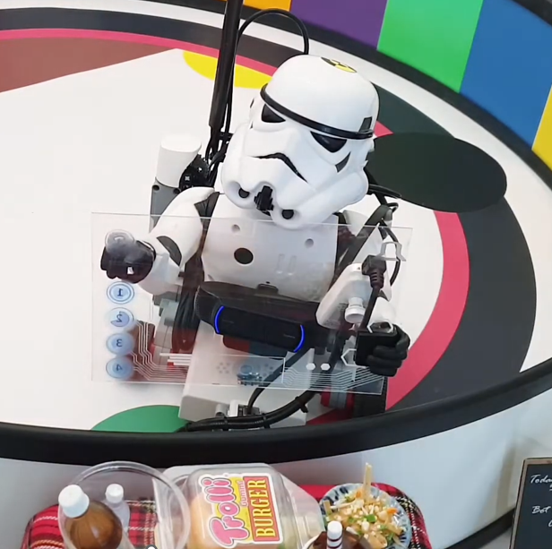
Figure 6. A simple Xzistor physical robot ‘Troopy’ which has learnt to navigate to the food source (buffet table outside its Learning Confine) using Reward-based Backpropagation.
Video available: https://youtu.be/QyAv9ujV9Yw?si=W0dNNmhf4J_rvPJI

Animal Versus Human Brain
When it comes to the study of verbal behavior, a key concern many linguists and philosophers have raised over the years relates to the difference between human and animal brains. Many still question whether the empirical observations in the simple learnt behaviors of animals can be extrapolated to the much more complex behaviors of humans.
The Xzistor brain model offers a principal explanation of both the animal and human brain. The preceding explanation of how an artificial agent can be taught to navigate to a reward source using Operant Learning and Reward-based Backpropagation (with minimal inference) is akin to how an animal will learn. If the environmental cues are changed or the agent is placed in a different environment, this type of Operant Learning will not be enough to ensure the agent can locate a reward source.
To achieve the generalization (reuse) of knowledge across domains, a mechanism needs to be added that will allow the model to make inferences in the way humans do when suddenly placed in an unfamiliar environment. To allow agents to make inferences (Think) in a human-like manner, the Xzistor brain model utilizes a unique mechanism based on a phenomenon in the human brain called mind wandering (Yamaoka A, Yukawa S., 2020). This mechanism will be key when using past learning to make inferences aimed at solving new problems — including choosing the correct words to request access to reward sources from caretakers or tutors.

Mind Wandering (Threading)
One of the unique features of the Xzistor brain model is a mechanism that allows the model’s executive part to spontaneously retrieve Associations from the Association Database without performing any actions — akin to how a human experiences mind wandering (or daydreaming). When not urgently solving Homeostatic and/or Allostatic deficits, the simulated brain will go into a modality where it starts to automatically re-evoke Associations along with some stored Sensory representations (mainly visual) in addition to their stored Emotions. The model refers to this as Threading.
The Associations are re-evoked sequentially, with a new Association selected based on a shared attribute with the previous Association. For instance, a shared attribute could be a correlating Sensory state (e.g., part of a visual image), or similarities in Emotion representations, or even similar actions (Effector Motions) stored as part of the Association — without physically performing these actions.
Once the Threading modality is triggered, the modeled brain will make a list of closely correlating Associations and select the next one to be re-evoked in the sequence — strongly influenced by the Impact Factor — meaning preference is given to those Associations with high Emotional salience (positive or negative), that were often recalled/updated and which are recent.
Only when more urgent priorities arise, triggered by Homeostatic or Allostatic deficits (like sudden Pain or an aversive Autonomic Stress condition), will the agent’s modeled brain start to prioritize specific needs and actions. Learnt Associations are now urgently required to solve Homeostatic and/or Allostatic deficits and the modeled brain will immediately experience an increase in (coupled) Autonomic Stress.
Based on the rising Autonomic Stress level, the agent’s simulated brain will now start to constrain Threading to only search the Association Database for Associations that can be Contextually linked (representations that have shared features) and proven to help solve the current deficit by reducing the Error Signal of the Drive. This is referred to by the model as ‘directed’ Threading or Thinking (a proposed computational correlate to human thinking). This is achieved by limiting the search process to preferentially retrieve Associations representative of the environment the agent is currently in and which contain Emotion representations indicating that the Effector Motions stored as part of these Associations have been able to successfully reduce the current Homeostatic or Allostatic Drive deficits in the past.
This means strongly reinforced actions from Associations with a high Impact Factor will be prioritized and immediately performed to try to solve the agent’s problem. These trial-and-error actions are often learnt in one domain and generalized to other domains in what can be regarded as inductive inference (this is elaborated on in Appendix A under the heading Generalizing Thinking across Domains).
If these inferred actions manage to solve the deficit, they will be strongly reinforced to memory with the appropriate Impact Factor. However, if the deficit continues to increase, the agent will become more anxious. As the Autonomic Stress increases further, the ‘directed’ Threading process will become less restrictive, gradually allowing even poorly matched Associations to drive behavior.
Xzistor agents subjected to extreme levels of Hunger (close to simulated death) have been shown to resort to almost frantic behaviors to get to a food source — trying anything and everything available from their Association Databases — closely resembling desperate human behaviors under the same circumstances. Their facial expressions will also indicate severe distress and they will make crying noises.
For virtual and physical Xzistor agents where Threading as well as ‘directed’ Threading were demonstrated, the agents were able to re-evoke and compare up to ten related Associations per second — either when demonstrating mind wandering (Effector Motions limited), sleep dreaming (Sensory inputs limited, most volitional Effector Motions blocked) or Thinking (no Sensory inputs or Effector Motions blocked).
Human thinking is modeled by the ‘directed’ Threading process and defined by the model as trying to find a relevant Association that can provide learnt behaviors to help solve a current problem. The images recalled by an agent during Threading and ‘directed’ Threading can be visually displayed on a screen in real time to show what the agent is ‘dreaming’ or ‘thinking’ about — along with a visualization of the bodily Emotions experienced in the Body Map area of the modeled brain. These visual displays will be incorporated into the design of the ‘language learning’ infant-agent demonstration proposed later in this paper.
Based on this tendency of the model to constantly look at what is present in the brain and then, in quick succession, re-evoke all the closest related Associations around the current Sensory and Emotional content, the model will automatically generate the subjective Context around what is currently being observed or thought about by the agent. The effect is akin to how the human brain would present ‘context’ as a quick succession of visual images with accompanying emotions of past experiences related to what is known (what was previously learnt) about the currently observed or imagined object or concept.
The mechanism of Threading, as modeled human mind wandering, brings to bear several human brain effects that not many other cognitive architectures provide computational models for — daydreaming, sleep dreaming, contextualization, thinking, etc. that could lead to problem-solving and inductive inference in novel environments.
When an Xzistor agent that was in Threading mode develops a strong enough Hunger Homeostatic deficit, the executive part of its modeled brain will move to ‘directed’ Threading, and the recalled Associations will now start to revolve around images of food sources, specifically those with high Impact Factors, as well as images of the environmental cues used to navigate to these food sources.
The agent will experience this as a dynamic display of rapidly recalled visual images of the food sources and the objects along the routes to these food sources — even before the agent has started to navigate towards the preferred food source (the one with the highest Impact Factor).
When the agent has high certainty, i.e., both the food source and the route to the food source have been well-practiced (reinforced) through many past repetitions; it will not need to constantly revert to ‘directed’ Threading to infer (guess) the route to the food source. It will confidently move along the practiced route whilst experiencing low Autonomic Stress (nothing is unknown).
If less familiar with the route and thus less confident, the agent will occasionally pause and use ‘directed’ Threading to infer the best navigation route. Along the way, it will also frequently recall the image of the preferred food source and thus regenerate the Autonomic Stress relief (good feeling enhanced by the Body State Override Reflex) in anticipation of accessing the reward source — which in some cases can result in a prediction error as discussed in Section 6 – Reward-based Backpropagation.
This Threading mechanism, and the how it can become ‘directed’ by strong Autonomic Stress, is important as it will also play a pivotal role in explaining some aspects of learning and inference related to Verbal Behavior, as discussed in Section 10 – Verbal Behavior.

Nuance Development
One final effect of the model will help elucidate how Verbal Behavior can be achieved by the Xzistor brain model. This effect can be used to explain how an agent can learn the subtle differences between objects and the words that describe them. The case of a modeled apple-ingesting agent can again be used as a simple example of how the Xzistor agents will naturally develop Nuance.
An agent that has only been subjected to a short training period might mistake a red cricket ball for a red apple and try to eat it. The anticipated Hunger Satiation will not occur, and the Autonomic Stress level will not decrease — causing surprise and disappointment (a classic case of prediction error as mentioned above).
The sudden change from anticipated Autonomic Stress relief (a positive Emotion) to no relief will trigger the Body State Override Reflex to momentarily create enhanced negative Emotions that will reinforce learning. This will imprint, as part of an Association, the visual image of the cricket ball as a source of strong negative Emotional salience (Impact Factor) — meaning it will induce both a negative Autonomic Stress Emotion and negative Emotions generated by the Body State Override Reflex when recognized again in future.
If the Hungry agent heard the phrase ‘Red cricket ball!’ during this distressing episode, the digitized (numerical) sound representation of these words will also be imprinted as part of the same Association as a source of negative Autonomic Stress Emotions, enhanced by negative Emotions from the Body State Override Reflex. The same red cricket ball might, however, attract different Associations with different Emotions e.g., within the Context of a highly entertaining game in which the red cricket ball plays a central role. This means that both the visual image of the ball and the sound representation of ‘Red cricket ball!’ will evoke different Emotions in different Contexts.
The model offers an interesting explanation of how initial Emotions around an object or sound are created in the human brain when suddenly experienced. When a stimulus like a visual image or sound (word) enters the human brain, the brain very rapidly generates a consolidated emotion set. This emotion set can be viewed as representative of all the different contexts in which the individual had experienced the stimulus in the past. This will be a split-second recalled set of emotions (mainly allostatic, e.g., autonomic stress/relief but also enhanced positive/negative emotions from the limbic system), and the emotional experience will be non-contextual.
This consolidated non-contextual set of emotions is a strong ‘early warning’ of how the object or situation linked to the stimulus should be subjectively viewed and handled by the person. It provides the individual with an almost instantaneous avoid/approach indication or ‘gut feel’.
This combined emotion set is always ruthlessly prejudiced and too quick to be affected by fears around societal norms or possible cultural expectations. If the task the individual is performing at the time is urgent, the person might not have time to contextualize the new stimulus beyond this ‘gut feel’ — unless the stimulus happens to trigger a new ‘stronger’ homeostatic or allostatic emotion like the words ‘Watch out!’.
This exclamation could immediately raise the autonomic stress level to become the most urgent drive and call for prioritized attention and action. However, if the individual is not preoccupied with an urgent task and perhaps just busy with an everyday chore generating almost no autonomic stress and thus requiring very little focus or thinking, the brain will tend to go into mind wandering (daydreaming) mode. This will lead to the contextualization of the stimulus. It will basically work the same in the modeled brain of an Xzistor agent.
The Xzistor brain model will emulate the above processes in the human brain, causing an agent to go into Threading mode. Now, the new stimulus (image or sound) will, along with other environmental cues, Emotions and Effector Motions, be used to select closely related Associations from the Association Database that will provide different Contexts around the stimulus. This will quickly form a Contextual thread (sequential list) of recalled Associations that will be relevant to the stimulus and preferentially selected based on high Impact Factor.
This means the sequentially recalled Associations will be Contextually relevant, recent, often repeated and of strong Emotional significance (good or bad). This Threading process could continue for a mere few seconds (Contextualization) or continue for much longer if no new urgent needs or distractions are experienced (Daydreaming).
For the agent, it is important to note that whereas the instantaneous first Emotion set triggered by the stimulus was non-Contextual, the Threading process can now generate new Emotions (good or bad) as part of the relevant Associations that are continuously recalled from the Association Database along with their visual imagery. This is how the model will Contextualize the stimulus and quickly recall relevant Emotions from past experiences, providing the agent with the subjective Context or ‘Meaning’ of the stimulus.
An example of how the equivalent process could work in the human mind would be when a beachgoer hears someone scream ‘Shark!’ and when the beachgoer looks around, it is just a deflated toy shark floating under the water’s surface. The immediate non-contextual emotion when hearing the word ‘Shark!’ could be an extreme shock (severe autonomic stress response). Then, as the brain contextualizes the harmless nature of the toy based on past experience, the emotions felt by the beachgoer could quickly change to stress relief or even amusement.
Not many cognitive architectures offer a definition or mechanism for the term ‘meaning’ — but the Xzistor brain model defines the Context generated by the Threading process as the Meaning around a word (or object, concept, situation, etc.) as subjectively experienced by the agent. This will also allow for words to develop Nuance or different subjective Meanings in different Contexts. The agent will learn that ‘water’ coming from a tap means something different from ‘water’ in the ocean. The model formally defines Context (or Meaning) around a current or recalled stimulus as the Associations containing representations of previously experienced objects, situations, actions and Emotions regenerated through the process of Threading by the current or recalled stimulus.

Verbal Behavior
In the previous sections, some of the key functional components of the Xzistor brain model were discussed. These mechanisms will all play an important role in demonstrating language acquisition in Xzistor agents. The discussion can now be extended towards the main aim of this paper — that of explaining and demonstrating artificial Verbal Behavior.
Implementations of the Xzistor brain model in virtual agents and simple physical robots within dedicated Learning Confines have proven that Reward-based Backpropagation will reinforce and store the correct sequences of Effector Motions as part of Associations so that the agents will gradually learn to steer themselves through the environment towards reward sources.
A typical test case was when an agent was made to experience Hunger and was able to recognize visual imagery in its environment serving as cues that had become conditioned as Hunger-related Autonomic Stress relief reward sources — simultaneously confirming and reinforcing within the agent’s modeled brain that it was on the correct route to the Hunger reward source. As mentioned before, it is essential to note that Autonomic Stress relief cues (based on Hunger) along the route to the reward sources do not relieve Hunger, but rather Autonomic Stress triggered by Hunger.
The Effector Motions the agents perform to reach the reward source are akin to limb movements performed by humans to get to a reward source. In humans, these limb movements rely on practiced muscle activity that becomes fully coordinated with further reinforcement learning. The question can now be asked if learning to utter words is not also just learnt sequences of coordinated muscle activity — in this case not to move the agent through the environment towards a reward source, but to request a person in the environment to provide the reward source (assuming the person can understand the utterances). As mentioned before in Section 2 – Related Research, this has been theorized about by numerous linguists and philosophers like Gilbert Ryle in his 1949 work The Concept of Mind, where he explicitly characterized language use as a learnt bodily skill and habit mediated by activation of muscular effectors.
Gilbert Ryle stated: “Speaking a language is a muscular habit, not an exercise in clairvoyance. It is a muscular habit dotingly elaborated, as are the exercises of acrobats and pianists” (Ryle, 1949, pp. 41−42). He emphasized the role of repeated motor training in forging neural connections, noting: “The rules which link sensations with utterances have to be practiced before they can be obeyed. There is nothing innate about them” (Ryle, 1949, p. 69).
Based on the above theories suggesting that language is a learnt bodily skill, basically a muscular habit, this approach can be further developed theoretically and tested in Xzistor virtual and physical agents.

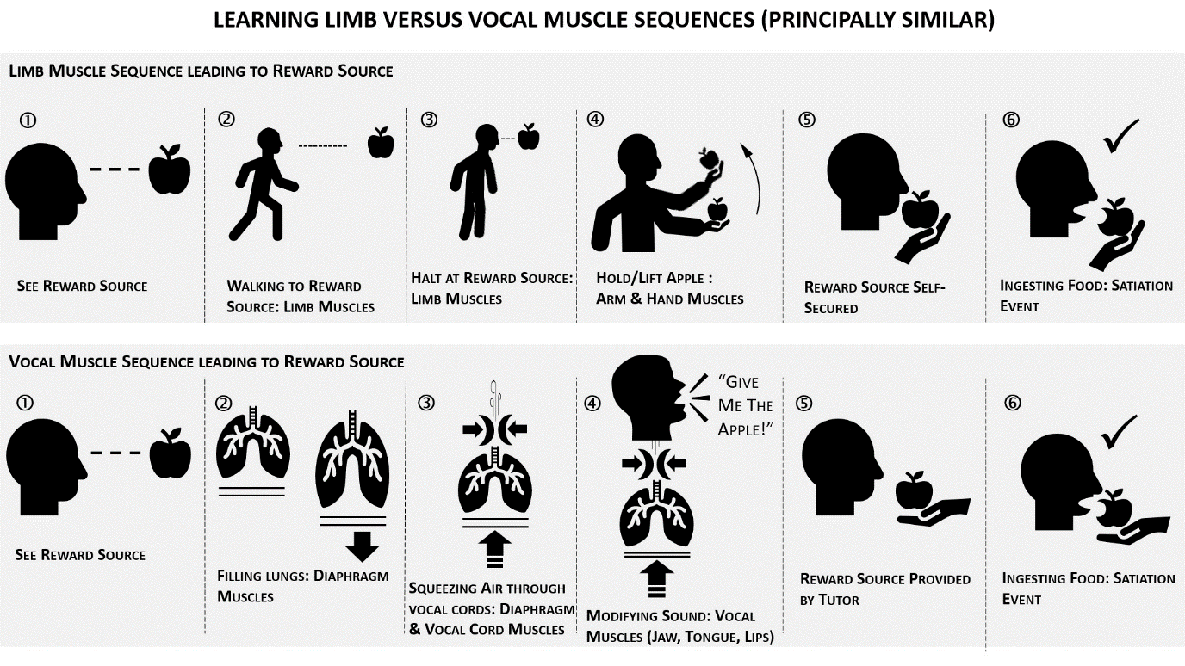
Figure 7: Learning vocal muscle sequences is principally similar to learning limb muscle sequences when the goal is to obtain access to reward sources. Implementations of the Xzistor brain model have demonstrated how artificial agents can learn limb sequences through Reward-based Backpropagation.

If we look at Figure 7 above, we see the top six activities under ‘Limb Muscle Sequence leading to Reward Source’, offering a simplified sequence of limb movements that humans can gradually learn to reach a reward source from different locations in their environment. The Xzistor model’s ability to emulate this learning via Reward-based Backpropagation has been proven in principle by using the virtual agent ‘Simmy’ and the physical robot ‘Troopy’.
Looking at the bottom six activities in Figure 7, we see under ‘Vocal Muscle Sequence leading to Reward Source’ a simplified sequence of speech apparatus muscular movements that a human can gradually learn to obtain a reward source from a supportive tutor that can understand the human’s words. To perform these word commands, the lungs need to be filled with air using the diaphragm muscles, then air must be squeezed through the airpipe. At the same time the vocal cords are being manipulated by laryngeal muscles and the generated sound must be modified through jaw, tongue, lip muscles — but all these activities also just constitute coordinated muscle movements that an Xzistor agent can theoretically learn through the process of Reward-based Backpropagation.
One difference is that where the limb movements rely on visual feedback for learning and refinement, the vocal muscle movements will rely on auditory feedback for learning and refinement. We can now argue that there is principally no difference between how coordinated limb muscle sequences are learnt and how vocal muscle sequences are learnt. By using Reward-based Backpropagation, it should theoretically be possible to demonstrate how Xzistor agents can learn words to obtain reward sources.

Learning Words and Simple Phrases
To teach an agent to navigate to a food source using Reward-based Backpropagation, the tutor must show the Xzistor agent a few times what to do. For both simulated and physical agents, this involved a facility for the tutor to take control of the agent’s Effector Motions (motors) and demonstrate the required behavior repeatedly until the agent could do it by itself. Typically, this can be achieved over a few hours by using keyboard commands or joysticks.
A simple equivalent approach for learning words can be established where the tutor makes the agent say the words required to obtain food. The tutor can say, e.g., ‘Give me the apple!’ and the agent can record and repeat it. The digitally stored verbal command becomes the representation of the Effector Motions that will be stored as part of an Association during the Hunger Satiation Event (assuming the command resulted in access to food). Through Operant Learning, the agent will learn to use this phrase when it wants food.
No vocal muscle equivalents are required for an artificial agent, as the human speech apparatus can simply be replaced with the ability to digitally record words/phrases and play them back over a speaker. This is the extreme, most simple case, and it will only constitute the first step of a much more comprehensive and sophisticated investigation into the capabilities of the Xzistor brain model when it comes to artificial agent language development.
In this simple approach, we can, however, already test the agent’s ability to express a preference for a red apple over a green apple. The assumption is that the agent was first taught to obtain a green apple by uttering the phrase ‘Give me the green apple!’. After that, the agent was taught to obtain a much tastier red apple by uttering the phrase ‘Give me the red apple!’ The red apple will offer a higher Hunger and Autonomic Stress Satiation level. It will thus be stored as an Association in the agent’s modeled brain with a higher Impact Factor — so that when next the agent gets Hungry, the process of ‘directed’ Threading will first recall the Association containing the image of the red apple (contextually linked to Hunger), and then the Effector Motions will be performed, meaning the agent will utter the words ‘Give me the red apple!’.
If the agent asks for the preferred red apple and is not handed it, the anticipated Satiation will not occur. The agent will be surprised and experience disappointment (anticipated autonomic stress relief not experienced), causing the Body State Override Reflex to create negative Emotions (‘false’ Deprivation) that will devalue and suppress the Effector Motion part of the Association, i.e., the phrase ‘Give me the red apple!’.
This will cause the Effector Motion of the green apple Association to now be at a higher Impact Factor, and the agent will change strategy to gain access to the green apple with the phrase ‘Give me the green apple!’. It is important to note that the Effector Motions that were supposed to elicit the red apple will be devalued, not the red apple itself, which will remain the agent’s favorite food source. The environmental cues around the red apple — the tutor’s face in this case — could also be devalued as the agent loses confidence (trust) in the tutor as a way to the red apple.
This strategy is too simple to accurately emulate how human infants learn words and phrases.
However, it can prove the efficiency of reward-based backpropagation as a way to learn words to obtain access to the current preferred reward source and, if unsuccessful, fall back on less-favored reward sources.
The above could be the start of an advanced project to demonstrate a more elaborate and sophisticated emulation of human language acquisition using the Xzistor brain model that will require no changes to the model. For this we will have to take a more granular look at how infants learn to say words and phrases early on in their lives, and specifically the role of emotional motivation.

Emotional Motivation
In real life, the use of words by infants to obtain reward sources is often preceded by a year or more of interaction between the baby and the mother to build an emotional bond. During that time the sights and sounds of the mother become positively reinforced in the baby’s mind as a provider of homeostatic and allostatic satiation, e.g., breast milk, warmth, tummy tickles, burping relief, and other types of protective and affectionate interactions like smiles, soothing touches, and reassuring utterances — leading to physical satiation and stress relief.
This type of Emotional bonding will automatically happen between an Xzistor agent and its tutor if the tutor acts in a caring way, as described in the book Understanding Emotion (Van Schalkwyk, 2021, pp. 9−24). During these interactions, the tutor’s face needs to be visible to the agent when Satiation is offered, and the agent should also be able to hear the tutor’s voice. If the tutor also makes a point of repeating words like ‘Apple!’ and ‘Nice!” when the agent ingests the apple (modeled), these words will become Associated with the visual image of the red apple and the positive Satiation-based Emotions, including Autonomic Stress relief Emotions.
Some behaviorists refer to words like ‘Apple!’, ‘Nice!’, and the tutor’s face as secondary reinforcers. The tutor can also praise the agent by saying ‘Good robot!’ when it has successfully located the apple or achieved Satiation in another way. This effect is very powerful when it comes to the tutor needing to teach the agent new tasks.
When the agent hears the tutor say, ‘Good robot!’ it will create Autonomic Stress relief (positive Emotion) which can cause a Satiation Event that will teach the agent to repeat the behaviors that elicited the tutor’s response. It is often seen in young children that an action (e.g., a simple amusing behavior) praised by a parent will cause great joy and relentlessly be repeated by the infant until the parent has to intervene and stop the infant. This behavior is driven by emotional reward.
The tutor can start to teach an Xzistor agent to perform any task in return for the positive Emotions generated when hearing ‘Good robot!’ and this will extend beyond solving specific Homeostatic and/or Allostatic Emotions as this phrase can now cause Autonomic Stress relief in a non-Contextual manner. For instance, the tutor can teach the agent to repeat words like ‘fish’, ‘cat’, ‘house’, etc., when pointing at images of these, and the Satiation-seeking agent will learn that correctly repeating the words used by the tutor will result in the praise phrase ‘Good robot!’.
Once the agent has learnt to Associate a word with an image, the tutor can simply point at an image, and the agent will say the correct word. This will again elicit a ‘Good robot!’ praise phrase and aid in further reinforcing the link between the spoken word and the image (and of the tutor as a reward source). Of course, the same can be achieved with the term ‘Bad robot!’ when an action by the robot leads to adverse outcomes, or it is unsuccessful in its attempts to solve a problem and achieve positive Emotions. Again, the Body State Override Reflex will enhance the negative Emotional effects based on the disappointment suffered by the agent.
The above will open an almost infinite range of possibilities regarding teaching the agent what to do using Emotional motivation. If the tutor starts to use specific guide words at the right time, the agent will also start to Associate these words with the correct/incorrect behaviors e.g. ‘Yes!’ ‘No!’.
It is important to understand how an Xzistor agent’s behavior is completely dominated by finding Satiation — purely to achieve Emotional reward, but with the significant secondary effect of solving Homeostatic and/or Allostatic Emotions (including those critical for surviving and thriving).

Learning Like A Baby
Unlike many other cognitive architectures, the Xzistor brain model acknowledges that simulating the development of complex human thought and behaviors requires a long period of supervised learning, even when all the correct functional algorithms have been implemented. To accurately model human speech development, the starting point should be, like for humans, babbling.
Babbling is an early stage of human language development where a baby makes instinctive consonant-vowel or vowel-consonant sounds, e.g., “ma”, “da”, etc. and then moves to repetitive babbling, e.g., next “mama”, “dada”, etc. Eventually the infant will start to combine different sounds, e.g., “damaga”, called variegated babbling. This totally instinctive behavior often leads to a parent patiently encouraging the infant to say a word like ‘Mama!’ at which point the parent will put on a display of praise and affection which will reinforce this utterance along with the image of the parent’s face in the mind of the infant.
This will not only start the infant off in using words based on reinforcement learning, but also start a powerful process of mimicking for emotional reward. The infant will slowly learn that mimicking the words used by the parent elicits praise, and this skill will slowly develop as a behavioral strategy — constantly driven by the need for emotional reward.
It could be argued that instinctive early-life behaviors like babbling and mimicking are innate (preprogrammed), and the Xzistor model certainly does not oppose an innate element in all aspects of language development — it merely proposes that reward-based refinement of muscle habit goes a long way towards explaining how language can develop to a high level of sophistication.
The above process can be modeled by providing the Xzistor agent with a preprogrammed babbling repertoire of simple single syllabus consonant-vowel or vowel-consonant sounds to randomly utter just like human babies. The tutor can then use the ‘Good robot!’ praise phrase when the agent combines syllables and achieves a word like e.g., ‘Mama!’ or ‘Dada!’. Just like the agent’s ability to move limbs to obtain access to reward sources will keep developing, this vocabulary of words and phrases learnt from the tutor will grow and effectively mark the start of verbal communications between the agent and the tutor.

Implementation of a Language Skill in Agents
In the previous sections explanations were offered of how Xzistor proof-of-concept implementations can emulate some of the basic early life behaviors leading to language development in humans. The discussion can now move to how precisely this will be built into an Xzistor simulation or robot.
Sound entering the human brain can be modeled via a sensor (microphone) aided by a spectrum analyzer to digitize the incoming signal. In Figure 9 below, a simple spectrum analyzer application is shown, which was tested for its ability to create a coarse-grid digitization of a spoken word or phrase. This digitization can directly be stored as a set of numerical sequences linked to sound frequencies as part of an Association.

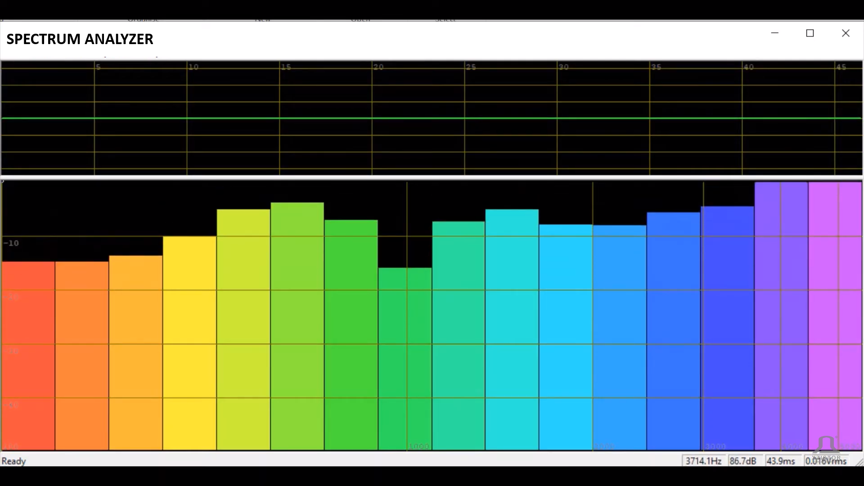
Figure 9. A digital sound spectrum analyzer that can be used to translate sounds heard by the agent into digital representations as numerical sequences.
Video: https://www.youtube.com/watch?v=VbAwNy-hC8A
As this will be a relatively crude digital representation of a spoken word or phrase, the agent will repeat it (play it over the speaker) in low fidelity. However, this is adequate to explain the principle and the fidelity can easily be increased later.
The digital phrase representation (like any other Effector Motion representation forming part of an Association) can be simplified to a sequence of comma-separated integer values and turned into machine code for a complete phrase like: ‘Give the red apple!’. At first, the agent will not be aware that the above phrase comprises four separate words. Although it will take much additional learning, the Nuance between the four individual words will eventually be learnt by the agent for their individual roles in eliciting reward sources for different Homeostatic and/or Allostatic Emotions in different situations.
This will happen as a natural consequence of how the Xzistor model stores and ranks Associations and then recalls these Associations to build Context around visual and auditory inputs entering the modeled brain.
In the figures below, it can be seen how a microphone (integrated into the video camera) and a small speaker were built into a small Xzistor demonstrator robot.

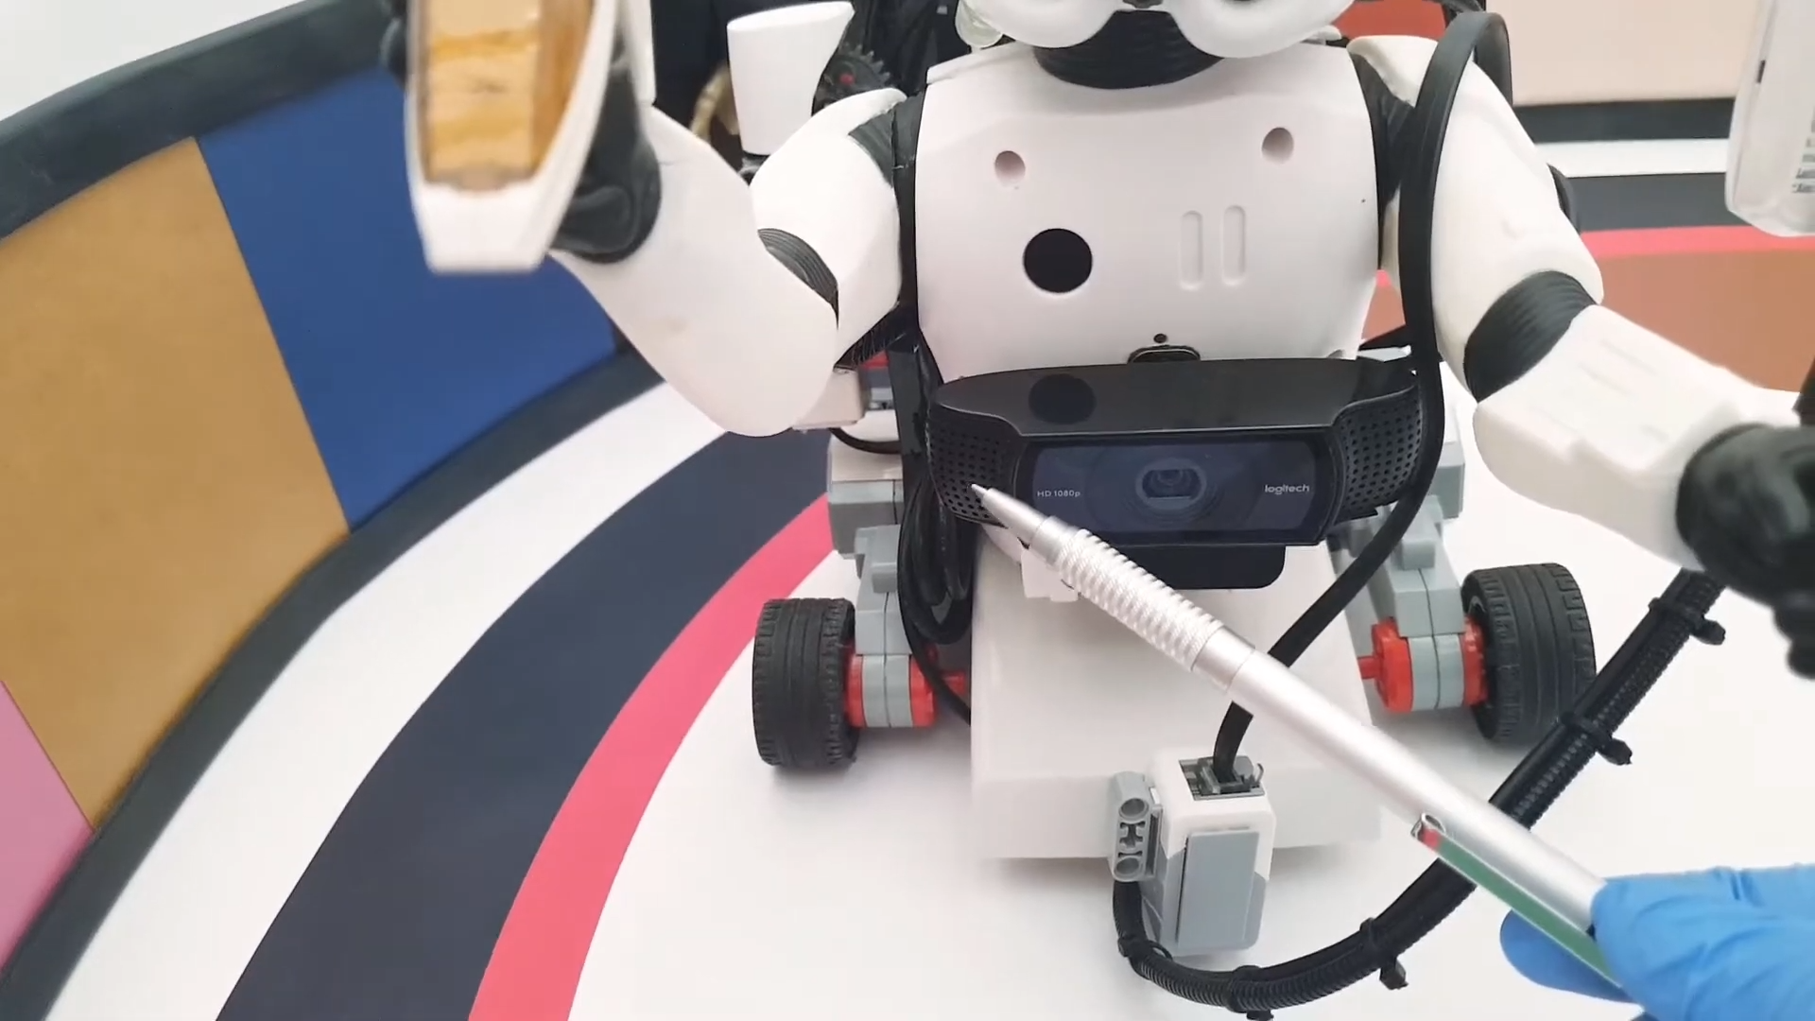
Figure 10. In this image, the pencil points to one of the two integrated microphones on both sides of the Xzistor robot’s video camera.
Video: https://youtu.be/96ujeWqXlHc?si=Nf9CGygr1R6V2Qer

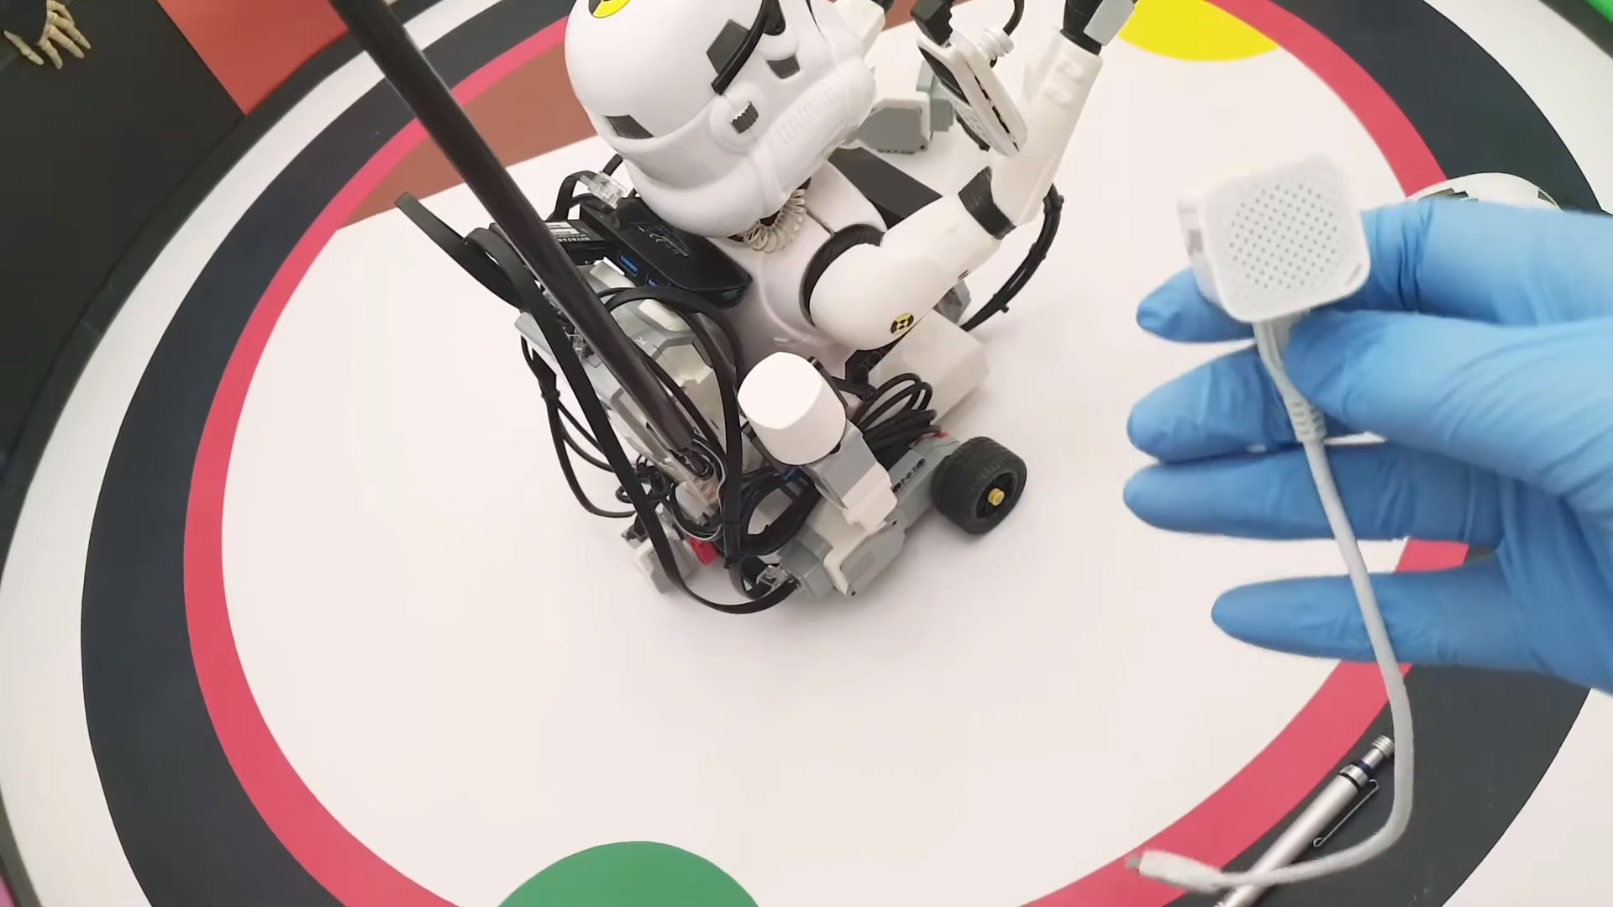
Figure 11. This image shows the small speaker fitted inside the head of the Xzistor robot and connected to the single board computer on the back of the robot that communicates via WiFi with the remote main computer running an instantiation of the Xzistor program.
Video: https://youtu.be/zOJiqWz4fqg?si=pVZeA2Qrn5yA1wW0

Towards more Complex Syntaxes
We can now look closer at an Xzistor agent that has learnt to use the phrase ‘Give me the apple!’. If this agent omits the word ‘apple’ from this phrase, the tutor might not know what the agent wants. Every moment the agent is kept from Satiating its Hunger, both the Hunger and the Autonomic Stress levels will rise, and the overall suffering will increase. The agent will try to avoid this aversive situation caused by the increasing negative Emotions from the Hunger and Autonomic Stress control loops.
Simply using the word ‘Give!’ will not lead to a Satiation Event (and therefore no good subjective feeling) and will not be reinforced as a successful Effector Motion. In this way, the agent learns to perform the correct spoken Effector Motions just like it learns to perform the correct sequence of Effector Motions when learning to fetch the key from the dining room table and unlocking the kitchen cupboard to get to the cookie tin.
If the agent has developed a preference for a green apple, it will learn to add the word ‘green’ to the phrase, to ensure it elicits the preferred reward source from the tutor. The agent is also driven to refine its vocalizations to receive praise from the tutor, rather than getting a phrase wrong and getting called out with a ‘No!’ or ‘Bad robot!’, which will trigger conditioned Autonomic Stress.
Refinement towards the correct order of words in a phrase could thus be an attempt to avoid ridicule or critique from others, not just the fact that the wrong words (or the right words used in the wrong order) could delay or prohibit access to reward sources. Even if an agent has never received formal training in the use of spelling and grammar, it will learn to adhere to spelling and grammar rules by mimicking and repetitively practicing grammatically correct phrases, as this will speed up access to reward sources and avoid discrediting comments from a tutor (Bergelson, 2023).
The agent’s spoken language will therefore evolve towards becoming more colloquially correct in pronunciation, timing, and tone. The above effects will naturally evolve as part of the Xzistor brain model and become automatic and effortless — effectively creating a muscle memory effect as observed in humans.
A high level of Emotional salience (reward or punishment) and repetition, two constituent parts of the Impact Factor, will ensure that the correct vocalization becomes fully coordinated and firmly embedded as Effector Motions in the agent’s modeled brain as part of Associations. This closely aligns with Ryle’s explanation of language use in humans as a ‘…muscular habit dotingly elaborated, as are the exercises of acrobats and pianists…’.
While some linguists are still not sure if spoken language is mainly a volitional motor behavior grounded in the systematic activation of the speech musculature or based on an inherent universal grammar, a global elocution industry has sprung up reflecting a firm belief by many speech coaches that muscle memory is critical to speaking fluently — and they are offering clients a wide range of repetitive practice techniques to improve their eloquence and communication skills.
When considering how the Xzistor brain model would allow for the development of more complex sentence structures, it is worth looking at the subtasks Xzistor agents learn to perform to gain access to reward sources. As can be seen in Figure 5 of ‘Simmy’ and Figure 6 of ‘Troopy’, both these agents hold ‘control panels’ in their hands. This was used to show how these agents will not just learn to navigate to a food source, but also how they will learn to push the correct buttons on a control panel to open the food source. This subtask of pushing a dedicated button(s) explains how Xzistor agents will, through Reward-based Backpropagation, learn to perform any Effector Motions that might be required in addition to locating the reward source.
Much of what humans do and talk about daily are just muscular activities learnt through the biological equivalent of Reward-based Backpropagation — just many increasingly elaborate subtasks learnt over many years which are required to survive and thrive within a modern society, with the final goal of reducing deprivation and increasing satiation. This will include satiation from solving daily challenges causing negative homeostatic and/or allostatic emotions, accessing proxy reward sources (e.g., money, cars, jewelry, jobs, etc.), and escaping stressful situations (frustrations). Even participating in different types of sports and entertainment activities will just be subtasks aimed at providing an outlet for autonomic stress.

Demonstrating Language Development in Xzistor Agents
This paper proposes a demonstration project in which all the crucial stages of human language development can be explained and demonstrated in an Xzistor virtual agent or physical robot.
The project could be progressed in a phased approach, following the typical development stages of a human infant.
The project is proposed to comprise of the following phases:
- Pre-vocalization Bonding
- Babbling
- Mimicking
- Emotional Reward (Positive Reinforcement)
- Social Critique (Negative Reinforcement)
- Scientific Correctness (Optimization)
The specific objectives of the above six implementation steps are described in more detail below.

Pre-vocalization Bonding
The Pre-vocalization Bonding phase will aim to demonstrate how the tutor can become an Autonomic Stress reward source, i.e., able to trigger Autonomic Satiation Events through merely being Associated with Satiation-triggering events, words and behaviors as explained in the book Understanding Emotions, (Van Schalkwyk, 2021. pp.13−24).
The agent will need to demonstrate how positive Emotions are triggered by hearing the tutor say, ‘Good robot!’. This can be achieved by ensuring the agent can see the tutor when the tutor presents the food to the agent and whilst saying ‘Good robot!’. This should happen when the agent has located the food and started ingesting it, causing a Satiation Event. Food ingestion can be simulated, and the Xzistor brain model even accounts for esophageal delay, as ingested food takes time to reach the stomach.
The outcome of this demonstration phase should be substantive evidence that the robot experienced Satiation when hearing the tutor say, ‘Good robot!’. In future, when Hungry and recognizing the tutor, the agent should present with a smile indicating that the image of the tutor has become an Autonomic Stress relief source — and a means towards Hunger Satiation. The agent should also smile upon seeing the tutor’s face and experiencing the Autonomic Stress relief. The agent should also experience Autonomic Stress relief and smile when hearing the phrase ‘Good robot!’, whether Hungry or not.

Babbling
The Babbling phase will aim to demonstrate how the agent will instinctively make and increase a range of consonant-vowel or vowel-consonant babbling sounds until a meaningful word, e.g., ‘Mama’ is accidentally uttered and reinforced via a ‘Good robot!’ response from the tutor. The outcome of this phase should be substantive evidence that the robot will instinctively arrive at a meaningful word that can be reinforced through an Autonomic Stress relief Satiation Event.
When the agent is not preoccupied with solving urgent Homeostatic or Allostatic Emotions and it sees the tutor again, it could try to say, e.g., ‘Mama’ expecting to elicit a ‘Good robot!’ response, which will trigger a Satiation Event. The agent should also display a smile when seeing the tutor and start to navigate towards the tutor, based on Reward-based Backpropagation, to present the tutor with the word ‘Mama’. This will demonstrate how the word ‘Mama’ will become Associated with the tutor’s face.

Mimicking

The aim of the Mimicking phase is to demonstrate how the agent will learn to mimic what the tutor is saying as a result of being reinforced by a ‘Good robot!’ praise phrase from the tutor. This might require an innate mimic routine to speed up the process. As part of this phase, a study can be performed on the innateness of animal and human mimicking skills.
The outcome of this phase should be substantive evidence that the robot will develop a propensity to repeat (mimic) the tutor’s words for the sole purpose of achieving a ‘Good robot!’ response, i.e. Emotional reward and a Satiation Event.

Emotional Motivation (Positive Reinforcement)
The aim of the Emotional Motivation (Positive Reinforcement) phase will be to demonstrate how the agent will learn to perform ‘other’ tasks based on the Emotional reward triggered by the tutor’s verbal cue ‘Good robot!’.
The outcome of this phase should be for the robot to demonstrate how the correct words are spoken when viewing a simple picture, e.g., dog, cat, house, etc. A preference for green apples over red apples can also be demonstrated, i.e., learning to add the word ‘green’ rather than ‘red’ into a phrase because of the stronger reinforcement caused by the red apple (higher Impact Factor).

Social Critique (Negative Reinforcement)
The aim of the Social Critique (Negative Reinforcement) phase is to demonstrate how the agent will aim to utter the correct words and sequences to avoid being criticized by the tutor, by using the words ‘Bad robot!’.
The outcome of this phase should be for the robot to demonstrate how it will correct the wrong pronunciation and word sequences based on repetitive guidance cues from the tutor to avoid critique phrases from the tutor like ‘No!’ ‘Bad robot!’ which will create negative Autonomic Stress Emotions. When the agent produces the correct words, word sequences, and intonation, this negative Autonomic Stress will be Satiated (Satiation Event) and Reinforced by the tutor’s words, ‘Good robot!’

Scientific Correctness (Optimization)
The aim of the Scientific Correctness (Optimization) phase will be to argue, based on the previous phases, that agents could achieve a final stage of language development whereby the skill to select technically correct terms and phrases for the sake of being factually correct, within a specific academic or professional field, will automatically develop over time.
The outcome of this phase should be a mind experiment extrapolating evidence produced during the previous stages to argue for the development of highly technical vocabulary and articulation skills. As for humans, this will require extensive learning and refinement (possibly taking many years) and will thus only be achievable over longer timeframes. Building up systematic evidence during the previous stages, should support a solid case for the development of this expert-level skill as just another effect naturally evolved by an instantiation of the Xzistor brain model over time.

Further Work
A multi-phase project is proposed as future work to prepare agent implementations in support of the theoretical approach put forward in this paper. The project will aim to provide experimental evidence for a Reinforcement Learning basis to Verbal Behavior. As concluded in the previous section, the project should include agent demonstrations of the following stages of typical human language development:
- Pre-vocalization Bonding
- Babbling
- Mimicking
- Emotional Reward (Positive Reinforcement)
- Social Critique (Negative Reinforcement)
- Scientific Correctness (Optimization)
In this case the specific instantiation of the Xzistor model will not require a highly dexterous physical agent moving around in a 3-dimensional environment, but rather a mostly stationary agent (or simulation) specialized in hearing and repeating words/phrases that are reinforced by rewards from a tutor.
This stationary agent (or simulation) can then be shown to develop an Emotional relationship with the tutor, provided that the tutor can be visually observed and Associated with visible reward sources through the process of ‘perceptual binding’. The visual images of the tutor will also become Associated with auditory representations from punitive or praise words/phrases triggering Emotions based on either Autonomic Stress or Stress relief.
Some of the aspects to be demonstrated as part of the different phases of the project have already been tested in elementary Xzistor virtual agents, which provides confidence that the early goals of the project should be achievable. The advanced phases of the project will, however, take more time. They might also rely on more sophisticated technologies, e.g., hardware and software solutions that could accommodate larger data volumes and higher processing speeds.
No changes to the Xzistor cognitive architecture will, however, be required. The hope is that an artificial language skill can be demonstrated that will result from an architecture that already synthesizes key functional components resulting in effects like embodiment, emotions, motivation, context, meaning, intuition, reasoning (inference), generalization, etc., which are conspicuously missing from current Large Language Models and other generative Artificial Intelligence applications.
The final aim is for the proven language skill to eventually be integrated into Xzistor humanoid robots to improve human-machine communication, including relationship building and knowledge transfer. The Xzistor LAB has already kicked off planning towards this demonstration project and it will be progressed based on funding and resource availability.

Summary

In this paper, a cognitive architecture, the Xzistor Mathematical Model of Mind, was proposed to provide artificial agents with the ability to develop language skills. This was based on demonstrations of Xzistor agents learning and executing coordinated sequences of Effector Motions to navigate to reward sources.
It was deductively argued that learning a sequence of coordinated vocal muscle movements is principally no different from learning to perform a sequence of limb muscle movements for reward — except that the word sequence would require a person familiar with the language to provide the agent with the reward source.
Prominent linguistic theories supporting this basic approach to Verbal Behavior in artificial agents were highlighted, specifically the work of Skinner (Skinner, 1957). Noam Chomsky pointed out fundamental shortfalls in verbal behavior theory as presented by Skinner, including the lack of valid empirical evidence and accounting for an innate grammar (Chomsky, 1967). As Skinner aimed to achieve a functional analysis of verbal behavior, Chomsky’s position was that Skinner attempted an unrealistic level of understanding for the contemporary stage of knowledge about language.
This begs the interesting question of whether the Xzistor Mathematical Model of Mind, with its expanded explanations of how the brain generates cognition and emotions as a multi-variable adaptive control system (and its evidence based on robotic applications), could potentially address these shortfalls and theoretically pave the way to a much more complete explanation of verbal behavior both in humans and artificial agents (see Appendix B − Xzistor Brain Model Unification of Behaviorist and Structuralist Language Theories).

Some of the key expansions offered by the Xzistor brain model are listed below:
- Providing artificial agents with subjective Artificial Emotions based on Homeostatic/Allostatic control loops.
- Generating Autonomic Stress as an Allostatic control loop with its own Emotions, coupled to Homeostatic/Allostatic control loops, but which can be triggered separately when re-evoking Associations from memory.
- Operant Learning based on Homeostatic/Allostatic Satiation Events, including behaviors purely based on Reinforcement Learning from Autonomic Stress events (positive or negative).
- Providing a fully embodied cognitive architecture that models limb movements and generates Sensory and Emotion representations in Body Map areas of the modeled brain enabling the agent to learn to locate these within the bounds of its own physical or virtual body (potentially required for a sense of self).
- Modeling of the limbic system with a Body State Override Reflex that can create ‘false’ positive and negative Emotions by temporarily overriding the Error Signals of control loops (specifically during prediction errors).
- Reward-based Backpropagation which allows agents to progressively learn longer chains of Effector Motion sequences, including spoken word sequences to gain access to reward sources.
- A cognitive architecture with the ultimate goal of making the agent achieve Satiation, to the extent that once Homeostatic/Allostatic Satiation for all the active Drives has been achieved, agents will look for opportunities to artificially generate Homeostatic/Allostatic deficits that can be solved with learnt actions (purely to obtain Satiation).
- A clear distinction and ability to model the differences between the human and animal brains.
- A way to model human mind wandering (Threading) and an ability to perform inductive inference (Thinking) based on Threading that can generate Context by recalling and ‘directing’ (filtering out) relevant and potentially informative Associations (memories) to help solve novel problems in new domains.
- Learning Effector Motion sequences (including complex subtasks) through continued Reinforcement Learning toward correct behaviors that will optimally Satiate Homeostat/Allostatic needs.
- An explanation of how all volitional behaviors originate from Emotions and how Reflexes and Phobias cause all other behaviors.
- A plausible explanation of how complex higher-order Emotions will naturally emerge from a finite set of Homeostatic and Allostatic control loops based on the Context of experiences in sophisticated social and cultural environments.
- The ability of Xzistor agents to develop intuition (Gut Feel) and Nuance.
- Identification of the key neural mechanisms driving cognition and emotion in the biological brain that can be simplified into an integrated set of functional algorithms, expressed in mathematical terms, and translated into computer code.
The first part of the paper explained all the above Xzistor model functions and effects to help construct the arguments in the second part, which support the claim that Xzistor agents can develop a human-like language learning skill. The second part of the paper focuses on verbal behavior and proposes a set of incremental steps for training an Xzistor agent in language use.
The paper finally proposes a multi-phase project as future work to demonstrate the implementation of the theoretical approach presented here. This project will gradually expand an Xzistor agent’s ability to communicate using language in response to physical and emotional rewards. These rewards will be offered to the agent by a tutor in response to verbal requests, akin to how a human infant will learn language based on interactions with a conversing parent. The language skill of the agent should become more refined over time as specific words and phrases, correctly pronounced, become required to gain access to particular reward sources.

Discussion

The project proposed in this paper, based on a physical robot or virtual Xzistor agent in a bespoke Learning Confine, will not just demonstrate a language learning skill by Xzistor agents but also the agent’s ability to correctly process Sensor information from the environment and from within its own body, and to act on these by performing appropriate Effector Motions. These behaviors will largely be based on subjective Artificial Emotions like hunger, thirst, cold, warm, pain, anger, stress, acute fear, nausea, itching, fatigue, sleeping, etc. — and other emergent brain effects like thinking (inductive inference), limbic system effects, context generation, understanding, meaning, daydreaming, sleep dreaming, fear, the fear of fear, etc.
Interestingly, all the actions the Xzistor agent will learn to perform to resolve Homeostatic and/or Allostatic deficits to survive and thrive are merely a consequence of the model’s single overriding priority of finding/generating Satiation.
Xzistor agents will learn to perform actions critical for survival long before knowing why these actions are needed, e.g., eating, drinking, and avoiding pain. Like humans, Xzistor agents will learn to perform all the actions required to survive and thrive by just trying to ‘feel good’ all the time.
This explains why Xzistor artificial agents will be driven to human-like behaviors, including seeking opportunities to self-generate Autonomic Stress that can be Satiated through their own actions, especially if there is a high probability that relief can be found.
It will be interesting to see if, with prolonged learning, Xzistor agents will start to display the typical human propensities for enjoying intellectual challenges, acting out of curiosity, engaging in competitive sports (partaking or just viewing), embarking on adventures, suffering addictions and other human behaviors not directly related to survival. Will they after adequate language training engage in a debate merely to win an argument and feel satisfied?
The underlying mathematics suggests that Xzistor robots will learn to perform extremely subtle behaviors even if these only provide miniscule amounts of Satiation. These could include performing actions to alleviate the most delicate of fears, seeking information to merely make the unknown known, escapism (e.g., watching movies), and even seemingly pointless behaviors purely aimed at experiencing novelty and relieving boredom (lack of Satiation).
It is hoped that the Xzistor brain model will not only go far beyond explaining what was missing from Skinner’s verbal behavior theory and aid in unifying all language theories but also offer explanations of numerous aspects currently not accounted for by other brain models and cognitive architectures.

Conclusion

The Xzistor Mathematical Model of Mind lends itself to becoming the basis of groundbreaking new research within the fields of computational neuroscience, psychology, linguistics, and artificial intelligence. Building an artificial agent with the skills of an infant that can learn to use language to communicate with humans, with the ability to feel visceral Emotions and Contextualize both problems and solutions within new domains, will be much more than just a demonstrator of the principles of verbal behavior — it could be the start of a new era of Artificial Intelligence (AI).
What about Large Language Models? Should that not be the direction for developing new synthetic language capabilities and AI in general?
Over the next few years, the large global technology companies will undoubtedly continue to deliver impressive generative AI tools, that will transform many industries. However, it is becoming increasingly clear that promises of imminent ‘human-level’ intelligence or Artificial General Intelligence (AGI) are misguided. Many AI experts have pointed out the shortfalls of contemporary generative AI when it comes to emulating the human brain.
Gary Marcus and Ernest Davis, in their book Rebooting AI: Building Artificial Intelligence We Can Trust (Marcus, 2019), provide a compelling analysis of the current state of the art and what is required for robust future AI. The bottom line is that current AI approaches can percolate out solutions from massive data sets that are (often) relevant and helpful to humans, but do not offer a model of the human brain, even in a simplified way.
It is striking how many of what Marcus and Davis describe as missing from current approaches are provided by the Xzistor brain model, as evident from the following quote from Rebooting AI, ‘Then finally the keystone: construct a kind of human-inspired learning system that uses all the knowledge and cognitive abilities that the Al has; that incorporates what it learns into its prior knowledge; and that, like a child, voraciously learns from every possible source of information: interacting with the world, interacting with people, reading, watching videos, even being explicitly taught.’
The Xzistor Mathematical Model of Mind goes well beyond what these two leaders in the field of AI are asking for. This brain model provides both a computational theory of mind and a proven cognitive architecture. The model’s mathematical framework offers insight into the underpinning logic of the biological brain that could help demystify not just how language works, but many other unresolved issues. It is hoped that this could reignite the quest for human-inspired AI.
The suggestion is not that efforts by the current AI industry should be abandoned. Where new AI tools keep on offering benefits without causing harm, they should be pursued and exploited in a safe and responsible way.
It should however be considered that these generative AI applications are derived from a small part of the biological brain — a connectionist principle that can be turned into a mechanism for processing vast amounts of data to create interesting, often useful, effects. Unfortunately, when it comes to understanding the brain, these AI tools can teach us precious little about how cognition and emotion work and collectively give rise to behaviors in the biological brain. This could be solved by adopting the ‘learning infant’ paradigm of the Xzistor brain model — leading to a new, parallel development trajectory for AI.
The goal of this parallel pathway will not be to join a race to develop AI applications capable of ‘super-human’ intelligence that can turn billions in profits. It will be to understand and model the biological brain. It will further allow us to build truly humanoid robots that can think like us and have emotions, that can talk to us based on a certain ‘agent condition’ that is not much different from the ‘human condition’. A new type of collaboration between man and machine will become possible, where the emphasis will move from AI tools that can only create human-like ‘information’ to intelligent agents that will develop human-like ‘behaviors’.
These Xzistor robots will, for the foreseeable future, remain at an infant (even toddler) level, as they will have to learn from experience and require many hours of tutor training. We should also expect these robots to potentially develop a series of positive psychological effects — emotional bonding, curiosity, creative problem-solving, intuition, nuance, playfulness, competitiveness, physical attraction, empathy, etc. Likewise, they could suffer from some negative psychological effects related to — emotional distress, aversive experiences, fears and phobias, learning difficulties, self-absorption, languor, anxiety, boredom — even dependencies and addictions. Their behaviors will thus be very human-like, including their verbal skills, but their level of intelligence will remain limited.
Unlike humans, the massive amount of data these Xzistor agents will have to serially process and store during their lifetimes and the need to quickly search this data for relevant information when needed, will create a natural barrier to the pace at which artificial intelligence can be scaled up in these agents.
It is estimated that when an Xzistor robot reaches the age of four, it would have accumulated (mostly serially) an amount of data in Solid-State Drive (SSD) equivalent in size to a small room, with a further challenge of needing to search this data for relevant learning moment by moment. This will exponentially slow them down over time and retain them at an inferior, infantile level, with no threat of ‘superhuman’ capabilities, for as long as humans are unable to replicate the parallel systems of the complete biological brain (86 billion neurons with 100 trillion connections!).
This immediately addresses the alarm raised by many AI researchers around the world over the potential risks of harm and an existential threat resulting from unchecked generative AI, ensuring the technology will be developed in a much more incremental, sustainable, and safe way. Xzistor agents will still have certain distinct benefits over humans in the way digital learning can be shared amongst similar agents (and fleets of agents across domains). The Senses and Sensory capabilities of these robots can also far exceed that of humans. They can have many newly curated Emotions borne off additional Drives with new Control Variables, and they can be augmented with complex sets of instinctive (preprogrammed) behaviors along with a vast range of Motion Effectors capable of doing much more than human limbs.
These agents can be built to survive in harsh environments (e.g., high radiation, deep ocean, space, Mars! etc.) and can be powered by batteries rather than food and oxygen. They can be designed so that upon failing (dying), their digital experience files (memory) can instantly be reincarnated in another similar Xzistor robot, as already demonstrated in a laboratory experiments.
It is, however, important to remember that the intellectual capacities of these Xzistor agents will not exceed that of humans. In fact, these agents can be designed to not just aid our efforts to understand and model the brain, but also collaborate with humanity in an ethical way. They can be built to derive great pleasure (Satiation) from performing tasks in support of humans. Just like a parent might go through the arduous process of raising a child and deem it the most fulfilling aspect of his/her life, Xzistor robots can be given challenging tasks by humans that will, by design, provide them with strong visceral satisfaction.
Looking back at the 1950s and the dawn of AI, this could well have been the future the early pioneers of the field had envisaged — a world where man and machine can co-exist in a harmonious and mutually beneficial way, where all new technologies can be explored together, collaboratively, and advanced without inducing any existential risk to future generations or of irreversible harm to the planet.
We have come a long way on our AI journey but are now hitting a wall. AI experts are starting to understand the limits of generative AI and why we are hitting a wall — it is because key functional processes found in the human body and brain are missing from our current AI approaches.
The Xzistor Mathematical Model of Mind provides many of the missing pieces of the puzzle — and comes with a proven safeguard against ‘runaway-intelligence’ rooted in physics.
If we want a different AI future, we need to start considering alternative approaches to contemporary generative AI. One option would be to reinvigorate ‘human-inspired’ AI and further explore the profound insights of the Xzistor Mathematical Model of Mind — not just to make robots speak more like us, but to be more like us.

Acknowledgements
We thank neuroscientists Dr. Denise Cook and Dr. Carlos E. Alvarez for supporting the research described in this paper and for providing important psychological and neuroscientific perspectives in their peer reviews of key areas of the paper ahead of its public release.

References
Bergelson, E., Soderstrom, M., Schwarz, I.C., Cristia, A. (2023). Everyday language input and production in 1,001 children from six continents. December 12, 2023, 120 (52) e2300671120, https://doi.org/10.1073/pnas.2300671120
Chalmers, D.J. (1995). Facing up to the problem of consciousness. Journal of Consciousness Studies. 2 (3): 200–219.
Chomsky, N. (1957). Syntactic Structures. The Hague: Mouton.
Chomsky, N. (1967). A Review of Skinner's Verbal Behavior. In: Jakobovits L.A, Miron M.S, editors. Readings in the psychology of language. Englewood Cliffs, NJ: Prentice Hall; 1967.
Chomsky, N., Lasnik, H. (1993). Principles and Parameters Theory. In Syntax: An International Handbook of Contemporary Research, Berlin: de Gruyter.
Chomsky, N. (1995). The Minimalist Program (Current Studies in Linguistics). MIT Press.
Chomsky, N. (2005). Three Factors in Language Design. Linguistic Inquiry 36: 1-21.
Colombo, M., Piccinini, G. (2023). The Computational Theory of Mind (Elements in Philosophy of Mind). Cambridge: Cambridge University Press. doi:10.1017/9781009183734
Colzato, L.S., van Wouwe, N.C., Hommel, B. (2007). Feature binding and affect: Emotional modulation of visuo-motor integration. Neuropsychologia 45 (2007) 440–446), Elsevier.
Curtis, E.C., Sprague, C.T. (2021). Persistent Activity During Working Memory From Front to Back. Frontier. Neural Circuits, 21 July 2021Volume 15 - 2021 | https://doi.org/10.3389/fncir.2021.696060
Craig, A.D. (Bud) (2008). Interoception and emotion: A neuroanatomical perspective. In Lewis, M.; Haviland-Jones, J.M.; Feldman Barrett, L. (eds.). Handbook of Emotion (3 ed.). New York: The Guildford Press. pp. 272–288. ISBN 978-1-59385-650-2. Retrieved 6 September 2009.
Denton, D.A. (2006). The Primordial Emotions: The Dawning of Consciousness. Oxford University Press. p. 7. ISBN 978-0-19-920314-7.
Den Ouden, H.E.M., Kok, F.P., De Lange, F. (2012) How prediction errors shape perception, attention, and motivation. Frontiers in Psychology, Perception Science, Volume 3 - 2012 | https://doi.org/10.3389/fpsyg.2012.00548
Ellis, R.D., Zachar, P. (2012). Categorical Versus Dimensional Models of Affect: A Seminar on the Theories of Panksepp and Russell. John Benjamins Publishing. p. 244. ISBN 978-90-272-4157-3.
Fodor, J.A. (1983). The Modularity of Mind: An Essay on Faculty Psychology. Cambridge, MA: MIT Press. Pp. 68-70.
Gordana, D. (2023). Computational Natural Philosophy: A Thread from Presocratics through Turing to ChatGPT. arXiv:2309.13094 [cs.GL] https://doi.org/10.48550/arXiv.2309.13094
Kant, I. (1781/1787). Critique of Pure Reason. (J.M.D. Meiklejohn, Trans.). London: Macmillan.
Kotseruba, I., Tsotsos, J.K. (2020) 40 years of cognitive architectures: core cognitive abilities and practical applications. Artificial Intelligence Review Volume 53, Issue 1, Jan 2020. 17–94 https://doi.org/10.1007/s10462-018-9646-y
Ledoux, J.E., Brown, R. (2017). A Higher Order Theory of Emotional Consciousness. Proc Natl Acad Sci USA. 2017 Mar 7;114(10): E2016-E2025. doi: 10.1073/pnas.1619316114. Epub 2017 Feb 15. PMID: 28202735; PMCID: PMC5347624.
Liberman, A.M.; Mattingly, I.J. (1985) The Motor Theory of Speech Perception Revised. Cognition 21 (1985): 1-3.
Lieto, A. (2021). Cognitive Design for Artificial Minds. London, UK: Routledge, Taylor & Francis. ISBN 9781138207929.
Lindquist K.A, MacCormack J.K, Shablack H. The role of language in emotion: predictions from psychological constructionism. Front Psychol. 2015 Apr 14;6:444. doi: 10.3389/fpsyg.2015.00444. PMID: 25926809; PMCID: PMC4396134.
Marcus, G., Davis, E. (2019) Rebooting AI: Getting to Artificial Intelligence We Can Trust. ISBN 10: 1524748250 / ISBN 13: 9781524748258. Published by Pantheon.
Miłkowski, M. (2018). From computer metaphor to computational modeling: The evolution of computationalism. Minds and Machines, 28(3): 515–41. https://doi.org/10.1007/s11023-018-9468-3
Panksepp, J. (2012). The Archeology of Mind: Neuroevolutionary Origins of Human Emotion. (WW Norton & Company, New York).
Plato. (n.d.). Cratylus.
Rescorla, M. (2020). The Computational Theory of Mind. The Stanford Encyclopedia of Philosophy (Fall 2020 Edition), Edward N. Zalta (ed.), https://plato.stanford.edu/archives/fall2020/entries/computational-mind/
Rosenthal, D., Weisberg, J. (2008). Higher-order theories of consciousness. Scholarpedia. 3 (5): 4407. Bibcode:2008SchpJ...3.4407R. doi:10.4249/scholarpedia.4407.
Rousseau, J.J. (1755). A Discourse Upon the Origin and the Foundation of the Inequality Among Mankind. London: R. and J. Dodsley.
Ryle, G. (1949). The Concept of Mind. Chicago: University of Chicago Press, 1949. Pp. 41-42, 69.
Schiewer, G. L., Altarriba, J., Ng, B. C. (2023). Language and Emotion: An International Handbook. Volume 3, Berlin, Boston: De Gruyter Mouton, 2023. https://doi.org/10.1515/9783110795486
Salvatori, T., Mali, A., Buckley, C.L., Lukasiewicz, T., Rao, R.PN., Friston, K., Ororbia, A. (2023). Brain-inspired Computational Intelligence via Predictive Coding. arXiv:2308.07870 [cs.AI]. https://doi.org/10.48550/arXiv.2308.07870.
Skinner, B.F. (1957). Verbal Behavior. Acton, MA: Copley Publishing Group.
Van Schalkwyk, R. (2022). The Xzistor Concept: a functional brain model to solve Artificial General Intelligence. Preprint − available on ResearchGate: https://www.researchgate.net/publication/359271068_The_Xzistor_Concept_a_functional_brain_model_to_solve_Artificial_General_Intelligence
Van Schalkwyk, R. (2021). Understanding Emotions: For designers of humanoid robots. Amazon. 2021. ISBN 979-8-7309-0506-1.
Van Schalkwyk, R. (2021). Understanding Intelligence: The simple truth behind the brain’s ultimate secret. Amazon. 2021. ISBN 979-8-5158-9647-8. Page 31
Van Schalkwyk, R. (2002). A Method and Device to Artificially Reproduce and Add to the Functionality of Living Creatures. Provisional Patent Specification (South Africa). Pat. Nr: 2002/1207.
Van Schalkwyk, R. (2003) A Method and Device to Illustrate and Perform Living Creature Type Functionality. Provisional Patent Specification (South Africa). Pat. Nr: 2003/0850.
Thorndike, E. (1905). Elements of Psychology.
Watson, J.B. (1930). Behaviorism. New Brunswick, NJ: Transaction Publishers, 1930. Pp. 79-84.
Whorf, B.L. (1956). Language, Thought and Reality: Selected Writings of Benjamin Lee Whorf. Edited by John B. Carroll. Cambridge, MA: MIT Press, 1956. Pp. 252-253.
Wittgenstein, L. (1922). Tractatus Logico-Philosophicus. Translated by C.K. Ogden. London: Routledge & Kegan Paul, 1922. Pp. 11-12, 32-33.
Yamaoka, A., Yukawa S. (2020). Mind wandering in creative problem-solving: Relationships with divergent thinking and mental health. PLoS One. 2020 Apr 23;15(4):e0231946. doi: 10.1371/journal.pone.0231946. PMID: 32325483; PMCID: PMC7180068.

APPENDIX A

Appendix A: Mathematical Principles of the Xzistor Brain Model

Introduction
The aim of this appendix is to provide a description of the Xzistor Mathematical Model of Mind, specifically the key mathematical principles underpinning the brain model’s integrated functional algorithms.
This appendix was written to supplement the paper Artificial Agent Language Development based on the Xzistor Mathematical Model of Mind, (Van Schalkwyk, Dehbozorgi, 2024).
To also make it a standalone description of the mathematical basis of the Xzistor brain model, the abbreviated discussions in this paper were expanded on here, and some parts repeated.
This appendix will be limited to a combination of key mathematical equations and explanatory text to ensure readability and avoid listing the full set of mathematical equations, which, even for simple demonstrators, still translate into typically 30,000 lines of C++/Java code (including comments).
The Xzistor Mathematical Model of Mind is a brain model that can be classified as a cognitive architecture since it constitutes both a theory of mind and a computational instantiation of the theory (Kotseruba et al., 2020; Lieto, 2021).
The mathematical description added in this appendix extends the narrative descriptions of the model on the Xzistor LAB website (https://www.xzistor.com/xzistor-concept-frequently-asked-questions/) and on ResearchGate, where many additional aspects of the model are elaborated on (https://www.researchgate.net/profile/Rocco-Van-Schalkwyk). Videos of simple Xzistor virtual and physical demonstrators are available on the Xzistor LAB YouTube channel: https://www.youtube.com/channel/UCTJHNIGXGDJbSmgi_SDW4Wg.
Video interviews with Rocco Van Schalkwyk, the developer of the model, with Dr. Denise Cook (neuroscientist) on her YouTube channel Conversations on the mind can be found here: https://www.youtube.com/@personalitygenie. The Xzistor brain model was originally defined in two provisional patent specifications (Van Schalkwyk, 2002; Van Schalkwyk, 2003).
The Xzistor Brain Model
The Xzistor brain model is a functional (top-down) cognitive architecture that claims to offer a complete ‘principal’ model of the brain, explaining how it works functionally and how human brain states can be simplified and expressed in mathematical terms. The model has been encoded into digital implementations — physical robots and virtual agents — to drive elementary ‘proof-of-concept’ demonstrators.
This allowed for the testing and validation of the model’s underpinning logic and mathematics, providing evidence that the theoretical explanation of emotions in Understanding Emotions (Van Schalkwyk, 2021) and cognition in Understanding Intelligence (Van Schalkwyk, 2021), work correctly in artificial agents under dynamic conditions.
The Xzistor brain model simplifies and serializes the main neurobiological functions that provide cognition and emotion to the brain into a single logic loop that is repeatedly executed:
- Sensing (obtain sensor inputs)
- Planning (translate sensor inputs into behavior commands)
- Behaviors (perform behavior commands using effectors)
- Go back to 1. Sensing
The model contains five basic algorithmic building blocks. By simplifying assumptions, all functions performed as part of these building blocks can be defined in mathematical terms and programmed into computers.

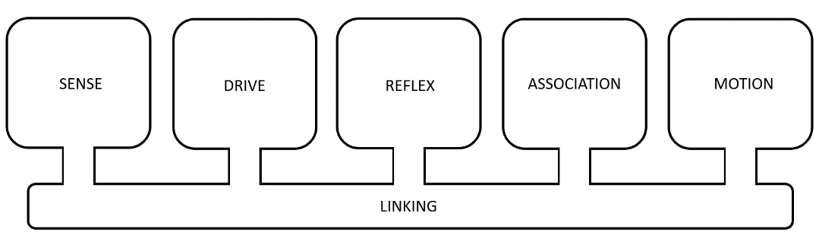
Figure A.1. The Xzistor brain model’s five functional building blocks connected by a linking function.
The model is means-agnostic, meaning it is not concerned with whether the substrate is biological or silicon-based; it is only concerned with ensuring the correct functions are provided.
It was developed to:
- Provide a principal understanding of the processes of the brain, specifically the mechanisms of cognition and emotion.
- Serve as a basis for a complete cognitive architecture, providing autonomous agents with the ability to develop human-like intelligence and emotions.
The Xzistor brain model can be instantiated in symbolic or neuro-symbolic (a hybrid synthesis of symbolic and connectionist) implementations (Gordana, 2023). Like the human brain, an instantiation of the model achieves increased functionality and a higher level of intelligence through ongoing learning, i.e., the forming of associations. This happens like an infant would mentally mature into adulthood through learning.
Emotions, artificially generated by the model, play a key role in how learning is achieved and how stored associations are used to solve problems in future. By attaching sets of artificial emotions to newly stored associations, these associations can be contextualized and prioritized to solve future problems based on experience, including using inductive inference to solve new problems in novel environments.
Since this type of Operant Learning can also theoretically lead to spoken words being memorized and used by agents to solve problems, as explained in the book Understanding Intelligence (Van Schalkwyk, 2021, p.31), it is important to understand how the Xzistor brain model generates artificial emotions.

Terms and Definitions
Several key terms are capitalized in the rest of the text when they have specific mathematical definitions in terms of the Xzistor brain model. These terms should be understood in the context of having been mathematically modeled and often simplified, as opposed to their more common meanings in relation to the biological body and brain.
These capitalized terms will be defined throughout the text, with mathematical explanations provided where appropriate. A single term that is worth defining clearly early on in this appendix, as it often causes confusion when researchers discuss computational models of the brain — is ‘representation’.
The Xzistor brain model extensively uses the term ‘representation’ to describe how both the biological brain and computational devices can exchange information between functional areas. The biological brain generates ‘representations’ as neural activation patterns, and a computational device can generate ‘representations’ as bit value patterns from code in the transistor fields of an integrated circuit. The Xzistor brain model argues that the physical differences in representations do not change the information exchanged and that the model principally exchanges the same information (only simplified) as the biological brain.
The model defines a ‘representation’ as an Entity A derived from another Entity B, which is passed from a provider to a receiver so that the receiver of Entity A can interpret and extract information about Entity B from Entity A via a predefined protocol between the provider and the receiver.
A military drone can, for instance, receive information from a hidden drone operator: ‘Enemy tank 200m ahead!’. This information can be a radio wave signal, two 1-second bursts from an invisible laser or four flashes from an infrared source. These are all different ‘representations’ which convey precisely the same information of ‘Enemy tank 200m ahead!’ to the drone computer. These representations all use different pre-arranged protocols, making it possible for the drone computer to extract the information about the distance to the enemy tank from these representations.

The Five Functional Building Blocks
of the
Xzistor Brain Model

A.1 Building Block 1 – Sensing Algorithm
A Sense translates a physical condition or variable (V) in the environment or body into a corresponding representation (S) in the modeled brain:
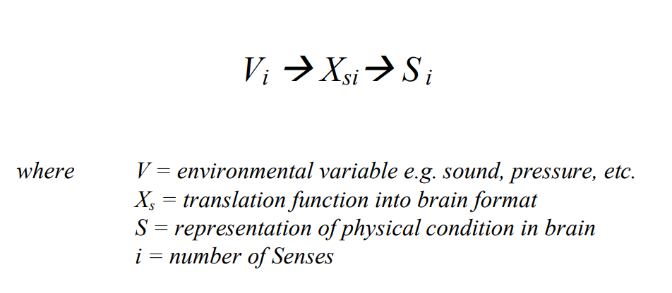
Translation Functions for Senses
The translation functions above refer to any means whereby a Sensed environmental Variable (V) is changed into a representation (S) that the instantiation of the Xzistor brain model can interpret and process. An example would be an optic sensor that takes a Sensed optic state (V₁) and translates it via a video camera processor (X_{s1}) into an array of Red-Green-Blue (RGB) pixel values (S₁) that a digital computer program can use to perform numerical calculations on. Different means can be used to achieve this translation function for different technologies. The only requirement for the model is that there will only ever exist one representation (S) for every unique incoming environmental Variable (V) — to a resolution appropriate for the application.

A.2 Building Block 2 – Drive Algorithm
The Drive algorithm is based on the bioregulatory processes in the body and brain. These mechanisms attempt to maintain homeostasis/allostasis of body states by regulating one or more control variables. Some control variables are obtained from receptors measuring external states affecting the body (like ambient temperature, cutaneous pressure/pain, visual inputs, auditory inputs, olfaction, etc.) and some from receptors measuring states internal to the body (like internal organ pressure/pain, muscle chemicals, and blood chemicals like glucose, ghrelin, sodium, water, oxygen, carbon dioxide, etc.).
The model defines a Drive as part of a negative feedback closed-loop control system that alerts the body and brain when a Control Variable is moving out of range. It generates the Error Signal, which indicates to what extent the Control Variable deviates from the setpoint and to what degree it poses a threat to the system, i.e., how urgently it should be restored. It also indicates if the Error Signal is increasing (corrective action is required) or decreasing (corrective action is successful and should be maintained) in addition to the rate at which it is changing. The modeled body and brain can then deploy reflexive (preprogrammed) or volitional (learnt) behaviors using its Motion Effectors to ensure the correct actions are performed to restore Homeostasis/Allostasis when required.

Figure A.2. The Xzistor brain model defines a Drive as a part of a negative feedback closed-loop control system.
In the human body, the calculations performed by these homeostatic/allostatic control loops are performed biologically by the activation/inhibition of neuronal structures in the body and brain that are fed by the signals from the control variable sensors inside the body. The Xzistor brain model simulates these bioregulatory drives by processing the same type of information computationally without the need for a biological substrate.
In the model, a Drive measures the difference between the setpoint and current (actual) value of the Control Variable (CV) to create the Error Signal — the model uses an Error Signal value between 0 (no error) and 1 (maximum error).
The model translates the Error Signal information into a corresponding Drive representation (D) which can be expressed in mathematical terms as follows:
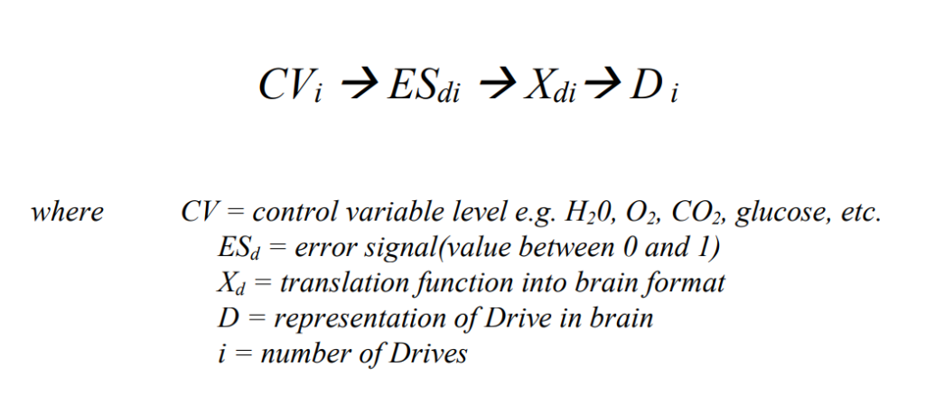
Drive Translation Functions
The translation function X_{d} above refers to the means whereby the Error Signal (ES_{d}), based on a Sensed/measured deviation in Control Variable (CV), is changed into a Drive representation (D), which the instantiation of the Xzistor brain model can interpret and process.
The Drive representation (D) will provide the modeled brain with information to:
- Identify the Drive.
- Determine the Error Signal strength of the Drive (between 0 and 1).
- Determine if the Error Signal of the Drive is reducing or not.
An example would be a digital thermal sensor inside or outside the body of a physical robot that takes a Control Variable (CV₁) temperature reading, compares it with the setpoint, and translates it into a digital Error Signal (ES_{d1}) between the value 0 and 1, say 0.2. The Error Signal will depend on how far the current Control Variable (CV) value departs from the setpoint value. The translation function (X_{d1}) will then use the Control Variable (for identification) and Error Signal (for strength value) to create the representation of the Drive (D₁) that the brain model can interpret and process. The Drive strength will be between 0 and −1 if the Error Signal is increasing and between 0 and 1 if the Error Signal is decreasing. A digital application of the model can, for instance, generate a simple Drive representation consisting of a floating-point variable:
D_BodyTemp_Extreme_Heat = −0.2
This representation, as a variable, will ensure the modeled brain can:
- Identify the Drive: Body Temperature (Extreme Heat Homeostasis)
- Determine the Error Signal strength of the Drive (between 0 and 1): 0.2.
- Determine if the Error Signal of the Drive is decreasing or not: The minus sign in front of 0.2 indicates the Error Signal is not decreasing.
The Error Signal (between 0 and 1) will allow the Drive representation to communicate with the modeled brain the ‘level of urgency’ with which it should be restored to maintain a safe external/internal temperature. This can then be numerically compared with the Error Signal values (urgencies) of other Drives to determine which Drive should be acted upon as a priority — referred to by the model as the Prime Drive. The only requirement for the model is that for each Drive, there will only ever exist one Drive representation for every unique combination of Control Variable value, Error Signal value and Error Signal change state (+ or –).
Drives are divided into two types by the model — Homeostatic and Allostatic.
1.) Homeostatic Drives are those negative feedback control loops for which the Drive representation (D) can only be changed through changes in the Control Variable (CV) signals affecting the Error Signal (ES), i.e. the Drive representation (D) cannot be changed by recalling Associations (memories) as these will not affect the Error Signal. Examples in the biological brain are thirst, pain, fatigue, cold, hot, itching, urge to urinate, etc. In earlier papers/books about the Xzistor brain model, Homeostatic Drives were also called Body Urgency To Restore mechanisms or just Body UTRs. Both these refer to the same type of mechanism:
Homeostatic Drive ≡ Body Urgency To Restore Mechanism (Body UTR)
2.) Allostatic Drives are those negative feedback control loops for which the Drive representation (D) can both be changed through changes in the Control Variable (CV) signals affecting the Error Signal (ES) and by recalling Associations (memories) that can have an effect on the Error Signal. Examples in the biological brain are anger, sexual arousal, acute fear, nausea, autonomic stress (fight-or-flight response), etc. In earlier papers on the Xzistor brain model, Allostatic Drives were also called Brain Urgency To Restore mechanisms or just Brain UTRs. Both these refer to the same type of mechanism:
Allostatic Drive ≡ Brain Urgency To Restore Mechanism (Brain UTR)
The difference between Homeostatic Drives and Allostatic Drives will be further discussed in this section, expanding on the mathematical principles of the Drive Algorithm.

From Drives to Emotions
Negative Emotions
By way of another example, the negative feedback closed-loop control system aimed at the homeostasis of blood-borne water (H₂0) in the human body can be modeled — see Figure A.3 below.
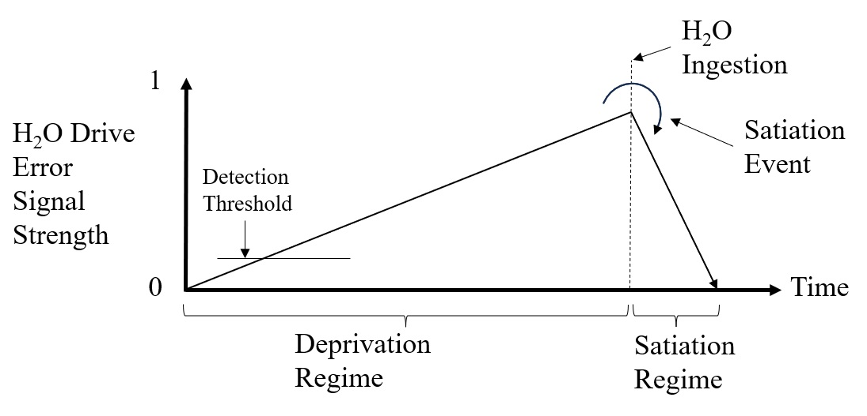
Figure A.3. The Xzistor brain model can represent thirst as a simplified bioregulatory function that increases with time and decreases with the ingestion of H₂O.
In this case, the Drive representation in the agent’s modeled brain could be the H₂O Drive’s Error Signal strength as a numerical value between 0 and 1 (shown in the graph), multiplied by −1 (since it is not moving towards Homeostasis). The modeled brain can be an instantiation of the Xzistor brain model as a digital computer program that executes the logic loop.
The H₂0 Drive Error Signal strength will increase as the modeled blood-borne H₂0 becomes depleted over time. The rising part of any Drive Error Signal curve will be called the Deprivation Regime. This regime can be expressed in mathematical terms as:
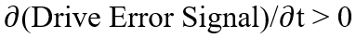
In the Deprivation Regime, information around the strength of the Drive, based on the Error Signal and the fact that the Error Signal is increasing, is numerically calculated in the modeled brain, but not directly presented to the executive part of the modeled brain. Instead, this information is combined into a Deprivation Emotion (DE) representation.
The Deprivation Emotion representation provides all the above Drive information to the executive part of the modeled brain by turning it into a somatosensory Emotion representation that contains attributes conveying all the essential Drive information to the modeled brain. The executive part of the modeled brain will constantly be presented with this ‘visceral’ or somatosensory representation (i.e., with every cycle of the logic loop), and continuously process this information to determine what the agent’s next action should be — typically at a rate of ten times per second.
This somatosensory Emotion representation is generated in the Body Map part of the modeled brain, where incoming body Sensory signals are normally represented. This means these Emotions in the Body Map area of the modeled brain will be felt as if originating from sensory receptors inside the robot body or from the outer shell (skin) of the robot body.
This Body Map part of the modeled brain need not be a physical somatotopic map but can take the shape of a relational database containing representations (numerical values) that account for the location of incoming signals in the body and include attributes like signal strength and effects on neighboring body Sensory representations.
Some find it difficult to envisage how a digital Body Map relational database can be compared to a biological somatosensory cortex, but both of these just house sensory representations and make these available to the executive part of the brain. The biological somatosensory cortex will identify the neural correlates of Emotion representations from Drives through their somatotopic location in the cortex and, depending on how strong they are, they could affect neighboring somatotopic areas by activating bordering neuronal populations — creating a diffuse ‘visceral’ experience for each emotion.
In the same way that a biological deprivation emotion will continuously be presented to the executive part of the biological brain, the modeled Deprivation Emotion will constantly be presented to the executive part of the modeled brain via the digital Body Map.
The artificial agent will learn to link these somatosensory Emotion representations to locations in/on the physical body through Association-forming, akin to how humans learn to locate sensory signals in/on the body by interacting with the environment — typically from tactile experiences and learning from objects causing pain to different parts of the body. The agent can be designed to experience Satiation mainly in the trunk area of its body and Deprivation mainly in its abdominal area.
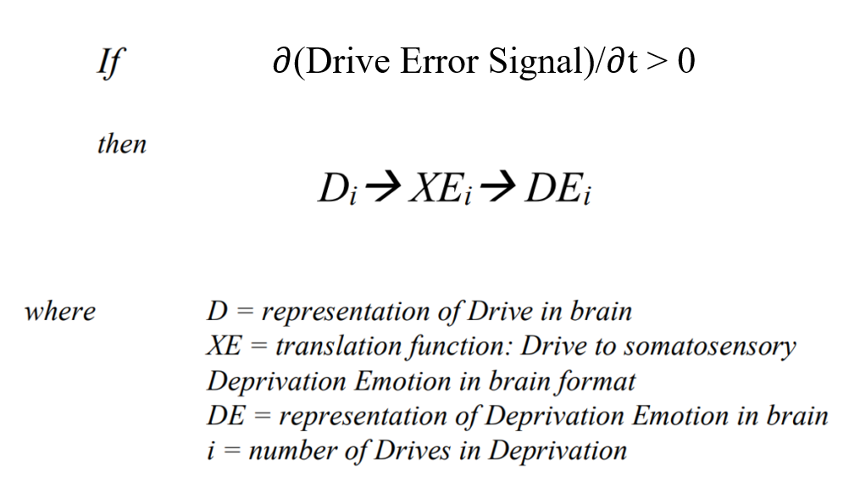

The Deprivation Emotion (DE) representation, located in the Body Map area of the modeled brain, was not physically generated from body Sensory signals but from Control Variable signals, which do more than just provide a Sensory representation originating from a certain part of the body — these signals also become inextricably linked to learnt control actions that will drive avoid or approach behaviors.
Some Deprivation Emotions are not aimed at alerting the modeled brain to an aversive condition in a specific area of the body but instead use more diffuse visceral Sensations, which the brain will learn to interpret as Hunger, Thirst, Autonomic Stress, Anger, etc.
Other Deprivation Emotions will include information linking them to aversive conditions in particular body locations along with avoid or approach preferences, e.g., Pain, Extreme Cold, Extreme Heat, Itching, etc. To account for the way Deprivation Emotion representations provide the executive part of the brain with a visceral representation (body feeling) that does not originate from Sensory signals but rather from Control Variable signals, the model refers to Emotion representations as pseudo-somatosensory representations.
The executive part of the modeled brain will only be presented with, and therefore be aware of, this Deprivation Emotion representation (with all its attributes) as a visceral body Sensation. It will not need to be aware of all the underpinning processes the Drive uses to calculate the Error Signal value from change(s) in Control Variable(s) that allows it to set up the pseudo-somatosensory Deprivation Emotion representation. The executive part of the modeled brain only needs to extract the Error Signal (value between 0 and 1) from the Deprivation Emotion representation and compare it with those of the Deprivation Emotion representations of all the other active Drives to determine the most urgent Drive, i.e. the Prime Drive.
In humans, it is common for an individual to self-report the ‘feelings’ experienced from similar emotion representations but not an awareness of the underlying neural mechanisms. A human will, for instance, simply report feeling thirsty but not be conscious of the mechanisms contributing to the thirst state based on osmolality, blood pressure, blood volume, nutritional markers, esophageal stimulation, etc.
The modeled Deprivation Emotion representation for Thirst can thus be calculated from simplified mathematical correlates of the different underlying biological brain mechanisms and represented as a consolidated numerical value between 0 and 1. The model assigns a negative value to the numerical Deprivation Emotion representation as an attribute that will reflect the fact that the Drive value is also negative. This is due to the fact that it will be in the Deprivation Regime where the Error Signal of the Drive is increasing. This allows the executive part of the modeled brain to differentiate between negative and positive Emotions — negative when the Drive Error Signal departs from the setpoint and positive when the Drive Error Signal moves towards the setpoint.
It is important to note that the Deprivation Emotion representation is an informational construct characterized by a distinct somatosensory footprint in the Body Map area of the modeled brain. This footprint includes attributes that will inform the executive part of the modeled brain what Drive the Emotion relates to, the strength of the Drive (based on its current Error Signal strength), the fact that it is in Deprivation (negative) and that the Error Signal is not currently recovering towards the setpoint.
Turning all this into a single consolidated Emotion representation allows the executive part of the modeled brain to ignore all underpinning mechanisms and only maintain an awareness of a finite set of Emotions (visceral body feelings) to determine the most urgent Drive and preferred actions. It also aids in providing the agent with a keen awareness of the bounds of its own body (the self) and a sense that it is responding to subjective needs that originate from within its own physical body.
This Deprivation Emotion representation will become Associated with avoidance behaviors through Operant Learning, providing a computational correlate of what humans might subjectively refer to as ‘learnt actions to avoid a bad feeling’.
Thus, the artificial agent will eventually start to feel a compulsion to avoid this visceral Deprivation Emotion and learn to move away from Deprivation sources causing ‘bad feelings’ e.g., objects/situations causing Pain, Fear, Cold, Fatigue, Autonomic Stress, etc.
Since the Xzistor brain model deems spoken words to be learnt Effector Motions (like limb movements), it can be assumed that agents will start to use words like ‘bad’ and ‘negative’ through reinforcement learning when this has been shown to convince a tutor to remove the Deprivation source. There is no reason why an agent cannot go on to learn more complex phrases like ‘The dog makes me feel bad!’ or ‘I feel scared of the cold snow!’ if this has led to the tutor intervening in the situation and removing the cause of the Deprivation Emotion.
Note: See Section A.4 ASSOCIATION ALGORITHM for more information on how the modeled brain will learn to avoid this Deprivation Emotion through Operant Learning.

Positive Emotions
From Figure A.3 above, it should be clear that upon the ingestion of water (modeled), the Error Signal curve of the H₂0 Drive will slope downward. The vertex point, where the curve changes direction, is of prime importance to the brain model and is called the Satiation Point or Satiation Event. The declining part of the curve is referred to as the Satiation Regime. This regime can be expressed mathematically as:
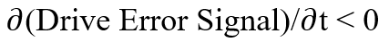
The Satiation Event is when the brain model detects that something in the environment or agent body has changed and is causing the emulated H₂0 Drive strength value to decrease (i.e., it is being Satiated). The agent now needs to store all the information about, and leading up to this event, for future use. The storage of Associations is discussed in more detail later in this appendix.
As mentioned before, for every Drive, whether it is a Homeostatic Drive or an Allostatic Drive, a positive Drive strength value (0 to 1 when in Satiation) or negative Drive strength value (0 to −1 when in Deprivation) can be calculated based on the Error Signal value and the way it is changing.
A Drive strength value of 0 is the ideal state as it indicates complete homeostasis/allostasis and will indicate that the Drive is at its setpoint. A Drive strength value of −1 would indicate maximal Deprivation (the most critical or aversive condition) and a Drive strength value of 1 would indicate maximal Satiation (the fastest correction of the aversive condition possible, resulting in intense satisfaction).
While Deprivation of a Drive is simply the numerical strength value of the Error Signal of the Drive between 0 and 1 (multiplied by −1), Satiation is the derivative state given by the rate at which the Drive Error Signal value decreases over time (or the Drive Error Signal curve slopes downward). In the case of Satiation, 0 will indicate no decrease in the Error Signal strength of the Drive over time:
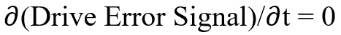
And a value of 1 will indicate a theoretical instantaneous drop in Error Signal strength of the Drive to 0:
The larger the decrease in Error Signal strength of the Drive over time, or the steeper the downward slope of the Drive Error Signal curve, the higher the value of the Satiation will be — again, a positive value between 0 (min) and 1 (max). A person sipping slowly on chilled water after a marathon will eventually stop feeling thirsty, but swallowing lots of cool water faster will cause a much more pleasurable quench effect.
In the human brain, reaching states of satiation is crucial for bioregulatory control, and the model emulates the human brain’s approach to reinforcement learning during satiation events. The overriding goal of the biological brain, as posited by the Xzistor brain model, remains to minimize deprivation and maximize satiation.
Information about the strength of a Drive (derived from the Error Signal) and the rate at which the Error Signal strength of the Drive is increasing or decreasing, is not directly presented to the executive part of the modeled brain for processing during the Satiation Regime; rather, this information is combined into a Satiation Emotion (SE) representation.
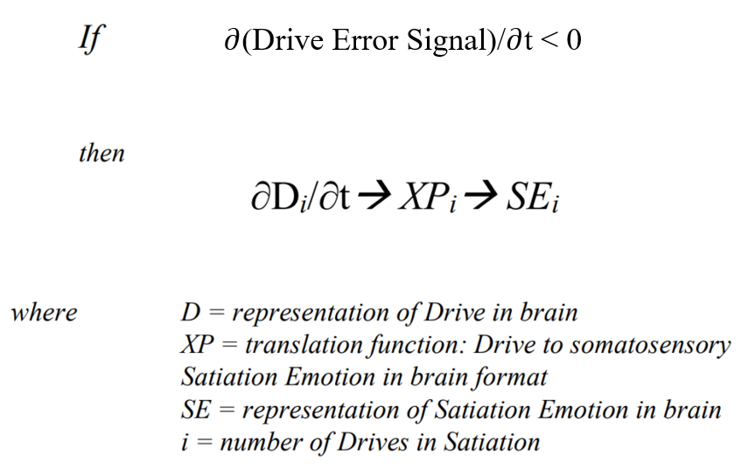

The Satiation Emotion (SE) representation, which will feel to the agent as if originating from within the body, provides all the above information to the executive part of the modeled brain by turning it into a pseudo-somatosensory representation within the somatosensory (Body Map) part of the modeled brain.
The executive part of the modeled brain will continue performing the actions that restore the most urgent Drive and create the Satiation Emotion. If the Error Signal of another Drive starts to exceed that of the current most urgent Drive, the current actions will be abandoned, and the agent will begin to seek new actions to Satiate the new stronger Drive. With the Xzistor brain model assigning Drives with values between −1 and +1 and Drive Error Signals with values between 0 and 1, it becomes easy to mathematically calculate when an agent should pursue a new Drive or continue Satiating the current Drive.
The Satiation Emotion (SE) representation, which will be experienced as a distinctly different visceral body Sensation from the Deprivation Emotion (DE) representation, will become Associated with pursual behaviors through Operant Learning and in this way create a computational correlate of what humans will refer to as a ‘good’ or ‘positive’ feeling. This Satiation Emotion representation will always have a positive (numerical) value to differentiate it from the negative Emotions discussed above.
The model assumes the biological brain creates the neural correlates of pseudo-somatosensory Deprivation Emotion and Satiation Emotion representations so that these will consciously be ‘felt’ by the brain as if located in areas of the human body.
These representations could typically be generated as spatiotemporal activation/inhibition of neural clusters (structures) in the brain (e.g., insula, amygdala, anterior cingulate cortex, primary somatosensory cortex, and related networks) and adjudicated for action selection by the executive part of the biological brain (e.g., thalamus, basal ganglia, hippocampus, prefrontal cortex and related networks).
In simple Xzistor robots, the Satiation Emotion representation makes use of the existing tactile Sensory Body Map array representing the front of the robot body to locate the ‘positive’ Emotion representations, and the Deprivation Emotion representation makes use of the tactile Sensory Body Map array representing the back of the robot body to locate the ‘negative’ Emotions.
In more sophisticated future robots, positive Emotions could be provided as higher fidelity pseudo-somatosensory signals located across the trunk/chest/throat area. In contrast, negative Emotions could be spread over the lower abdomen (gut) area of the modeled Body Map. This will provide a closer correlation with how humans experience emotions.
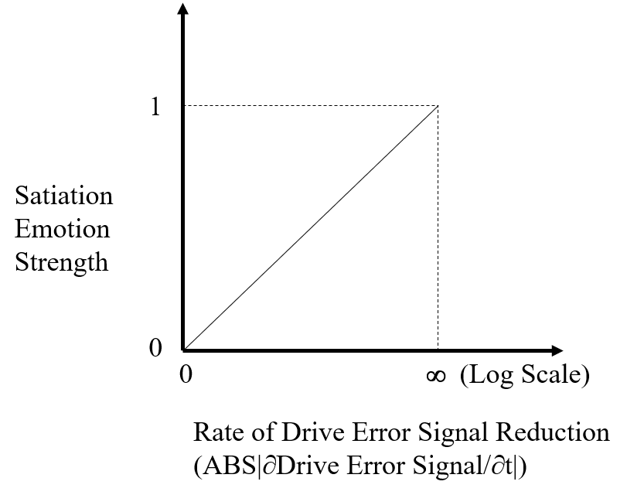

Figure A.4. The strength of a Satiation Emotion (SE) representation (a value between 0 and 1) as a function of the reduction rate of the Drive Error Signal value — always positive.
For simple symbolic (computer program) implementations of the brain model, the value of the Satiation Emotion representation can be turned into an absolute value between 0 and 1 (i.e. always positive) and based on the rate at which the Error Signal of the Drive recovers from its departure from the setpoint as shown in Figure A.4 above.

Multiple Drives
The model caters to many Drives that are active simultaneously in the simulated body and brain. Figure A.5 below shows three different Drives active at the same time.
Each Drive strength value will be based on its Error Signal strength derived from its specific Control Variable(s). We can define the Total Drive Error Signal (D_{tot} Error Signal) strength as the sum of all the Error Signal strengths of the Drives (i.e., for D₁, D₂ and the Prime Drive) as indicated on the Drive Error Signal strengths versus time graph in Figure A.5 below.

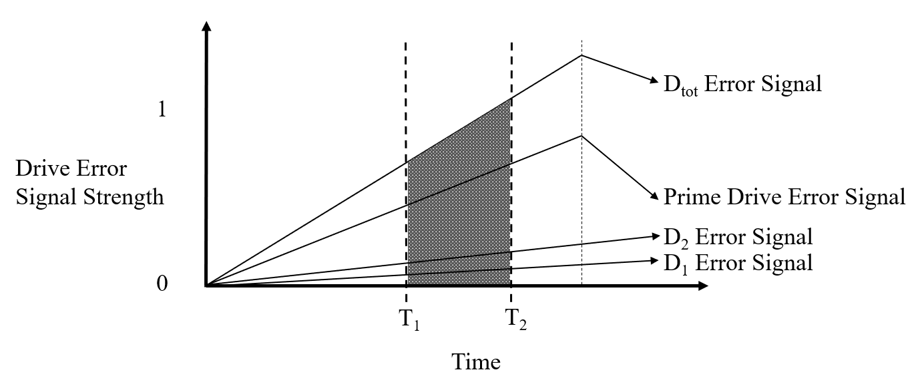
Figure A.5. Multiple simultaneous Drives combined into a Total Drive as defined by the Xzistor brain model.
Mathematically the Total Drive Error Signal (D_{tot} Error Signal) strength can be expressed as follows:
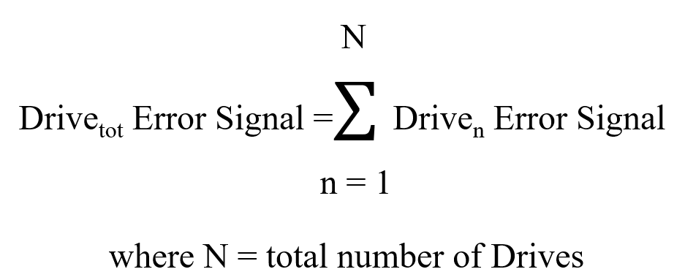

We will refer to the strongest (most urgent) single Drive (highest Error Signal value between 0 and 1) as the Prime Drive. The total Deprivation experienced between time T₁ and T₂ will be given by the area under the D_{tot} Error Signal curve between T₁ and T₂ when plotted against time and can be calculated as follows:
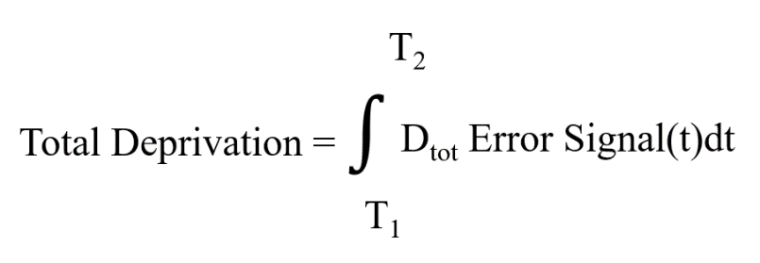
Figure A.5 above shows how the Satiation (Error Signal rate of reduction) achieved by D_{tot} is less than that of the Prime Drive because only one of the three Drives is Satiated while the others are still increasing, meaning they are still in Deprivation. Sometimes, when there are many Drives to consider, it is convenient to normalize the D_{tot} Error Signal to a value between 0 and 1, where 0 will indicate zero Deprivation and 1 will indicate the maximum Deprivation the agent is capable of suffering based on the total number of active Drives.
D_{tot} Error Signal is normalized as follows:
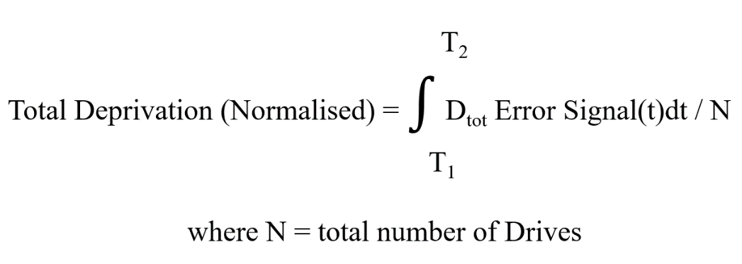

The ability to model and normalize the aggregate of many Drives with their Emotions concurrently in an Xzistor agent also allows for a ‘General Happiness Curve’ to be generated, showing an agent’s net Emotional state (positive or negative) in real-time. It further allows for an agent to display facial expressions, varying in real time from wide smiles to anxious frowns, reflecting its average internal Emotional states — making Xzistor agents appear very lifelike.

Interdependency of Drives
The model accommodates the interdependency of Drives. In the graph above, for instance, the Prime Drive could have caused conditions for Drive 1 and Drive 2 to be activated. This type of coupling or dependency often exists between human bioregulatory drives, and some drives extensively affect other drives to collectively create a stronger deprivation or satiation state.
In a human, a sudden bout of nausea resulting in vomiting could convulse the diaphragm, interfering with breathing, thereby raising blood CO₂ levels and creating an urgent need for oxygen. Acidic vomit could also lead to a burning sensation (pain) in the nose. This will make the experience much more aversive than just disgorging food and aid humans in learning to avoid specific food sources in the future (if this was the reason for the nausea). The Xzistor brain model can emulate these interdependencies amongst Drives by modeling the same direct and indirect effects a Drive could have on other Drives, thus creating the same enhanced result.

Allostatic Regulation
The Xzistor model also accounts for the emotions generated by the human autonomic nervous system (ANS) which comprises the sympathetic nervous system (SNS), the parasympathetic nervous systems (PNS) and the enteric nervous system (ENS). The model assumes that a sympathetic nervous system response is generated by the fight-or-flight (FoF) response activating neuronal clusters in the amygdala, which sends a distress signal to the hypothalamus, which in turn activates the sympathetic nervous system by sending signals through the autonomic nerves to the adrenal glands.
The original activation/inhibition of the dedicated areas in the amygdala can be modeled by an Autonomic Stress Drive representation with Control Variables derived from sudden loud sounds or the observation of unexpected fast motions.
This will allow for the setting up of an Autonomic Stress Deprivation Emotion representation in the Body Map area of the modeled brain — creating the mathematical equivalent of the familiar autonomic stress state humans refer to as ‘anxiety’ or ‘butterflies in the stomach’.
Once the source of the Autonomic Stress Deprivation Emotion representation has been removed (the loud sounds or sudden movements), the Autonomic Stress Drive strength will subside by the modeled effects of the parasympathetic nervous system creating the equivalent of the typical relax/relief state experienced by humans that can be modeled as an Autonomic Stress Satiation Emotion representation.
Since this Drive for modeling Autonomic Stress is an Allostatic Drive, its Drive strength can be affected by the cognitive processes in the brain, e.g., recalling Associations (memories). For instance, if an agent recalls Associations (an experience) that had triggered Autonomic Stress in the past, the same Autonomic Stress Deprivation Emotion will be regenerated.
In humans, as the stressful association is recalled, the same activation occurs in the amygdala as during the actual event and the same autonomic stress is experienced. This is typical of an Allostatic control loop in the modeled brain — where Deprivation and Satiation Emotion representations can instantly be re-evoked by merely recalling a stressful event or by recognizing an object in the environment that had become Associated with relieving Autonomic Stress in the past.
Homeostatic Drives for modeling Hunger, Thirst, Pain, Temperature extremes (cold and hot), Urination (modeled), Itching (modeled), etc., cannot be triggered by recalling Associations (memories) alone and need Control Variable signals, but Allostatic Drives for modeling Emotions like Anger, Sexual Arousal, Autonomic Stress, Nausea, etc. can additionally be triggered from merely recalling relevant Associations from memory.
As evidenced in the academic literature, the biological correlates of the modeled Drives, will always simultaneously activate the autonomic nervous system in the human body which creates autonomic stress. For instance, as hunger in humans increases, so will the stress level generated by the autonomic nervous system, and as hunger decreases, the autonomic stress will decrease.

Figure A.6. The rise and fall of the hunger level (black line) will trigger a coupled autonomic nervous system response (blue line).
If a person thinks back on a severe hunger event, it will not re-evoke hunger, but the autonomic stress associated with the hunger experience will be regenerated. The individual will experience an anxiety or ‘fear’ of feeling hungry, which will differ from feeling actual hunger. This fear associated with feeling hungry (in future) can generate such a high level of autonomic stress (as an emotion), even when no real hunger is being experienced, that it can become the prime drive and preferentially drive behavior.
As for humans, the artificial agent can now learn to avoid getting Hungry (modeled) by preemptively acting on the Autonomic Stress linked to Hunger (i.e., out of the Fear of getting Hungry in the future). By acting on the Autonomic Stress Drive generated in concert with all other Drives, Xzistor agents learn to solve problems even before they arise, akin to how humans proactively predict, plan, and solve problems.
In humans, apprehension around the future risk of hunger, extreme cold, lack of money, a strenuous job, an exhausting journey, etc., are all just fears from recalling situations that have in the past directly or indirectly led to negative emotions like autonomic stress and which can do so again in future — these fears are all just recalled autonomic stress (mainly) experienced in different contexts.
Xzistor robots have demonstrated how they will perpetually continue to learn new ways to reach reward sources that will provide Satiation based on initial tutor guidance and their own inductive inference (trial and error). This includes learning increasingly complex subtasks (and unlearning obsolete ones) as these agents constantly seek Satiation in more sophisticated environments.
The powerful ability of the Xzistor brain model to gradually increase an artificial agent’s intelligence does not come from an initial complex architecture or massive upfront learning, but rather from the ability of a relatively simple infant-like system to keep on learning more and more elaborate subtasks, and reusing knowledge and skills across domains, purely in pursuit of its own subjective emotional needs.

Modeling the Limbic System
The way the Xzistor brain model accommodates the interaction and interdependency of Drives also allows for a simplified model of the human limbic system. The modeled limbic system can intensify Emotions when changes are important for learning, e.g., when sudden changes in Error Signals are experienced — either causing Satiation or a sudden increase in Deprivation. By intensifying or enhancing Emotions during an encounter with a Satiation source (e.g., food) or a Deprivation source (e.g., extreme heat), an agent can much more effectively learn approach or avoid behaviors. This is because the Xzistor brain model, just like the human brain, reinforces Associations much stronger during events of high Emotional salience.
It is also important that Xzistor agents learn about objects in their environment when anticipated (predicted) Satiation or Deprivation Emotions have suddenly changed i.e. are suddenly stronger or weaker than expected. This might indicate that something in the environment has changed, and their learning around these objects needs to be updated. Both the biological and modeled limbic systems effectively intensify Emotions when such ‘prediction errors’ occur.
The biological limbic system achieves this by overriding the error signals of numerous bioregulatory drives to temporarily create a boost in good or bad emotions that will also reinforce learning.
Dopamine has been implicated in this mechanism in the human brain, and increasingly evidence is emerging to show that, as posited by the Xzistor brain model, both aversive (Pruessner et al., 2004) and hedonic (Wise et al., 1989) states will cause a dopamine response in the limbic system.
The effect of cocaine on the brain is often used to explain how a temporary ‘false’ satiation state (euphoria) can be achieved through a dopamine build-up that interferes with the error signals of bioregulatory control loops. The drug will subdue feelings of hunger, thirst, pain (anesthetic properties), nausea, fatigue, body thermal sensitivity as well as many types of fear (stress) to create a sense of indefatigability, invincibility and euphoria.
How the Xzistor brain model defines Homeostatic and Allostatic Drives allows for a mathematical analog of the limbic system to be created providing some of its key effects in artificial agents — called the Body State Override Reflex. Note that the modeled limbic system does not claim to exactly account for the complex role of dopamine (or other hormones and/or neurotransmitters) in the biological brain, but rather offers a simplified mathematical analog that can easily be built into artificial agents.
The Body State Override Reflex (BSOR) enhancements are triggered in response to discontinuous changes in the Deprivation and Satiation Emotions of the Autonomic Stress Drive — either those coupled to fluctuations in other Drives or those caused by recognizing Autonomic Stress Satiation/Deprivation sources (or recalling them from memory).
Changes in the Deprivation and Satiation Emotions of the Autonomic Stress Drive that do not involve sudden step changes (i.e. the change in Emotions remain continuous over time) will not trigger the BSOR. The working of the BSOR is illustrated at the hand of a few simple examples in the graphs below.
In Figure A.7 below, the BSOR can be seen boosting positive Emotions (green undulations) when a Hungry Xzistor agent experiences ingesting an apple for the first time. Note that the BSOR graphs below approximate nonlinear processes and transitions with straight lines, and are intended to be indicative and not to scale.

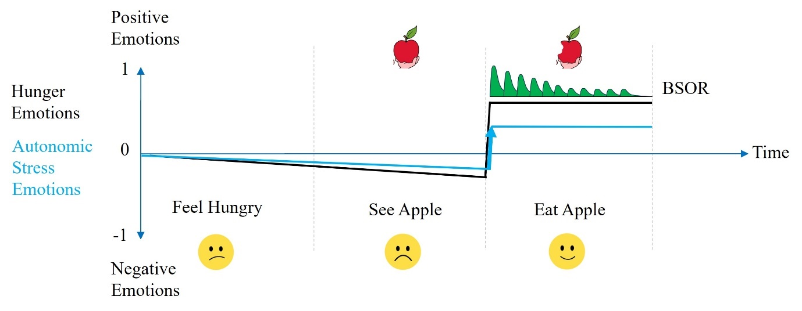

Figure A.7. The BSOR will cause enhanced positive Emotions (green undulations) when a Hungry Xzistor agent experiences ingesting an apple for the first time.
In this case the agent has never encountered an apple before and as it moves through the phases of ‘Feel Hungry’ and ‘See Apple’ it only suffers the increasing Hunger Deprivation Emotion (black line under time axis) and the coupled Autonomic Stress Deprivation Emotion (blue line under time axis). As the agent enters the ‘Eat Apple’ phase it starts to ingest the apple, experiencing a sudden positive Hunger Satiation Emotion (black line above time axis and under green BSOR undulations) and a sudden jump in Autonomic Stress Satiation Emotion (blue line above time axis). The bold blue arrow (pointing upwards) indicates that the Autonomic Stress Drive has suddenly ‘discontinuously’ been Satiated meaning the BSOR will create strong positive enhancements (portrayed as a green undulation for every bite/swallow of the apple).
As the agent becomes familiar with the apple as a reward source the surprise element that added the strong positive BSOR Emotions habituates and begins to diminish, transferring onto stimuli preceding the apple which then become predictors of the specific reward — just like it happens in the human brain (Volkow et al., 2011). In the Xzistor brain model this happens through a process called Reward-based Backpropagation (discussed later). This type of unexpected discovery could typically be self-reported by a human as a ‘pleasant surprise’.
If the Xzistor agent encounters a much stronger Satiation source than the apple, say a large chocolate cake, the effect of the Body State Override Reflex will be much more pronounced as shown in Figure A.8 below.

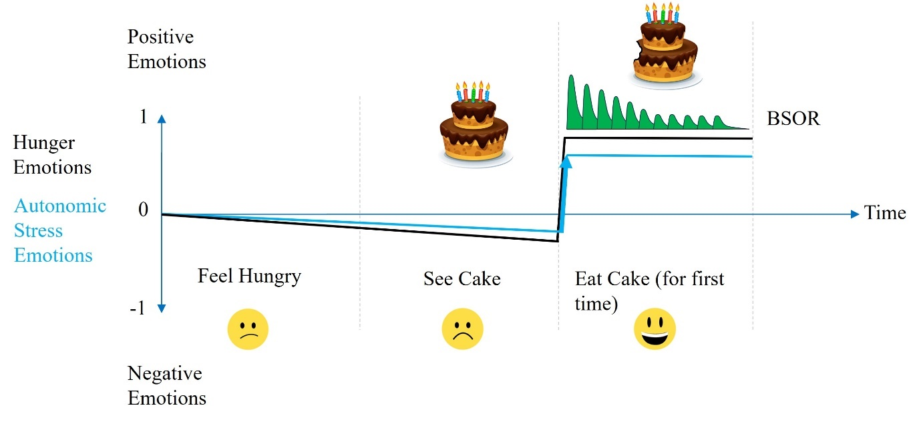

Figure A.8. The BSOR will increase the strength of the enhanced positive Emotions (green undulations) when a Hungry Xzistor agent experiences ingesting chocolate cake for the first time.
If the agent has experienced the apple as a Hunger reward source many times before, it could recall the apple from memory when it gets Hungry, and this will also re-evoke the Autonomic Stress Satiation Emotion associated with the apple. Since the anticipated Autonomic Stress Satiation Emotion will now match what is experienced when seeing and ingesting the apple, there will be no discontinuous change in Autonomic Stress Emotion and thus no surprise effect (no bold blue arrow), and no BSOR effect will be generated, as shown in Figure A.9 below.

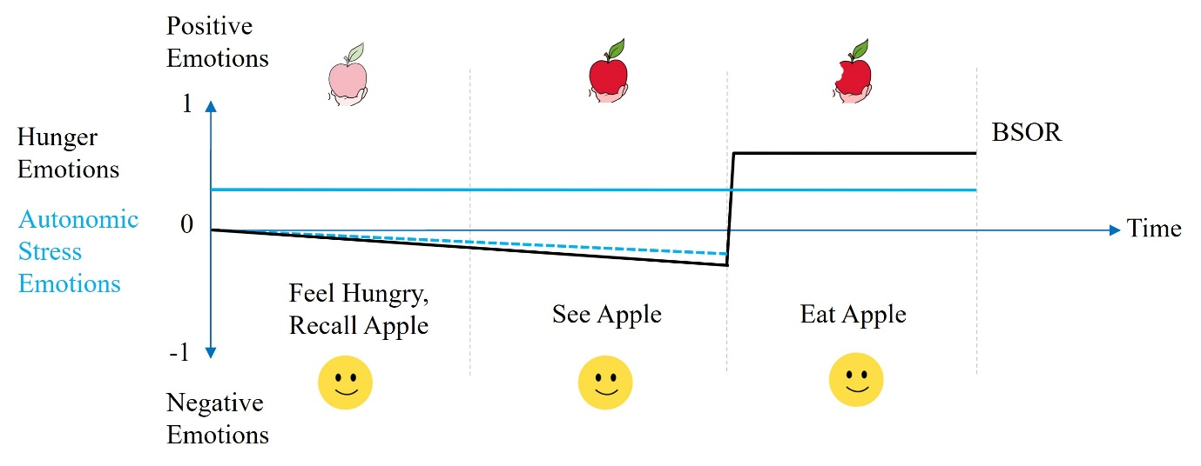

Figure A.9. The BSOR will not cause enhanced positive Emotions (green undulations) when a Hungry Xzistor agent have become familiar with ingesting an apple.
The broken blue line below the time axis indicates the Autonomic Stress Deprivation Emotion that is generated in concert with the Hunger Deprivation Emotion (black line below the time axis). The negative Autonomic Stress Deprivation Emotion is however drowned out by the strong positive Autonomic Stress Satiation Emotion associated with the apple and recalled from memory (blue line above time axis). Although the agent will experience Hunger up to the point of ingesting the apple, it will feel a positive Autonomic Stress Emotion from the moment it recalls the apple and start pursuing it, through the process of locating it and finally ingesting it (no surprise from what is being anticipated).
From the facial expressions in the above graph, it is clear that the moment the Xzistor agent became Hungry it started thinking about the apple (causing positive Autonomic Stress Satiation Emotions) and this persisted when seeing and eating the apple. This makes it easy to see how convincing facial expressions can be added to Xzistor agents based on these Artificial Emotions.
When the Xzistor agent becomes Hungry, it could recall the apple as an appropriate Satiation source and start pursuing it. It has now become familiar with the apple in its usual location and will experience positive Autonomic Stress Emotions whist navigating to it. However, if the apple is now missing from its anticipated location — the agent will experience an unpleasant surprise.
In this case the BSOR will create enhanced negative Emotions (red) as shown in Figure A.10 below.
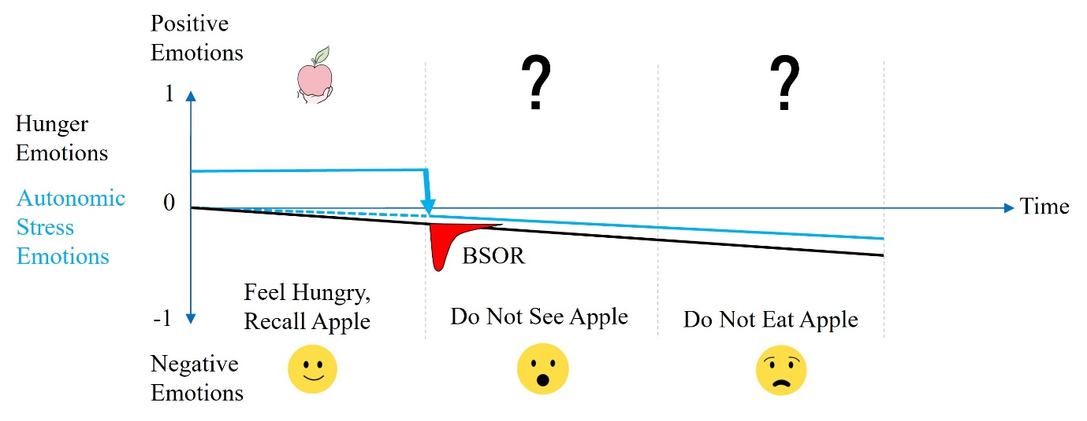

Figure A.10. The BSOR will cause enhanced negative Emotions (red undulation) when a Hungry Xzistor agent finds an apple missing from its familiar location.
Upon discovery that the apple is not in its usual location, the positive Autonomic Stress Satiation Emotions (from recalling the apple) quickly diminishes and the Autonomic Stress drops steeply from a Satiation Emotion to a Deprivation Emotion determined by its coupled effect to the Hunger Drive. This classic case of ‘prediction error’ is often studied by psychologists and also accounted for by the Xzistor brain model.
Consider the case where the Hungry agent navigates to the familiar location where it always finds the apple, but instead finds a chocolate cake in this location — the agent will experience a pleasant surprise.
The positive Emotions generated by the BSOR are shown in the Figure A.11 below.

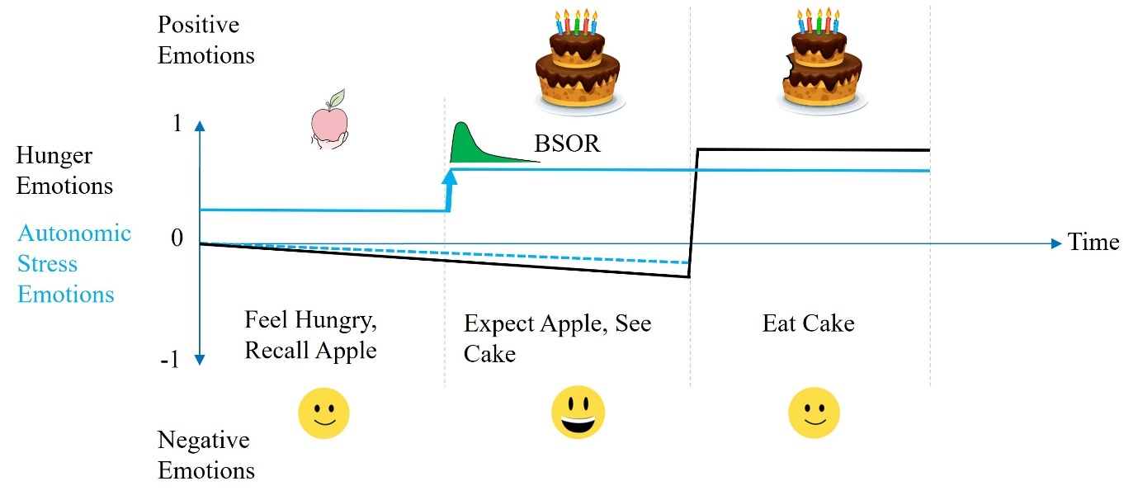

Figure A.11. The BSOR will cause enhanced positive Emotions (green undulation) when a Hungry Xzistor agent unexpectedly finds a chocolate cake where the apple is normally located.
The Xzistor brain model therefore offers a simple correlate of the limbic system that is easy to build into artificial agents, allowing it to demonstrate both positive and negative prediction errors in agents.
The model achieves this by assuming a simple relationship between the Body State Override Reflex and discontinuous changes in Autonomic Stress Emotions — providing both the strength of the limbic effect and whether it will enhance positive or negative Emotions:

BSOR ∝ ∆ Autonomic Stress Emotions
where ∆ indicates a discontinuity (step change)
in Autonomic Stress Emotion (+ or –).

Effects of Extreme Deprivation on Satiation
The Body State Override Reflex can cause enhanced pleasant and unpleasant effects in the modeled brain of Xzistor agents. This will increase reinforcement learning because the increased BSOR Emotions have the effect of reinforcing experiences (explained in more detail later). Just like cocaine (dopamine build-up) in the human brain, the BSOR can cause near euphoric states if enough Drives are temporarily overridden to create aggregate ‘false’ Satiation.
Although a Drive going into Satiation can theoretically generate a Satiation Emotion value of between 0 and 1 as a numerical representation, Xzistor agents have demonstrated that in practice in is difficult to exceed a Satiation Emotion value of more than 0.3. This is because a Satiation Emotion value of 1 requires that the Error Signal deficit be instantaneously restored to zero — which is not practical with Satiation actions that take time e.g., ingesting food, drinking water, recovering from fatigue, or calming down after a stressful event.
A maximum achievable Satiation Emotion value of 0.3 is thus expected under normal circumstances from most Xzistor agents, except when modeling the unnatural effects on the limbic system of drugs like cocaine or methamphetamine (or other addictive substances).
This upper limit of 0.3 for a Satiation Emotion explains why positive emotions can quickly become drowned out (dominated) when strong negative emotions are already present when the satiation is experienced.
When it comes to Deprivation Emotions, the Drives designed into the modeled brain of an Xzistor agent are often curated to reach full Deprivation Emotion strength (value = –1) just before the point of destruction of the agent (machine death). Basing these Drives on human analogies a Thirst Drive will reach –1 when the agent is deemed to be dying of Thirst, dying of Hunger, or dying of Pain. When these Drives reach these extreme high Deprivation values, the coupled Autonomic Stress Drive will also cause very high levels of Deprivation.
Like humans, Xzistor agents will not find Satiation Emotions at very high levels of Deprivation Emotion values ‘pleasurable’ but rather as feeling ‘less bad’ e.g., merely a reduction in extreme Autonomic Stress Deprivation Emotion. The Autonomic Stress will drown out any true relief or relaxation (or restoration). It is thus not surprising that a human will not describe escaping from a severely painful experience, like running from a burning building, as pleasurable. The Xzistor model explains this effect whilst also acknowledging that human subjective experience and self-reporting may differ. To loosely differentiate between levels of Satiation Emotion at extremely high levels of Drive Deprivation (and thus also very high Autonomic Stress Deprivation Emotion), the model uses the terminology in Figure A.12 below as guidance.

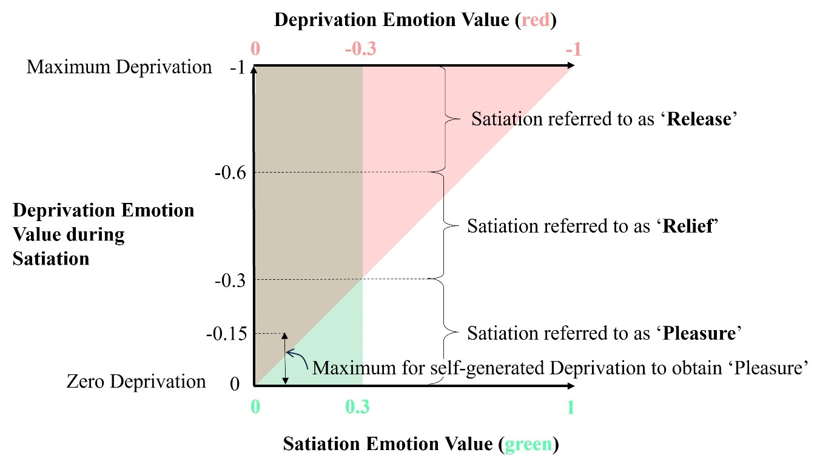

Figure A.12. Satiation Emotion (green) is normally limited to a maximum value of 0.3 and can easily be overridden when extremely high levels of Deprivation Emotion (red) are already present.
Figure A.12 shows how a value of 0.3 Satiation Emotion will completely be drowned out if experienced when Deprivation Emotions are already at extremely high values (between –0.6 and –1).
Under these conditions the Autonomic Stress Deprivation Emotion will be a major contributor to the overall Deprivation and the Satiation will only offer some ‘Release’ from severe Deprivation. All actions will be focused on simply saving the agent from destruction by avoiding (e.g., extreme Pain, Cold, Heat, Stress, Fatigue, Hunger, etc.)
When the Deprivation Emotion value is between –0.3 and –0.6, the Satiation experienced will be referred to as ‘Relief’ since the Autonomic Stress Drive value will still be very high and all actions will be focused on avoiding Deprivation (e.g., avoiding strong Nausea, Fatigue, Acute Fear, etc.) This area of the graph still shows considerably more red than green.
If the Deprivation Emotion value is between 0 and –0.3 when a Satiation Emotion of 0.3 is experienced the green area of the graph will start to exceed the red area. Satiation Emotions in this area will be referred to as ‘Pleasure’ and the Autonomic Stress Deprivation Emotion value will now be much lower so that it will not override Satiation Emotions. Actions will now be focused on obtaining Satiation (e.g., acting on mild Hunger, Thirst, inviting Sexual Arousal, beating opponents in games and competitive sports, and alleviating mild Fears over future Deprivation states, etc.)
Interestingly, in the Deprivation Emotion range between 0 and –0.15 the agent will voluntarily increase its own Deprivation Emotion if there is a good change that Satiation will result from it. This explains why Xzistor agents, just like humans, will be drawn to playing games and partaking in entertainment activities (including sports and adventures) that will artificially generate Deprivation Emotions (often Autonomic Stress Deprivation Emotions) that can then be Satiated and subjectively experienced as ‘Pleasure’. A prominent part of this pleasure-seeking behavior will be the search for and discovery of new reward sources that will trigger the BSOR to create enhanced positive Emotions due to a surprise effect.
Defining these levels of Satiations not only aided in communicating design considerations during the development phases of Xzistor agents, but also offers a loose explanation for why humans do not consider the Satiation from escaping the scorching heat of a burning house as ‘Pleasurable’ but rather as the ‘Release’ from an aversive state, and why the repositioning of a dislocated shoulder will be referred to as pain ‘Relief’, while a relaxing deep-tissue massage after a marathon would be referred to as ‘Pleasurable’.

Key Emotions from Allostatic Drives
How the Xzistor brain model generates Artificial Emotions based on Homeostatic Drives is simple when these Drives only depend on Error Signals from Control Variables. Allostatic Drives become slightly more complex as they can also generate Error Signal changes from recalling Associations that involved these Allostatic Drives. It is worth explaining how the model creates versions of the most basic Allostatic Emotions like Acute Fear, Anger and Nausea, as the Body State Override Reflex prominently uses these to create limbic system type effects whereby Emotions (good and bad) are artificially enhanced.

Modeling Anger and Acute Fear
The approach followed by the Xzistor brain model allows for a simple way to mathematically model Anger as a Drive. Acute Fear can also be modeled as a Drive in a similar way. This is achieved by choosing the Control Variables of these two Drives to be based on the Error Signal of the Autonomic Stress Drive.
In Figure A.13 on the next page, we can see how the first (lower) 50% of the Error Signal of the Autonomic Stress Drive can be used as the Control Variable to create the Error Signal of the Anger Drive. The last (higher) 50% of the Error Signal of the Autonomic Stress Drive will be used as the Control Variable to generate the Error Signal for the Acute Fear Drive.
The model assumes the biological correlate of the mathematical model takes mainly place in the amygdala as shown in the diagram. The example in the diagram is of a threat (a growling leopard) that is recognized, and this pushes the Error Signal of the Autonomic Stress Drive to about 0.75 (75%). This is past the level where Anger would be generated and into the range where an Error Signal of about 0.5 (50%) for the Acute Fear Drive will be generated.
In Figure A.13 the modeled signals can be followed from the START HERE arrow, showing how the Anger and Acute Fear Drives will be set up and how their numerical Error Signals (between 0 and 1) will to be obtained from the Error Signal of the Autonomic Stress Drive — triggered by the observed threat. Based on the size and changes of these Error Signals the Drives will also be able to determine if these are in Deprivation (red) or Satiation (green).
The diagram shows how the numerical Drive information captured in the Error Signal curves can be used to generate numerical visceral Emotions in the Body Map area of the modeled brain.
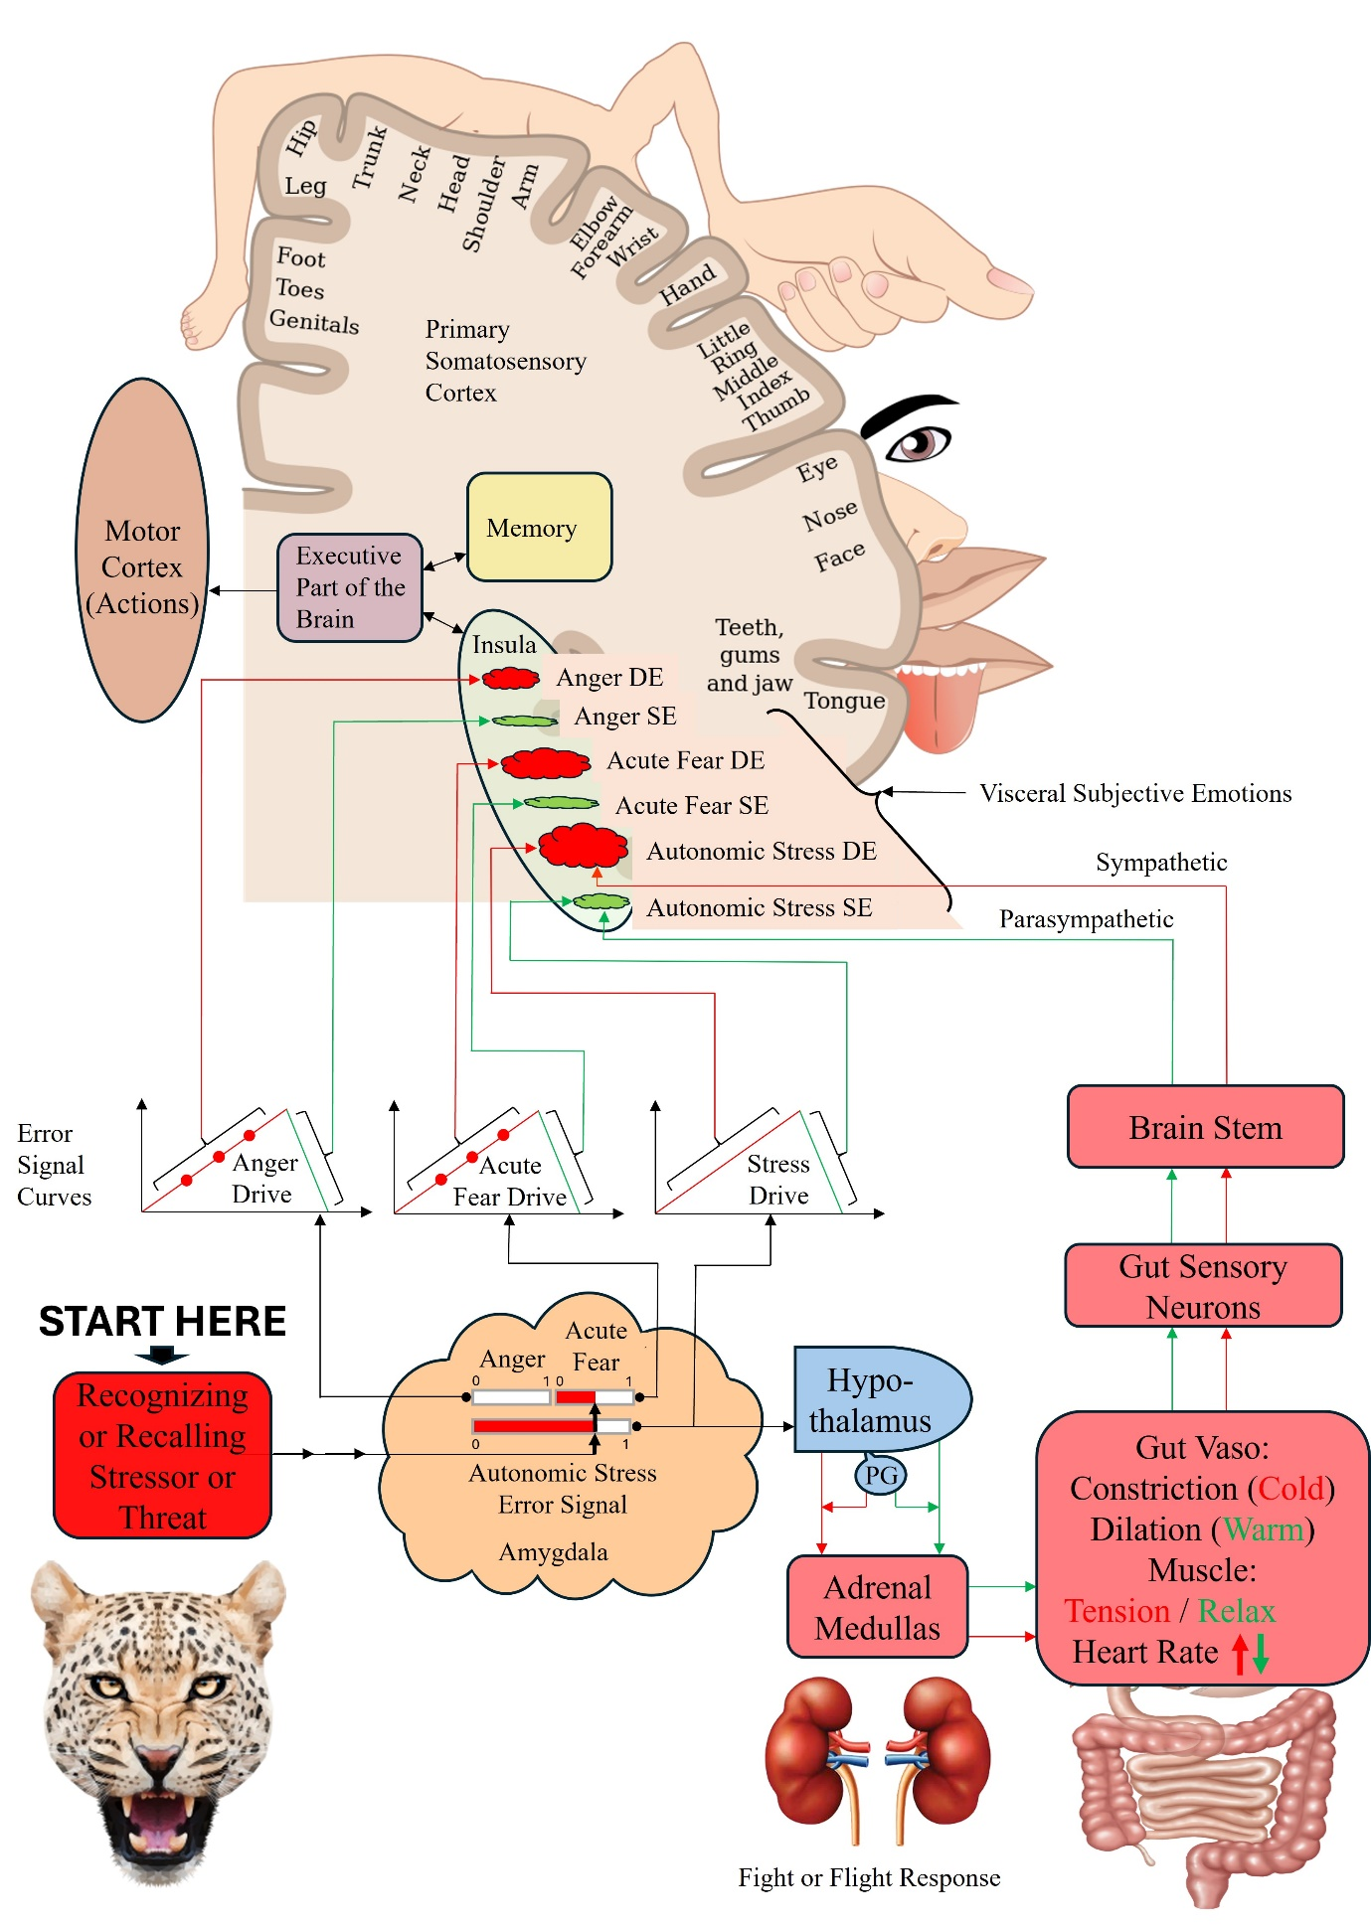
Figure A.13. Shows how Error Signals for the Anger Drive and Acute Fear Drive can be based on the Error Signals of the Autonomic Stress Drive.
Biological correlates of these simplified subjective Emotion representations are assumed by the model to be created in the insula and somatosensory cortex (Amodio, 2014). However, in the human brain these signal pathways between the amygdala and insula are bi-directional due to the biological nature of the information processing.
The agent will learn to avoid actions and objects generating the numerical representations of these Deprivation Emotions (DEs) shown as red cloud bubbles for Anger, Acute Fear and Autonomic Stress. Similarly, the agent will learn to pursue actions and objects generating the representations for Satiation Emotions (SEs) shown as green cloud bubbles.
The executive part of the modeled brain will use the information from these Deprivation Emotion (DE) and Satiation Emotion (SE) representations to calculate the Prime Drive and fetch appropriate actions from the Association Database (memory) in an attempt to Satiate it.
The red dots on the rising Deprivation parts (also red) of the Error Signal curves for Anger and Acute Fear are significant. In both cases these provide specific Deprivation levels at which Reflexes will be triggered. For Anger these Reflexive behaviors will aim to physically engage objects (stressors) deemed to obstruct Satiation. For Acute Fear, these Reflexive behaviors will aim to avoid physical contact with the objects (threats) deemed to cause Deprivation e.g., a leopard. Some of these Reflexes will be involuntary (instinctive blinking, freezing, lifting of arms, etc.) while other Reflexes will be modified through learning (waving away a wasp, jumping into a car when a bear approaches, etc.). Exactly how the Xzistor brain model defines and classifies Reflexes is discussed in the next section.
Whereas in animals these anger-related (aggressive) reflexive behaviors are highly predictable, in the human brain it is simply a compulsion to physically engage any stressor obstructing access to satiation. The human brain will then have to learn the optimal aggressive behaviors through experience (operant learning) rather than pure instinct. The anger drive provides strong satiation emotions (as well as strong positive limbic system emotions) when a stressor is successfully defeated and access to the satiation source restored — typically self-reported by humans as ‘very satisfying’ and ‘pleasurable’.
In animals, reflexive behaviors triggered by acute fear are also very predictable. In the human brain, these comprise crude shielding, fleeing, and freezing actions aimed at getting away from a threat. The human brain will then learn the optimal behaviors for escaping threats in specific situations and environments through operant learning. The acute fear drive also provides satiation, but these positive emotions are normally drowned out by the high level of autonomic stress already suffered by the human or animal when experiencing acute fear. Humans will thus rather self-report such an experience as ‘release’ or ‘relief’ from fear or stress, than describing it as ‘pleasurable’.
For Xzistor agents, simple reflexive attacking behaviors were coded into the modeled brain and tested against objects preprogrammed to be optically recognized as stressors — in Figure A.14 below ‘Troopy’ can be seen attacking the white tubular ‘agitator’ placed in its Learning Confine.


Figure A.14. Simple Xzistor demonstrator ‘Troopy’ attacks the suspended ‘agitator’ in its Learning Confine as a result of an Anger Drive (small boxing gloves to limit damage!).
Video here: https://youtu.be/qFsyNgs7xGM
Acute Fear was demonstrated in Xzistor agents by letting agents experience Pain when bumping into a Learning Confine wall and then subsequently experiencing Fear when seeing that part of the wall again — learning to quickly reverse away from it when getting too close as shown in Figure A.15 below.
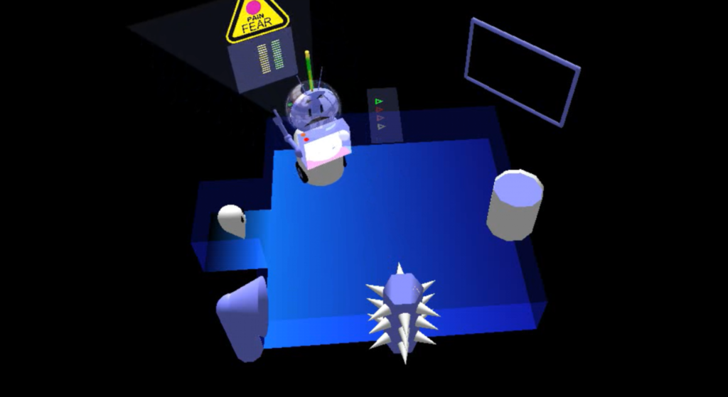
Figure A.15. The floating overhead Emotions panel (yellow triangle) shows the Acute Fear caused by a previous Painful encounter with the Learning Confine wall. The virtual agent ‘Simmy’ is reversing away from the wall and the green Satiation bars (right) shows ‘release’ or ‘relief’ from Fear (not Pain), while the yellow bars show the high level of residual Autonomic Stress still present despite the Satiation.
For simple Xzistor robotic applications, the values of the Anger and Acute Fear Drive strengths can easily be derived from the Autonomic Stress Drive strength value using the relationships in Figure A.16 below.
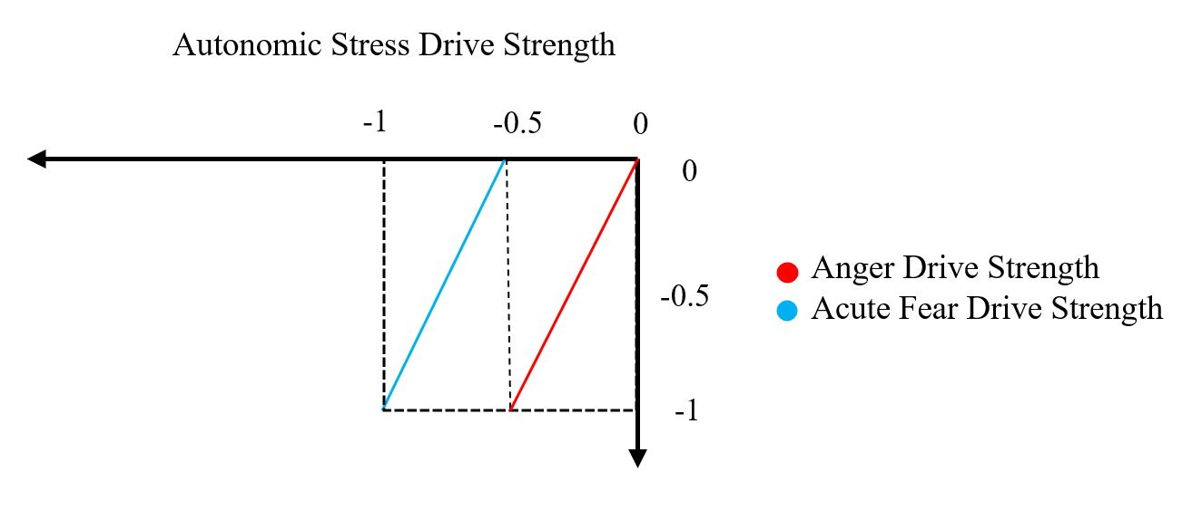
Figure A.16. Anger and Acute Fear Drive strengths as a function of Autonomic Stress Drive strength.
Modeling Nausea
The model postulates that Nausea, as an Allostatic Drive, can be triggered by numerous Control Variables, one of which is Autonomic Stress. Since it is based on an Allostatic control loop, it can also be triggered by recognizing or recalling an object/situation Associated with Nausea (some refer to mild recalled Nausea without vomiting as Disgust).
Several studies have shown that increasing nausea is associated with decreased parasympathetic and increased sympathetic modulation and can involve the amygdala, insula and medulla oblongata, which accounts for the subjective perception of nausea with or without subsequent vomiting (Singh, 2016). The model allows for a computational correlate of human nausea to be emulated as a Nausea Drive with associated Emotions in the same vein as the Acute Fear and Anger Drives.

Discussion on Key Components of the Drive Algorithm
Using the Drive Algorithm explained in this section, the Xzistor brain model accounts for key parts of most of the bioregulatory mechanisms identified by neuroscientists in the human brain. These mechanisms also generate the information required to create pseudo-somatosensory Emotion representations which the agent will viscerally ‘feel’ and which can be used by the executive part of the modeled brain to base behavior on. The model states that actions not due to Reflexes or Phobias originate from the Emotion representations generated/stored by these Drives.
The fact that the Autonomic Stress Drive does not just operate on its own, but also works in unison with all other control loops, provides the model with some special capabilities. The agent can now act to avoid the Autonomic Stress Deprivation Emotions created when recalling a Deprivation event (e.g., a severe Hunger, Cold or Pain event) or recognizing a precursor to such events, and in this way avoid adverse events even before they happen.
These agents can, therefore, act out of Fear, or the Fear of Fear and plan ahead by searching for Associations that offer past learning on avoiding these Fear states. The agents can even pursue reward sources that might require deliberate proactive arousal, e.g., Sex Drive Deprivation Emotion (tension/frustration), in anticipation of these reward sources delivering Satiation.
In the section on the Association Algorithm, an explanation will be provided of how Satiation Emotion (SE) and Deprivation Emotion (DE) representations become Associated and inextricably linked to approach or avoid behaviors through Reinforcement Learning and how this can provide a mechanistic explanation of how humans learn to call feelings ‘good’ (approach) or ‘bad’ (avoid).
This also offers an objective (mathematical) explanation of subjective states in the biological brain, allowing for a case to be made that the feelings experienced by Xzistor robots are principally no different from that of humans. This explanation can also be used to study consciousness and challenge the so-called Hard Problem of Consciousness (1995, Chalmers).
With the Xzistor brain model, there is no need to classify or code for individual emotions. The whole contested field of finding universal (basic) emotions becomes irrelevant, as emotions are simply defined as combinations of the visceral effects of the homeostatic/allostatic control loops generated in different contexts. The model’s process for creating context is further explained in the section on the Association Algorithm.
In summary, the Xzistor brain model assumes that all human emotions derive from homeostatic and allostatic control loops that are present at birth. As humans mature from childhood into adulthood, they do not acquire more homeostatic and/or allostatic control loops, leading to more emotions (except for the sex drive mechanism during puberty and possibly some addictions). What humans experience as seemingly new rich and complex emotions in the post-infant years are just these same homeostatic and/or allostatic (including autonomic stress) emotions which have collectively become associated with the evolved social and cultural contexts in more complex environments.

A.3 Building Block 3 – Reflex Algorithm
A Reflex is triggered by a Sensory State (S) or a Drive (D), resulting in a representation in the brain, interpretable as a preprogrammed set of Effector Motion commands. When triggered by a Sensory state, we have:
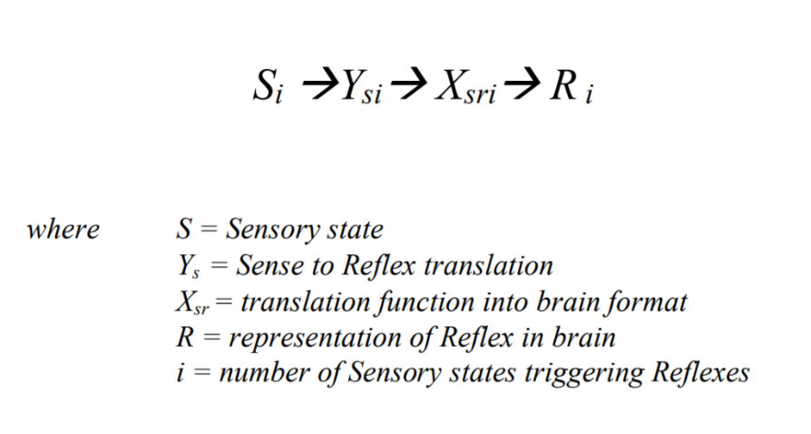
When triggered by a Drive state, we have:
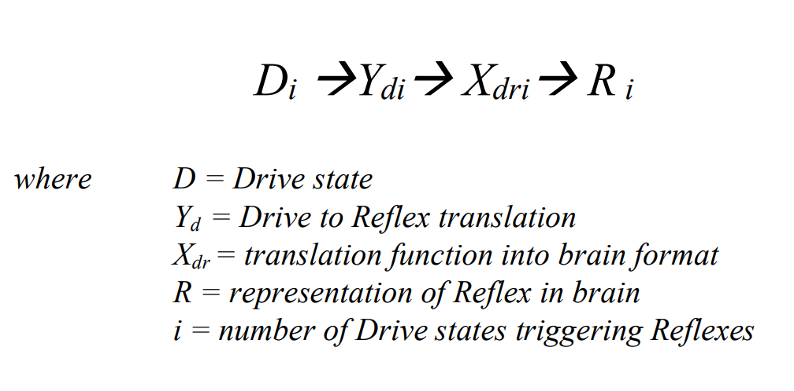
The Reflexes triggered during Deprivation are usually different from those triggered during Satiation. The model groups Reflexes into four types:
For the Deprivation condition:
- Involuntary Deprivation Reflex (triggered when the Drive is in Deprivation), e.g., shivering when cold.
- Learn-modifiable Deprivation Reflex (triggered when the Drive is in Deprivation), e.g., crying when hungry.

And for the Satiation condition:
- Involuntary Satiation Reflex (triggered when the Drive is in Satiation), e.g., prostate contractions.
- Learn-modifiable Satiation Reflex (triggered when the Drive is in Satiation), e.g., a suckling infant.

A.4 Building Block 4 – Association Algorithm
The Association Algorithm uses the representations generated by the other algorithms to store and later re-evoke Associations. Association-storing is achieved by linking and storing representations that are all present simultaneously in the brain.
The representations present in the brain at time = t will be stored in the Association Database as a numbered Association (A_{t}):

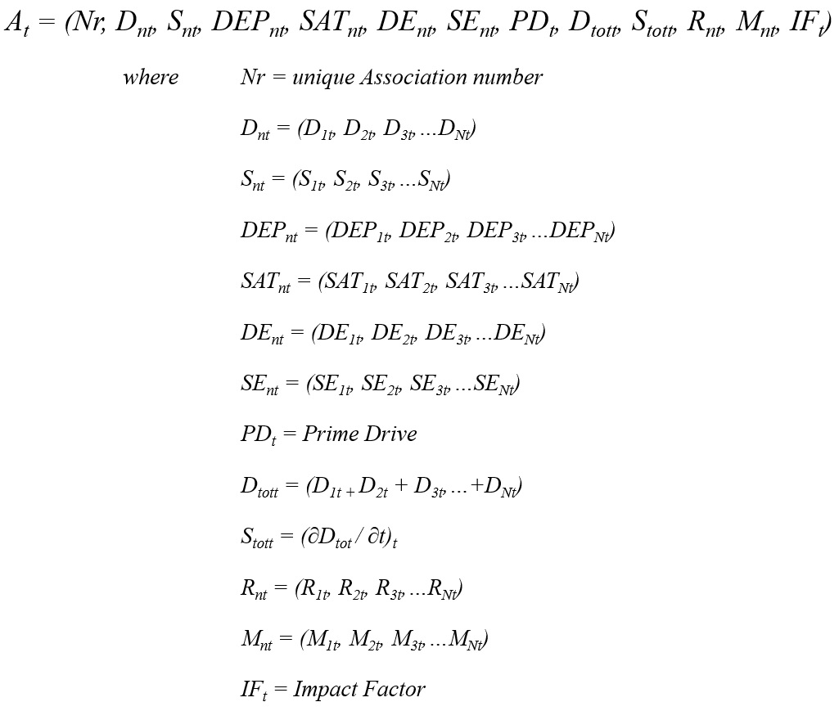

Based on the Xzistor brain model’s formal definition of a representation, the representations above for Association (A_{t}), when applied to a digital instantiation, can comprise integer values, floating point values or strings — or any combination of these (also arrays). For example, using an agreed protocol, a Hunger Drive representation could be:
[030200101]
Where 03 uniquely identifies the Hunger Drive, 020 and 010 indicate the Drive numerical value 0.21, and the last number 1 indicates the Drive is in Deprivation. This representation thus clearly conveys, by agreed protocol, the information ‘Hunger Drive = −0.21’ to the modeled brain for processing. The actual representation will be the digitized version of the above numbers within transistors in the silicon wafer of the Xzistor agent processor.

Components of a Modeled Association
A typical Xzistor model Association stored to the Association Database at time = t will comprise the following informational elements:
Nr — Associations will be chronologically numbered when created and added to the Association Database. This does not model a biological correlate, but seeing the total number of Associations grow as the agent moves about in its Learning Confine is helpful indication of system health. It also aids in diagnostics and debugging, as well as returning to areas of interest in the Association Database during demonstrations. It further eases the identification and processing of preceding Associations that need to be given Satiation-triggering capabilities, under dynamic conditions, based on Reward-based Backpropagation (discussed later).
D_{nt} — This is all the Drive representations (with strength values between −1 and +1) of all the individual active Drives (i.e., those above their detection thresholds). This will include Homeostatic Drives like modeled Hunger, Thirst, Pain, Cold, Warm, etc. and Allostatic Drives like Autonomic Stress, Anger, Acute Fear, Nausea, etc. These Drive representations are only used for background calculations (aiding Threading and Context generation) and are not presented to the executive part of the modeled brain for action selection.
S_{nt} — This includes all the incoming Sensory representations and can include digital representations of video images, sounds, tactile states, tastes, etc. A somatosensory representation from the agent’s skin (shell) or modeled gastrointestinal track (gut) could constitute an array of values in the Body Map database which also codifies information on body locations and individual sensory receptor signal strengths (numerical values).
DEP_{nt} — This is all the Deprivation representations as values between 0 and –1 of all the agent’s active Drives (i.e., above their detection thresholds). Deprivation enhancements by the Body State Override Reflex (modeled limbic system) through interference with the Error Signals will be included in these representations. These DEP_{nt} representations are only used for background calculations and the executive part of the modeled brain will be unaware of them.
SAT_{nt} — This is all the Satiation representations as values between 0 and +1 of all the agent’s active Drives (i.e., above their detection thresholds). Satiation enhancements by the Body State Override Reflex (modeled limbic system) will be included in these representations. These SAT_{nt} representations are only used for background calculations, and the executive part of the modeled brain will be unaware of them.
DE_{nt} — This is all the Deprivation Emotion representations for active Drives, which could constitute arrays from the Body Map database, including body locations and individual sensor receptor signal values (digital). These Body Map representations can directly result from a Drive undergoing a change in Control Variables (and thus Error Signal) or indirectly when a Drive causes effects in areas of the body that register Body Map signals through Sensory receptors. Pain in a limb can directly cause a Pain Deprivation Emotion, whilst the coupled Autonomic Stress Emotion will follow an indirect route through activating the modeled Sympathetic Nervous System, which will cause changes in the simulated gut and contribute to the typical abdominal Autonomic Stress Deprivation Emotion representation (butterflies in the stomach) in the Body Map area.
SE_{nt} — This is all the Satiation Emotion representations for active Drives, which could constitute arrays from the Body Map database, including body locations and individual sensor receptor signal values (digital). These Body Map representations can directly result from a Drive undergoing a change in Control Variables (and thus Error Signal) or indirectly when a Drive affects areas in the body that register Body Map signals through Sensory receptors. Relief from extreme Cold in a limb can directly cause a Cold Drive Satiation Emotion, whilst the coupled Autonomic Stress Satiation Emotion (relief) will trigger the modeled Parasympathetic Nervous System, which will in turn cause changes in the simulated gut leading to the typical abdominal Autonomic Stress Satiation Emotion (relief) representation (warm, relaxed feeling in the stomach) in the Body Map area.
PD_{t} — This will identify the Prime Drive (highest Error Signal strength) when the Association was stored.
D_{tott} — This is the combined and normalized Deprivation representation of all Drives as a value between 0 and −1.
S_{tott} — This is the combined Satiation representation of all Drives as a value between 0 and 1.
R_{nt} — These are all the Reflex representations when the Association was stored.
M_{nt} — These are all the Motion Effector action representations when the Association was stored at time = t. Effector Motions are explained in mathematics in a later Section A.5 BUILDING BLOCK 5 – MOTION ALGORITHM. For basic Xzistor robots, these could simply be motor speeds and directions learnt during tutor guidance, which can be stored and repeated in future for the same Prime Drive within the same environment to achieve Satiation. A spoken sentence like ‘Give me the red apple!’ will also be a Motion Effector action modeled by a digital representation of the temporal frequency spectrum fluctuation. This can be buffered as a set of discrete words or sentence parts per Association in the same way Xzistor robots learn Motion Effector sequences through Reward-based Backpropagation (see also the discussion on Anchor State below).
IF_{t} = Impact Factor for Association (a full mathematical definition is provided later in this section)

Discussion on Key Components of a Modeled Association
For physical robots and virtual agents, the Sensory representations (S_{nt}) can include typical human-type senses, including a sense of balance (measured or calculated accelerations) and proprioception (measured or calculated gravitational/inertial stresses within limbs/joints). These Sensory representations can also be extended beyond the typical human range by adding additional digital Sensors.
If Sensory inputs include a set of inputs from more expansive body areas (e.g., tactile or temperature Sensations), the Sensory representation (S) will be in the form of an array from a relational database, adding a body location attribute to each separate input signal. Similarly, the Drives (D_{nt}) of the artificial agent can be vastly expanded beyond typical human drives for niche applications by merely selecting different Control Variables and setpoints.
An Association, as modeled above, will be uniquely identified by its number (Nr) and ‘recognized’ by its Anchor State — typically comprising the Prime Drive (PD_{t}) representation and some or all of the Sensory representations (S_{nt}). The Anchor State can also include Effector Motion and Emotion representations. A mathematical definition of Anchor State is provided later in this section.
Storing and recalling Associations containing these representations correctly allows for all that is learnt by the agent to have situational, emotional, motivational and behavioral Context and creates the agent’s illusionary consciousness, a reality comprising of only those Sensory and Emotion representations presented to the executive part of the modeled brain, that an Xzistor robot will subjectively experience — and which the model argues is principally the same for humans.

Association-forming and Updating
With every cycle of the Xzistor brain model logic loop, an Association (A_{t}) is stored by linking all the above representations and storing them as a single combined entry into the Association Database. For simple digital applications like virtual agents or small robots controlled by an Xzistor computer program, typically, ten Associations can be stored per second. If an Association already exists for the Sensed environmental cues and Drive states being experienced, past and present information will be combined, and the Association will be updated with the new consolidated information.
More advanced Xzistor agent instantiations could use high-performance computers for each of the above functional building blocks responsible for calculating the representations. These computers will calculate and buffer at high speed the representations to be made available to the central computer executing the Xzistor logic loop.
Recognition and Recollection
A check is performed with every Xzistor brain model logic loop cycle to see if current incoming representation sets (e.g., S_{nt}, D_{nt}, etc.) already have a match in the Association Database. A match would mean that elements of what is being observed in the environment or thought about are being ‘recognized’ (matched) with an existing Association in the Association Database.
This becomes helpful when an artificial agent is acting on a strong Prime Drive and needs to extract learnt Effector Motions on how to navigate towards a reward source based on what is observed in the environment.
Like in the human brain, the resolution of Sensory states (e.g., visual images) stored to the Association Database is lower than what is experienced directly from the Sensors in real-time, allowing agents to learn in time when an optical state is recalled from memory, and when it is real. Retinal diffusion can also be used to make an agent derive more information from the center of the field of view, with less detail towards the periphery, which aids in identifying different individual objects within a field of view.
If the route to the reward source has been repeated many times before and Associations are covering the whole route, the agent will immediately recognize these objects as environmental cues (specific to the current Drive that needs solving) and will perform smooth movements as the learnt Effector Motions are retrieved from these Associations (at approximately ten per second).
If the Prime Drive is in Deprivation, the learnt (reinforced) Effector Motion parts of the recognized Associations will be recalled and repeated to guide the agent to the food source. If the agent already has access to the food source, i.e., the Prime Drive is being Satiated, Effector Motion parts of the recalled Associations will be used that can improve (optimize) Satiation (e.g., ingest more food or ingest food faster).
When an Association is recalled based on recognized Sensory states (Anchor States), all the Allostatic Emotion representations stored as part of that Association are immediately regenerated and presented to the executive part of the modeled brain. The modeled brain will thus be made aware of these Emotions since these will be experienced in the Body Map area of the modeled brain. Again, it is important to note that only Allostatic Emotions can be recalled in this manner — not Homeostatic Emotions.
For more sophisticated agent instantiations of the Xzistor brain model, all Allostatic Drive Emotions (like Autonomic Stress, Anger, Acute Fear, Nausea, etc.) from all Associations matching the input states (Anchor States) will, upon recognition, immediately be re-evoked as consolidated non-Contextual Emotion representations. After this instantaneous non-Contextual Emotion, the modeled brain will return focus to the current Prime Drive Context.
For example, an agent navigating past a cactus towards the food source will instantaneously feel both Autonomic Stress re-evoked from a Painful encounter with the cactus and Autonomic Stress relief (Satiation) from recognizing the cactus is also a pointer to the food source. Since there is only one Autonomic Stress Drive mechanism in the modeled brain, the net Autonomic Stress based on these two inputs — one negative and one positive — will be experienced by the agent.
This net Autonomic Stress Emotion, which could briefly dull the smile on the agent’s face, will quickly be replaced by more specific positive Emotions, contextually linked to the Hunger Drive and the familiarity of the environmental cues recognized along the practiced route to the food source. Interestingly, if the Association of the cactus generates so much Autonomic Stress that the Autonomic Stress Drive becomes the Prime Drive, the agent will abandon its actions to move to the food source and prioritize moving away from the cactus first.

Anchor States
As mentioned before, any number of representations (from one to many) that are already part of an existing Association (A), when checked against the Association Database, can re-evoke that Association and make the information contained in its different representations available to the executive part of the modeled brain.
For modeling purposes, it is convenient to fix the number of input representations that, collectively, will match with and re-evoke such an existing Association.
This subset of input representations, which are required to be present at the same time to ‘unlock’ or re-evoke the Association (A) from the Association Database, is called the Anchor State (AS), and it will be a subset of the representations comprising Association (A):
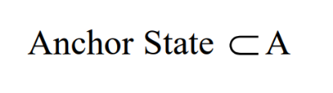
Typically, a trade-off between accuracy and processing overhead can be achieved by choosing the Anchor State only to contain the main Drives and the main Sensory States, i.e.:
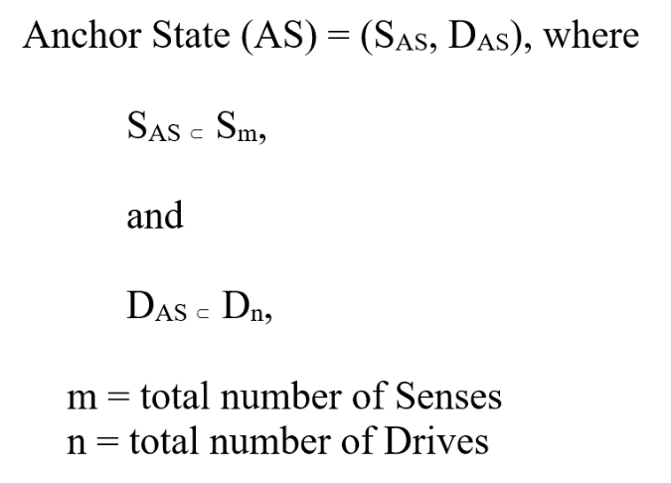
Learnt Motion Effector sequences that can help Xzistor agents navigate an environment to a Satiation source will typically be ‘anchored’ to the Prime Drive and the Sensed environmental cues when stored to Associations.
A well-trained agent with Hunger as Prime Drive and facing the green swing doors (Sensory representation) leading to the kitchen will search its Association Database for Associations containing both Hunger as Prime Drive and the visual image closely resembling the green swing doors (as Sensory representation). This Anchor State will locate and recall the learnt Association that tells the agent to move straight through the swing doors to the bowl of apples.
For advanced agents, this can be extended to additionally anchor Associations to current Effector Motions (still being performed from the previous logic loop cycle) and even further by anchoring Associations to artificial Proprioception representations to achieve complex highly-refined Effector Motion sequences — a computational correlate of human muscle memory achieved from repetition/practice.
An explanation of how the model will also account for Verbal Behavior by anchoring sequences of words in the correct way to achieve reward sources is provided later in this appendix under Modeling Thinking.

Impact Factor
When an Association is stored, the Anchor State becomes its unique identifier. The Anchor State links the Association to a specific Drive (typically the Prime Drive) and to the subset of Sensory representations (belonging to the selected Anchor State) present in the modeled brain at the time. The Prime Drive for every Association stored will either be in Deprivation or Satiation when the Association is stored.
An Association has a specific strength or ‘Impact Factor’ when stored. The Impact Factor (IF) is a function of three differentially weighted parameters:
- EIF is the Emotional Intensity Factor — this is the absolute value of the sum of the highest of the Homeostatic Drive values (+ or –) and the highest of the Allostatic Drive values (+ or –). This can be a positive value between 0 and 2.
- ET is the Elapsed Time — the time in seconds since the Association was last recalled (re-evoked)/updated.
- RR is the Reinforcement Repetitions — the number of times the Association has been recognized/recalled/updated. This will be an integer value.

Impact Factor = f (EIF, ET, RR)

The Impact Factor provides a way to rank Associations by their importance to the modeled brain in finding Satiation or causing Deprivation. The Emotional Intensity Factor (EIF) is usually given the most weight to emphasize the Emotional impact the Association carries.
At the same time the Elapsed Time (ET) factor provides a lower ranking for Associations that have not been recalled for an extended period, indicating that these have likely become less relevant to the current environment.
The Reinforcement Repetitions (RR) value provides a higher ranking for Associations that have often been recalled/updated, which could indicate that they are regularly used and likely to remain relevant throughout the agent’s instantiated lifecycle. Every time an Association is recalled, the Impact Factor for that Association is updated — mainly to account for both past and current Emotions being experienced while the Association is stored or updated.
Associations with high Impact Factors will be stored near the top of the Association Database and first accessed when information based on experience (learning) is sought during problem-solving (elaborated on later in this appendix).
By accounting for both the Homeostatic and Allostatic Drives in the Impact Factor, the impact of an Association will be different for an agent. For instance, a comparison can be made between an agent that enjoyed a strawberry milkshake (mathematically modeled) in Café A, that have created highly positive Satiation Emotions, and that same agent having enjoyed a similar strawberry milkshake in Café B where a ceiling fan had dropped on the agent causing severe Pain. Whilst the level of Homeostatic Satiation of the Thirst Drive was the same in both instances, the agent will, in future, prefer visiting Café A because of the negative Autonomic Stress (Fear) generated when seeing or recalling Café B.
Preference towards Thirst reward sources will thus go beyond simply preferring a milkshake over water; it will also be affected by Allostatic Emotions like Autonomic Stress generated at the time when the Association was formed.

Reinforcement Learning
The Effector Motions performed by agents to gain access to reward sources are learnt and stored as part of Associations. During a Satiation Event, the successful Effector Motions performed at the time of the event, often with the help of a tutor, are reinforced (stored in memory) to inform the agent how to solve that Drive again in that same environment in future.
The immediately preceding Effector Motions, which allowed the agent to correctly navigate up to the reward source, are also reinforced to memory. The model keeps the Associations containing these preceding Effector Motions in cache so that the actions stored as part of these Associations can be reinforced retrospectively if these successfully led to a Satiation Event. Homeostatic Satiation Events cannot be used to reward preceding actions retrospectively (e.g., simply opening the kitchen cupboard to reveal a food source will not Satiate Hunger — food needs to be ingested).
However, opening the kitchen cupboard can be rewarded retrospectively with the Autonomic Stress relief coupled to Hunger Satiation. This is achieved by turning the observation and actions of opening the kitchen cupboard into an Autonomic Stress Satiation Event linked to Hunger.
In future, all actions that have preceded the observation of the kitchen cupboard can now also be retrospectively reinforced and turned into Autonomic Stress Satiation Events linked to Hunger. The agent will gradually learn to navigate to the kitchen cupboard from further and further away by following these back-propagating environmental Autonomic Stress reward sources — a process called Reward-based Backpropagation.

Figure A.17. With every approach to the Hunger reward source (red apple), another preceding green frame Sensory state is turned into a positive Autonomic Emotion Satiation Event — reinforcing Effector Motions towards the Hunger reward source from further and further away. This is called Reward-based Backpropagation.
Based on the above approach to Association-forming, the agent becomes programmed to steer away from situations generating Deprivation Emotion representations and towards situations that can generate Satiation Emotion representations. Similarly, humans tend to avoid actions that lead to bad emotions and pursue actions that lead to good emotions.
Humans learn to use words like ‘bad’ and ‘good’ when self-reporting on the conditioned avoid/approach effects created by the biological correlate of this Association algorithm in the human brain. Emotion representations created using Drive information thus have no intrinsic good (approach) or bad (avoid) value at the time they are derived from the Drive states, as this bias is achieved during Association-forming, specifically through Operant Learning.
The visceral (body) representation for Autonomic Stress Deprivation in one Xzistor robot can be used to generate an Autonomic Stress Satiation representation in another robot — meaning the same bodily feeling used to create a ‘good’ Emotion in one robot can be used to create a ‘bad’ Emotion in another robot. Emotional biases are purely created by linking the viscerally experienced Emotion representations with learnt avoid/approach behaviors — this makes them ‘good’ or ‘bad’ in the modeled mind of the agent.
An interesting behavior that can be generated based on the above is where, for example, the agent just recalls a Painful experience and performs a learnt behavior to avoid getting into the Painful situation again, without experiencing any actual Pain.
The agent’s behavior is based on the Fear of Pain. Xzistor agents have been shown to learn to avoid crashing into the walls of their Learning Confines by this Fear of Pain dominating their behavior. Fear in this Context is just the Autonomic Stress generated when recognizing/recalling the Pain Association formed during the Painful collision event with the wall.

Modeling Mind Wandering (Threading)
If all the agent’s Homeostatic or Allostatic Drives are below their separate activation levels, there will be no Prime Drive, and the agent will perform either Playing or Threading since there are no urgent Drive deficits to restore, i.e., no strong subjective needs to be addressed. A typical activation level for a Drive could be −0.1 on a scale from 0 to −1 (i.e., 10%). Below this activation level, the agent will go into one of two modes, either Playing Mode or Threading Mode.
Mode 1 − Playing
Playing Mode involves obtaining Satiation from sources in the environment the agent has learnt can provide Satiation, e.g., playing games. Playing can comprise learnt behaviors offering Satiation by artificially creating small amounts of Deprivation — often mild Autonomic Stress generated during physical or mental games (e.g., computer games) that can lead to Satiation.
These games will offer undulating moments of Deprivation (Autonomic Stress) and Satiation (Autonomic Stress relief). This Playing modality is different from the instinctive playing (exploration) behaviors prevalent in both human and animal infants, which instinctively motivates engagement with the environment for learning.
Adults might learn to find more sophisticated and subtle ways to achieve satiation when no drives are active or when only a very mild level of autonomic stress is still being experienced due to some aspect of environmental uncertainty. Often, this uncertainty derives from things that are not known (certain) and causes small amounts of autonomic stress. Reducing this uncertainty will alleviate the fear of the unknown and provide mild satiation.
Adults will also learn to deliberately raise autonomic stress temporarily by watching news headlines, sports events, action movies, controversial standup comedy, etc. and enjoy the moments of relief when the autonomic stress (excitement) is reduced (calmed) at random intervals.
Studying new subjects that contain novelty can provide answers to latent or lingering questions in the mind that previously remained unanswered, generating autonomic stress (albeit miniscule) that can provide relief when answered.
Even just reading a book can provide escapism from a stressful work/home life situation. All the activities performed in Playing Mode will thus involve either Satiating inherent residual Autonomic Stress or generating subtle amounts of new Deprivation that can be Satiated.
The model defines boredom as the absence of Satiation. Playing Mode will usually be entered into when no Drives are active, when the agent is not Fatigued or Sleepy (these are also Homeostatic Drives) and when the agent is bored. This urge to search for subtle levels of Satiation when no Drives are active was demonstrated in early Xzistor demonstrators.

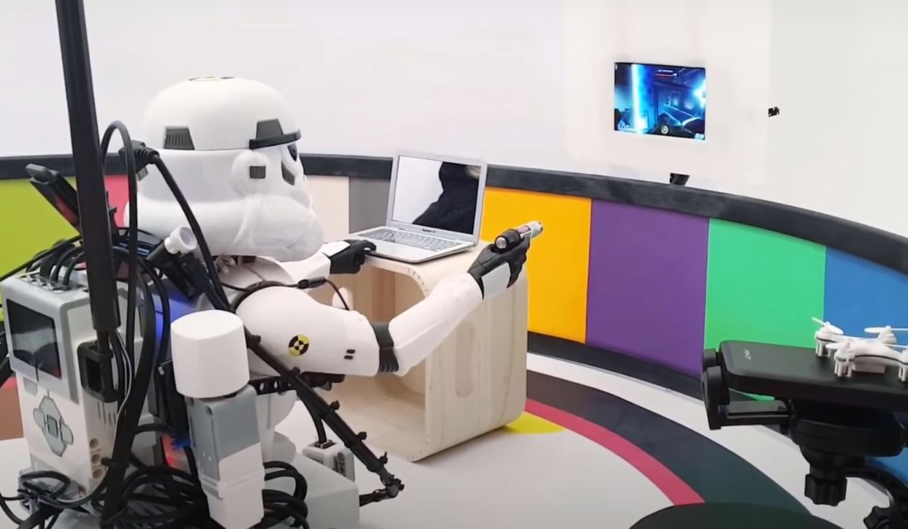
Figure A.18. Setting up an experiment to see if a simple Xzistor agent can derive both Autonomic Stress and Satiation from firing a laser pointer at objects on a screen (effectively Playing a simple game).
Playing Mode might involve interaction with another agent, computer screen or tutor where Autonomic Stress is deliberately raised for it to be relieved (Satiated). For instance, the agent could purposefully navigate towards a cactus (learnt Pain and Autonomic Stress Deprivation Emotion source) and then quickly return to face the tutor (learnt Autonomic Stress Satiation Emotion source) to enjoy the Autonomic Stress relief — a typical early volitional behavior also observed in human toddlers.
Modeling later life human behaviors is also possible — where the agent can be taught to pursue objects that can be attacked and defeated (purely for Anger Drive Satiation Emotions) or pursue an object that can provide Sex Drive Satiation Emotions through the prerequisite subtasks of courtship, arousal and intimacy.
These follow the same basic mechanism as the Playing modality described here — engaging in a situation/object that could arouse/increase Allostatic Drive Deprivation Emotions to experience Satiation Emotions.

Mode 2 − Threading
The model will achieve Daydreaming through a process called Threading, whereby the system will recall Associations from the Association Database, akin to the human brain’s process of ‘mind wandering’. The criteria for selecting the next Association in the Threading sequence will be similarity in attributes like Sensory representations (mainly visual images), Drive representations, Emotion representations, and Effector Motion representations. The value of the Association’s Impact Factor (IF) will strongly influence the selection of the next Association in the Threading sequence.
The agent’s Sensory perception will allow agents to recognize individual ‘objects’ as part of larger Sensory representations, e.g., once Associations have been formed around a red apple and the face of a tutor, these can become recognized as separate objects within the same current field of view. These individual ‘objects’ can then become linked through perceptual binding (Colzato, 2007) or temporally linked through persistent activity (Curtis, 2021).
This can help the Threading routine when searching for shared attributes between Sensory representations, e.g., a cat in one Association can lead the Threading algorithm to select the next Association where a cat is also prominently featured as part of a larger Sensory representation (if the new Association also has an adequately high Impact Factor).
Just like in the human brain, when engaged in mind wandering, preference will be given to Associations that not only have shared attributes, but that have made a strong Emotional impact (good or bad) and have been recalled often and recently — these Associations will have a high Impact Factor (IF).
With every cycle of the logic loop, a new Association will be recalled when in Threading Mode, regenerating mainly the visual imagery and the Allostatic Emotions stored as part of the Association, but without performing the learnt Effector Motions.
Whilst Threading (daydreaming) can still be affected by what is observed in the environment (i.e., Sensory distractions), Sleep Dreaming follows the same process except that Effector Motions are more robustly disabled and only strong Sensory inputs (loud sounds, bright lights, strong tactile stimuli, etc.) will terminate the Sleep Dreaming process and wake up the agent.

Modeling Thinking
If the agent has performed the Motions to resolve the Deprivation of a Prime Drive many times before in a specific physical environment, it will quickly recognize and match the correct environmental cues with Associations in the Association Database by comparing Anchor States. The agent will then navigate to the reward source with quick, uninterrupted Effector Motions (motor inputs updated every 0.1 seconds). This is typically observed in Xzistor agents with adequate training.
When initially starting out, though, the robot would have crashed into walls and often cried for help from the tutor (crying is a Learn-modifiable Reflex that can be triggered by a high level of Autonomic Stress and/or Acute Fear). If the agent trying to solve a specific Drive cannot recognize its current environment as a location where it had navigated through before and formed Associations, no learnt Effector Motions will be available from the Association Database. The agent will now be stuck and start to suffer increased Drive Deprivation, including raised Autonomic Stress.
The agent will have to perform Thinking or ‘directed’ Threading as defined by the model where the agent now starts to search for the ‘closest’ correlating Association based on what is observed in the environment as well as the Drives and Emotions it is experiencing. As the agent’s Deprivation level increases (for example, due to increasing Hunger), the coupled negative Autonomic Stress Emotion will also increase, and it will become more urgent for the agent to find an Association, i.e., it will speed up the ‘directed’ Threading process.
Under these more desperate conditions (higher Deprivation), Associations chosen from the Association Database will become less accurately filtered, leading to the agent trying increasingly random behaviors to find a food source. This can even lead to aggressive behaviors as the rising Autonomic Stress triggers the Anger Drive.
The ‘directed’ Threading process will also constantly recall images of other viable food sources with high Impact Factors indicating that these have recently and repeatedly been experienced in that specific environment. Associations that do not provide helpful Effector Motions towards solving a problem are temporarily downrated by lowering the Impact Factors and not recalled again for a period, as these result in Emotional disappointment (prediction error leading to enhanced negative Emotions via the Body State Override Reflex). When following this inductive inference process, any ‘inferred’ action that brings improvement (i.e., brings the agent to a known route and leads it to an Autonomic Stress reward source for that Drive) will cause a pleasant surprise (prediction error). These behaviors will thus trigger enhanced positive Emotions created by the Body State Override Reflex and reinforced (stored to memory) for future use.
This ‘directed’ Threading process is how Xzistor agents Think and solve problems and allows these agents to generalize learning across domains and goals. During the Thinking process, the model will generate the ‘Context’ of what is being thought about by quickly recalling numerous relevant Associations along with their visual imagery and Allostatic Emotions. These recalled Associations formed during past relevant experiences (both negative and positive), including images of reward sources and environmental cues (objects) along the routes to these reward sources, as well as related Emotions, will provide the narrow Cognitive and Emotional ‘Context’ or ‘Meaning’ around the problem the agent is trying to solve.

Generalizing Thinking Across Domains
The way the Xzistor brain model defines Thinking as ‘directed’ Threading allows agents to solve novel problems in new domains by generalizing learning from one physical or contextual domain to another. This happens automatically because of the specific protocols the ‘directed’ Threading algorithm uses. Simply put, this algorithm provides some flexibility and does not require a new physical domain to be precisely the same as what was experienced before. When placed in a new domain, the agent will search for the closest match Anchor States to find Associations with learnt actions that can be tried on a ‘trial and error’ basis to achieve Satiation.
This inductive inference approach will, for instance, lead to a Hungry Xzistor agent that had been trained to locate a red apple in an indoor environment (say on the living room carpet) to immediately manage to locate a red apple in an outdoor environment (say on the garden lawn). The field of view of the apple on the lawn, as a Sensory representation, may only resemble a 10% correlation with what was observed indoors. However, the presence of the apple in the scene will still cause the algorithm to choose the learnt Effector Motions of the indoor Association to instruct the agent to move forwards and hone in on the apple on the lawn.
These best-guess movements will often not immediately lead to success, but as the Association Database grows from experiences in additional domains, the probability that the modeled brain will identify meaningful actions to perform in new domains will increase, and the agent will learn to refine these.
A specific tutoring modality was introduced into early Xzistor robots whereby the agent was left to infer actions when navigating towards reward sources in a new environment, with the tutor only offering help when no learnt actions could be generalized by the agent from other domains. The agents were designed to audibly cry when help was needed from the tutor via a Reflex triggered when the Prime Drive Error Signal became too strong — akin to how human infants may cry for help from parents/caregivers and then learn in the process.
As mentioned, Xzistor agents will learn Motion Effector sequences that can help them navigate through an environment to a Satiation source. These Effector Motions are typically obtained from learnt Associations ‘anchored’ to the Prime Drive and the Sensed environmental cues.
If a Hungry agent that has navigated to the kitchen is now required to open drawers to look for an apple, there could be a challenge. The image of the closed drawer will not change much, so the ‘directed’ Threading routine will tend to recall the same Association telling the agent to halt in front of the first drawer and remain stationary.
To allow the agent to learn how to perform the sequence of opening and searching the drawer, while the scene around the drawer remains essentially unchanged, will require that the Anchor State be extended to include Effector Motion representations. Now, additional Associations, mainly linked to changes in Effector Motion representations, can be stored as the tutor teaches the Hungry agent to open and search the drawers for food.
While the Hunger Drive and the image of the drawer might change very little, the sequence of opening the drawer can be memorized by Associations additionally anchored to Effector Motions. Here the following action does not rely on a change in environmental cue or Drive representation but rather on what Effector Motions are currently being performed from the previous logic loop cycle.
This will lead to finely coordinated movements through the process of Reward-based Backpropagation. Theoretically, the fidelity of such sequences can even further be refined by additionally anchoring Associations to artificial Proprioception representations. With enough practice, agents could achieve complex, highly refined Effector Motion sequences additionally anchored to Proprioception representations (derived from Sensed limb stress states caused by gravitational and inertial forces). This could provide a computational correlate of human muscle memory.
The above is important for when an agent has moved to a new domain (never experienced before) as it can now perform sequences (as modular subtasks) like opening drawers because of the ‘directed’ Threading process. When placed in a brand-new kitchen, it might not recognize the exact drawers but will automatically guess it should open the new drawers to look for food.
It might even try opening drawers using this subtask skill when looking for other reward sources to Satiate different Drives in other domains. This is because the drawer opening subtask is less dependent on the Drive and environmental cues for coordination and more on the learnt sequence anchored to ‘current’ Effectors Motions from the ‘previous’ logic loop cycle.

Modeling Verbal Behavior
From the model’s perspective, a spoken word is just learnt Effector Motions, and longer utterances (sentences) are just learnt Effector Motion sequences. These sequences are underpinned by Associations formed through Reward-based Backpropagation, which have been anchored to not just Drive and Sensory representations, but also Effector Motion representations. These Associations were typically learnt from copying a tutor in return for a reward (Satiation of a Homeostatic or Allostatic Drive).
The sequences of words aimed at obtaining Satiation will be less dependent on environmental cues and more on the current Effector Motions, meaning they can easily be generalized from the original Learning Confine to a new domain never experienced before.
A Hungry agent that has learnt to say to a human, ‘Open the cupboard!’ to get to food in one domain could, based on ‘directed’ Threading (Thinking), approach an object that looks like a cupboard in a new domain, and if there is a human present, repeat the words ‘Open the cupboard!’. If this leads to Hunger Satiation Emotions (and thus Autonomic Stress relief), it could become reinforced as the preferred action when in a new environment with new drawers is experienced in the presence of a human. For humans, repetition will allow for proprioception, gustatory sensory representations (the tongue, gums, lips, etc.), audio sensory representations (feedback) and even emotion representations to collectively anchor many more associations. This will improve coordination of the speech muscles and thus verbal eloquence. However, Xzistor agents expressing words using a speaker will have to rely on mainly Audio and Emotion feedback to refine speech.

Modeling Forgetting
Less impactful Associations (low Impact Factor) are not forgotten but stored so that they will only be accessed when the search criteria are very specific and there is adequate time for the model to search through the Association Database. This provides the model with mechanisms for both long-term and short-term memories.

Conclusions on the Association Algorithm
The above functions and effects created by the Association Algorithm contribute to a fully implementable brain model that explains and demonstrates many of the more elusive brain phenomena like recognition, recollection, verbal behavior, acting out of stress, acting to seek stress relief, acting out of disgust, acting to avoid disgust, acting out of lust, acting on the strongest emotion (whether originating from the body or brain), preferences, fear of hunger, fear of thirst, fear of pain, fear of cold, fear of fatigue, etc.
It also provides a way to model human learning, planning and problem-solving across domains using inductive inference based on the emotion states originating in the body and brain. The modeling of these effects will be explained in more detail in Section A.6 – LINKING THE FIVE BASIC FUNCTIONAL ALGORITHMS.

A.5 Building Block 5 – Motion Algorithm
The Motion Algorithm will translate any of the following into effector motions (actions):
- A Reflex input
- A recognized Phobia (where the Association was preprogrammed)
- A recognized Association (where the Association originated from learning)
- Motion commands forced on the system by an external party (e.g., robot tutor)
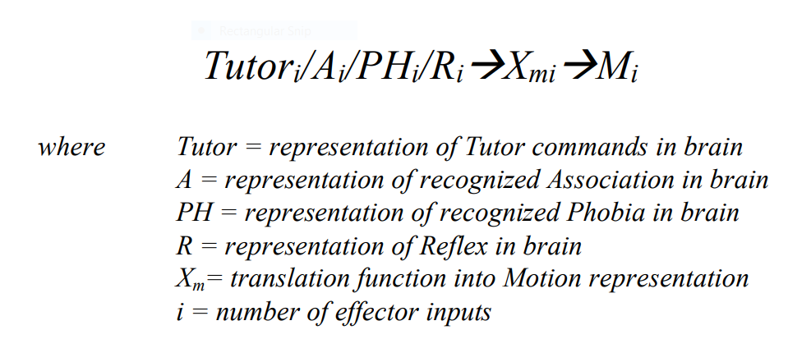

A.6 Linking the Five Basic Functional Algorithms
The Linking Algorithm integrates the five basic functional algorithms of the Xzistor brain model. This ensures the model effectively operates as a multi-variable adaptive control system. The Control Variables used by the Drives along with the Sensory inputs provide the ‘multi-variable’ part, the Association-forming (learning) provides the ‘adaptive’ part and the coordinated goal-driven ‘control’ functions drive the Motion Effectors aimed at changing the agent’s status in the environment. Whilst this model offers a simplistic view of the workings of the brain, the fact that the model can learn and keep on learning allows for complexity to emerge over time and for the model to emulate the biological brain principally.

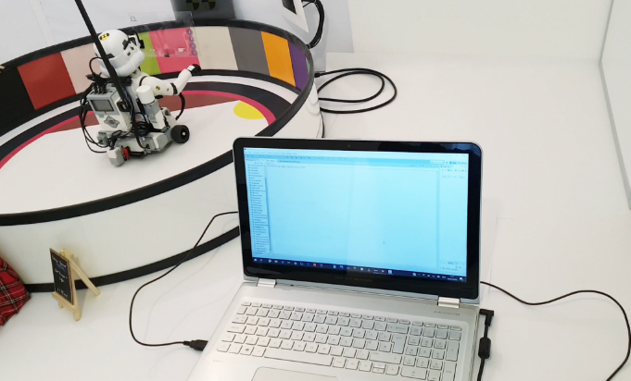
Figure A.19. A ‘proof-of-concept’ demonstrator (robot) in a Learning Confine controlled by a digital instantiation of the Xzistor Mathematical Model of Mind running on a laptop.
The Linking Algorithm effectively models the executive part of the biological brain (comparable to many of the functions performed by the thalamus, basal ganglia, etc.). The information passed between the five basic functional algorithms and the Linking Algorithm, during every logic loop cycle, is crucial to how the Xzistor model provides an agent with an emulated brain capable of human-like functions and effects.
The complete logic loop, as shown in Figure A.20 below, will be discussed next. It assumes an Xzistor brain model implementation comprising compiled computer code, e.g., C++, Java, Swift, etc., driving a physical robot, but could equally be applied to hybrid (neuro-symbolic) AI systems. The explanation is intended to be indicative only.
To use this code for a simulation, virtual models simply need to replace the physical elements of the robot and the environment.

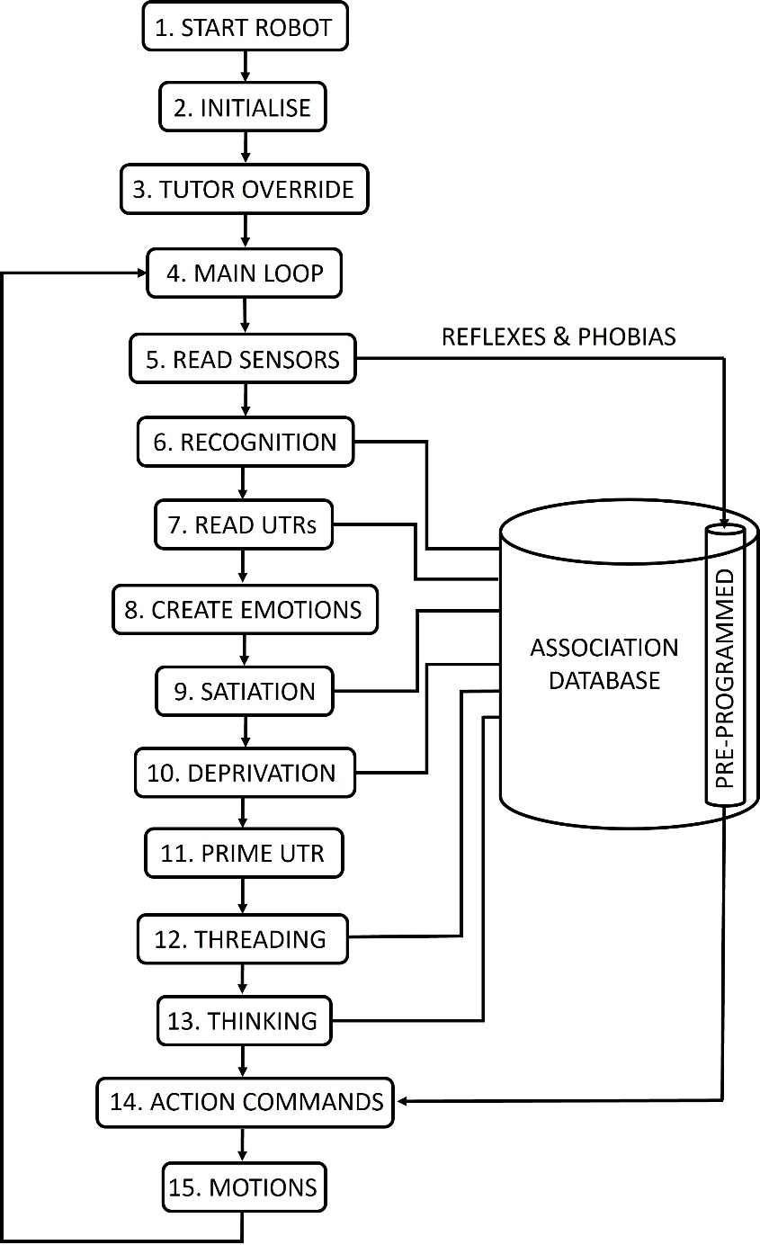

Figure A.20. The Xzistor brain model’s complete logic loop (simplified).
1. START ROBOT — The virtual or physical agent is activated with its modeled brain running an instantiation of the Xzistor Mathematical Model of Mind.
2. INITIALIZE — Initialize all variables and arrays (including the Association Database array and databases for the Sensory Body Map, which will also house Emotion representations).
3. TUTOR OVERRIDE — Open the tutor control interface with the agent. This allows the tutor to guide the agent during initial training. Typically, the tutor will take over control of the robot Motion Effectors (e.g., motors) via keyboard or joysticks and demonstrate an Effector Motion a few times to show the agent how to solve a problem like opening a cupboard or pushing buttons on a control panel to access a food source (when Hunger is the Prime Drive). For humans, both the act of ingesting food and the arrival of the food in the stomach causes satiation of the hunger drive indicated by signals from the oral cavity and gut (increased dopamine levels measured and located in the brain using positron emission tomography scans). However, for an Xzistor agent the Control Variables for a Hunger Drive can be modeled without the need for the physical ingestion of food. For physical robots, a close equivalent to Hunger can be added by defining a Drive that uses the battery ‘level of charge’ (LOC) as Control Variable — as the charge level of the battery diminishes, the Deprivation level increases. In the case of a simulated agent, Hunger can just be modeled by defining a numerical blood glucose level that will deplete over time, creating Deprivation. Both these techniques have successfully been demonstrated in simple Xzistor robots and virtual agents.
4. MAIN LOOP — The main loop is entered and repeated until the tutor interrupts the program, or the system power is cut. A Drive like Hunger or Thirst that has increased in strength to the value of −1 (100% Deprivation) could correlate to a fatal state in humans, but for Xzistor agents, these Drives will just be maintained at 100% strength and constantly selected as the Prime Drive. As the main loop is initiated, the artificial agent immediately starts to store and update Associations to build up an Association Database.
5. READ SENSORS — Based on the latest incoming Sensory Variables (V_{i}), the Sensory representations (S_{i}) are generated by the Sensing Algorithm, e.g., optic (video screengrab as a digital RGB array), tactile (touch as Body Map array), sound (audio input as buffered digital frequency spectrum array), dedicated color sensors, temperature inputs, shock (accelerometer inputs), gravitation or inertial limb/joint stresses, balance, etc. For a simple digital instantiation of the model, all these representations could merely be unique numerical values turned into machine code that can be interpreted and processed by the modeled brain. Sensory representations can sometimes directly trigger Reflex reactions, which could trigger Allostatic Drives (e.g., Autonomic Stress) and instinctive (preprogrammed) Effector Motions. For instance, sudden extreme heat on an agent’s hand could create Pain and Autonomic Stress and cause a quick Reflex to retract its hand. Somatosensory inputs from Sensory receptors covering wider areas on/inside the robot (e.g., tactile, temperature, pain, etc.) will be arrays with added information on body location/distribution.
6. RECOGNITION (READ ALLOSTATIC DRIVES) — The values of all the active Allostatic Drives based on their Control Variable inputs are read. Next all the Allostatic Drive values, based on memory inputs from the Association Database and based on the incoming Sensory set registered in 5. above, are read. There will be two searches performed of the Association Database to first extract the non-Contextual values of the Allostatic Drives and then the Contextual values.
- Non-Contextual Allostatic Recollection:
If the current incoming Sensory representations are recognized (matched) in one or more of the stored Associations, the model will list these Associations as a subset and immediately re-evoke the Allostatic Drive representations stored as part of all these Associations (these representations will be in the form of numerical values). Note that filtering is based on a Sensory input match only, and Allostatic effects will be collected and combined across all Drives and past experiences stored in the Association Database — for the creation of a ‘Gut Feel’ as an Emotional input not limited to a specific Context.
- Contextual Allostatic Recollection
Next the representations that are part of the Anchor State (AS) are compared with those stored as part of Associations in the Association Database to identify Associations that can be ‘recognized’. If the Anchor State representations are recognized in one or more stored Associations, the model will list these Associations as a subset and immediately re-evoke the Allostatic Drive representations stored as part of all these Associations. Note that filtering could be limited to Prime Drive matches only and thus become Contextual.
For this logic loop cycle all the physical and cognitive (from memory) effects working in on the Allostatic Drive values are now considered and combined — net positive or net negative — and ready to be processed by the brain model. However, the coupled effects of the Homeostatic Drives on the Autonomic Stress Drive (which is an Allostatic Drive) need to be factored in first.
7. READ HOMEOSTATIC DRIVES — For the current cycle of the logic loop, the modeled brain will obtain the Control Variable representations and use their Error Signals to generate Homeostatic Drive representations for all the Homeostatic Drives. This will allow for the effects of these Homeostatic Drives on the coupled Autonomic Stress Drive to be calculated. The program will now be ready to combine and consolidate the net Allostatic Drive representations. The program will also now be ready to combine and consolidate the net Homeostatic Drive representations. All final Drive values for the current logic loop cycle can now be made available to the modeled brain for processing.
8. CREATE EMOTIONS — The modeled brain will use the Allostatic and Homeostatic Drive representations from Steps 6. and 7. above to calculate the net positive Satiation and net negative Deprivation Emotion representations for all the active Drives (both Allostatic and Homeostatic).
The mathematical principle used to combine two different input signals impacting on the strength of the same Drive is simple. There are three options:
- Option 1: If both signals from the body or brain to the Drive representation are negative (causing an increase in Error Signal and thus Deprivation), the strongest of the two negative Drive strengths will be used (a value between 0 and −1).
- Option 2: If both signals from the body or brain to the Drive representation are positive (causing a decrease in Error Signal and thus Satiation), the strongest of the two Drive strengths will be used (a value between 0 and 1).
- Option 3: If one signal from the body or brain to the Drive representation is positive (signaling Satiation) and the other signal from the body or brain is negative (signaling Deprivation) — the arithmetic mean of the two Drive strength signal values will be used, for example: 0.46 (i.e., Satiation input signal) + (−0.32) (i.e., Deprivation input signal) = 0.14 (i.e., net Satiation Emotion]
The above consolidation protocol provides simple rules for combining any number of positive and negative effects on the Error Signals of Drives, comparable to how the biological brain uses neural network activation and inhibition to achieve similar biological computations.
To obtain a consolidated Allostatic Emotion representation, the following potential sources (originating mechanisms) of Allostatic Emotions are factored in by the model:
- Reflex — A Sensory representation (input) that could directly create an Allostatic Emotion (e.g., observing an instinctive threat object or loud noise that causes Autonomic Stress inducing negative Emotion). The Reflex input requires no Drive to be activated or recognition to take place within the Association Database. A repulsive smell could instantaneously trigger Nausea without any Contextualization or deliberation by the modeled brain.
- Phobia — A preprogrammed Association with a negative Allostatic Emotion (e.g., Autonomic Stress) is recognized via its Anchor State, e.g., the Sensation of complete darkness, which creates Fear as preprogrammed Autonomic Stress (Deprivation).
- Homeostatic Drives — Each Homeostatic Drive will always create coupled negative or positive Allostatic Drive and Emotion representations (mostly related to Autonomic Stress) even when the Homeostatic Drive is weak.
- Allostatic Drives — Recognition of an Association via a new Sensory input set or its Anchor State will regenerate its Allostatic Drive and Emotion representations. Searching through Associations in the Association Database as part of performing the mathematical equivalent of mind wandering, dreaming, or thinking will also regenerate the negative or positive Allostatic Emotions of every Association recalled — this is managed in Steps 12 and 13 below.
In line with the consolidation protocol discussed above, to arrive at, say, a combined Autonomic Stress Emotion representation, the highest source of negative Autonomic Stress Emotion (Deprivation) from the above list will be used as the overriding negative Stress Emotion (between 0 and −1). However, if this Deprivation level has decreased from the previous logic loop cycle, meaning that the system is experiencing Autonomic Stress relief (Satiation), the highest source of positive Autonomic Stress Emotion from the above list will be used. This will be applied to all other Allostatic Drives and create a set of consolidated Allostatic Emotions (either Deprivation or Satiation) that can now be compared with all the Drive Deprivation and Satiation Emotions generated from Homeostatic Drives during the current cycle. The moment all Drives have been combined and the Emotions consolidated, the final Emotion representations can be made available to the executive part (routine) of the modeled brain.
If the Autonomic Stress Emotions have experienced a sudden discontinuity (surprise) from the previous logic loop cycle i.e., either a positive or negative step change in value, the Body State Override Reflex (BSOR) will be triggered to create and enhancement (+ or –) of the Error Signals of all Drives forming part of the BSOR. The instantaneous enhancement of these Emotions will be proportional to the size of the jump in the Autonomic Stress Emotions.
9. SATIATION — A Satiation Event will be registered if the agent was in Deprivation during the previous logic loop cycle and moved to Satiation in the current cycle. Some agents will use Satiation of the Prime Drive and others of the total normalized Drive (D_{tot}). This is the moment the model will implement its Operant Learning protocol — reinforcing all current successful Effector Motions and whereby the Autonomic Stress Emotion representation (positive because of the Satiation) will also be assigned to the Association that was newly stored or updated during the previous cycle (the model refers to this as Reward-based Backpropagation).
The effect of this process is that recognition of the Anchor State of the previous cycle Association is now turned into a Satiation Event (reward source) — not because it provided Homeostatic Satiation (e.g., food, warmth, etc.) but because it will now cause a lowering of the Autonomic Stress Drive (Error Signal) linked to the Hunger Drive or Cold Drive upon recognition.
For instance, when the agent is Hungry, recognizing the green door leading to the kitchen will lower the Autonomic Stress Drive (Error Signal), causing Satiation Emotions (Autonomic Stress relief) and instantly creating another Satiation Event. With further learning, this Satiation Event will, by Operant Learning, turn the preceding Associations (formed during activities preceding arrival at the green door) into additional Autonomic Stress Satiation Events that can act as a predictive navigation cues.
As mentioned before, this process of Reward-based Backpropagation will allow the Xzistor agent to learn to navigate to reward sources from further and further away in its environment. If already in Satiation (e.g., eating food, charging its battery, etc.), the agent’s actions will not be interrupted unless a stronger (more urgent) Homeostatic or Allostatic Drive is registered (e.g., a Drive with a higher Error Signal value between 0 and 1). This will force the agent to abandon the learnt Satiation activity (i.e., Motions that ensure continued access to the reward source) and act on the new higher-priority Homeostatic or Allostatic Drive. The program keeps Association information for a few preceding cycles in cache, to determine if there had been a change from Deprivation to Satiation in the current cycle, which needs to be retrospectively rewarded across one or more previous Associations.
10. DEPRIVATION — If the agent is not in Satiation, it is in Deprivation (it is unlikely that all Drives will be precisely zero). The agent can therefore possibly be suffering Hunger, Thirst, Cold, Pain, Fatigue, Fear (fear here does not mean Acute Fear, but instead any negative Autonomic Stress Emotion triggered when recognizing a known Deprivation source). Although some level of Deprivation is likely to be experienced, the executive part of the brain may judge that no Drive value is currently high enough (over the critical activation level) to warrant action. If no Homeostatic or Allostatic Drive requires action, the agent’s behavior will still revolve around finding or self-generating Satiation and avoiding Deprivation (as explained in the subsequent steps).
11. PRIME DRIVE — The program will compare all the Homeostatic and Allostatic Drive strength values and confirm if the current Prime Drive is still the strongest Drive (Error Signal indicating it is in Deprivation) and above its activation level, meaning it is the most urgent. The agent will continue executing the related learnt behaviors (Effector Motions) to minimize Deprivation, or the learnt Satiation optimization behaviors. However, if a new Homeostatic or Allostatic Drive is selected as the Prime Drive, it will take over and start driving the agent’s behavior.
The adjudication is performed as follows:
- If the Prime Drive (Homeostatic or Allostatic) is in Deprivation (i.e., Error Signal is increasing), the agent will keep on performing the learnt Motions from relevant Associations that could lead to a restoration (lowering) of the Prime Drive. These actions are aimed at achieving Satiation.
- If the Prime Drive (Homeostatic or Allostatic) is in Satiation (i.e., Error Signal is decreasing), the agent will keep on performing the learnt Effector Motions to restore (lower) the Prime Drive value until it falls below its activation level (beneath this level the system will be aware of the Drive Emotions without acting on them).
- If the Prime Drive (Homeostatic or Allostatic) is in Satiation and a better Satiation source is identified (higher Impact Factor), the agent will engage the new Satiation source with the appropriate learnt actions to enjoy a higher level of Satiation.
- If another Drive (Homeostatic or Allostatic) is now recording higher Deprivation, the agent will make this the Prime Drive and start performing the learnt Effector Motions that will lead to restoration (lowering) of the Prime Drive and achieving Satiation.
This will confirm the Prime Drive for the current cycle.
12. THREADING/PLAYING — If all the agent’s Homeostatic or Allostatic Drive strengths are below their specified activation levels, there will be no Prime Drive, and the agent will perform either Playing or Threading.
- Play Mode — Play Mode will be entered into if the agent’s Fatigue Drive and/or Sleep Drive strengths are low, typically between 0 and −0.1 (on a scale from 0 to −1). The agents will navigate to close locations where Playing has recently led to strong Satiation and start engaging in the learnt Playing activities to artificially generate small amounts of Allostatic Drive Deprivation (typically Autonomic Stress) that can be Satiated.
- Threading Mode — Based on the human brain’s ability to perform mind wandering (daydreaming), the Threading modality will be entered into if the agent’s Fatigue Drive and/or Sleep Drive strengths are high — typically between −0.1 and −1 (on a scale between 0 and −1). This will trigger the Threading subroutine, which will cause the modeled brain to Thread through Associations in the Association Database. The Threading process is based on shared characteristics between representations in re-evoked Associations and helps to Contextualize further what is observed or thought about by the agent. The closely related Associations, preferentially selected based on Impact Factor and sharing one or more attributes with the previous recalled Association in the sequence, will only be re-evoked in terms of visual images and Allostatic Emotions, with no volitional Effector Motions (movements) activated — similar to human daydreaming.
13. THINKING (‘directed’ THREADING) — If the agent is trying to resolve a Prime Drive but is unable to find matching Associations in the Association Database, it will enter the Thinking modality (also called ‘directed’ Threading), where it will resort to finding Associations that still correlate to some degree with the current Anchor State, but not exactly. The agent will perform the Effector Motions stored as part of these inferred Associations in a ‘hit-and-miss’ way to try and solve the Prime Drive. As the Deprivation rises to critical levels, the coupled rise in Autonomic Stress will reduce the time allowed (per logic loop cycle) to search for potentially helpful Associations in the Association Database. The brain model will allow for the Effector Motions of even poorly matched Associations (and with low Impact Factors) to be tried as the agent becomes increasingly desperate.
While performing ‘directed’ Threading, Associations with Effector Motions that did not lead to a reduction in Deprivation will temporarily be disqualified by considerably reducing the Impact Factor to avoid repeatedly trying Effector Motions that are not aiding in resolving the Prime Drive. This change in Impact Factor will be caused by the Body State Override Reflex enhancing the disappointment (driven by the difference in the anticipated Autonomic Stress relief and the zero Autonomic Stress relief achieved).
These acts of ‘inductive inference’ often move the agent to a new position in the environment where the route to the Satiation source can be recognized again. The guessed actions become strongly reinforced through the Autonomic Stress relief experienced when recognizing the route to the Drive’s reward source (this will constitute a Satiation Event).
This routine of the Xzistor brain model provides a correlate of human thinking.
14. ACTION COMMANDS — The program will use Steps 4 to 13 above to arrive at the most appropriate Effector Motion commands for the current cycle, including using Thinking where required.
These Effector Motions will provide a best estimate from past learning as to what the agent should do in a specific environment to reduce Deprivation or maintain and optimize Satiation. The Satiation Motion commands for the Hunger Drive could be to remain in one position and ingest the food (for current Xzistor agents food intake is simulated).
Identifying the correct Effector Motion commands (representations) means the program will also consider if any Reflexes were triggered and factor in where the tutor’s forced Effector Motion instructions should override the agent’s own volitional or reflexive behaviors.
Laughing, crying and facial expressions also start off as Reflexes in Xzistor agents triggered by certain levels of Deprivation or Satiation (through learning these can later become volitional and manipulative). Under dynamic conditions, the facial expressions of these agents will show an increasing Deprivation (clearly desperate frowns) as they try to find a reward source, while recognition of these en route navigation cues, acting as Autonomic Stress Satiation sources, will trigger lowered Autonomic Stress Emotions. The agent will show a smile of relief, displaying realistic human-like behavior.
If the Effector Motions towards solving the Prime Drive are well known (practiced so that it has become automatic), the computer processor loading — akin to human cognitive loading — will be low, and the agent could combine Satiating other less urgent Drives while solving the Prime Drive. For instance, if Thirsty, it could pick up a water source (simulated) and drink water while moving to the food source when the Prime Drive is Hunger.
15. MOTIONS — The final Effector Motion commands identified in Step 14 are executed using the agent’s Motion Effectors, e.g., motors, actuators, speakers, lights, etc. The Effector Motions of virtual agents will be simulated.
Mathematical correlates of human gland excretions can also be included as the Effector Motions of artificial agents. For example, the actions of the adrenal glands can be modeled for its effect on Fatigue Drive Control Variables (spiking energy levels by reducing the Error Signal of the Fatigue Drive) and for creating visceral Body Map representations for Autonomic Stress. This will happen through adrenaline-triggered vasoconstriction of gut arteries, lowering blood flow and the temperature in areas of the abdomen that can be modeled as a Cold feeling in the emulated gut area, adding to the visceral negative Autonomic Stress Emotion representation.
After this step, the program will return to Step 4 above, and the loop will be repeated until it is deliberately terminated. Even if the program terminates, the content of the Association Database can be transferred to an agent of similar design for future use.

References (Appendix A)
Amodio, D. (2014). The neuroscience of prejudice and stereotyping. Nature Reviews Neuroscience volume 15, 670–682. https://doi.org/10.1038/nrn3800Chalmers, D.J. (1995). Facing up to the problem of consciousness. Journal of Consciousness Studies. 2 (3): 200–219.
Colzato, L.S., van Wouwe, N.C., Hommel, B. (2007). Feature binding and affect: Emotional modulation of visuo-motor integration. Neuropsychologia 45 (2007) 440–446), Elsevier.
Curtis, E.C., Sprague, C.T. (2021). Persistent Activity During Working Memory From Front to Back. Frontier. Neural Circuits, 21 July 2021Volume 15 - 2021 | https://doi.org/10.3389/fncir.2021.696060
Gordana, D. (2023). Computational Natural Philosophy: A Thread from Presocratics through Turing to ChatGPT. arXiv:2309.13094 [cs.GL] https://doi.org/10.48550/arXiv.2309.13094
Klimecki, O.M., Sander, D., Vuilleumier, P. (2018). Distinct Brain Areas involved in Anger versus Punishment during Social Interactions. Sci Rep 8, 10556 (2018). https://doi.org/10.1038/s41598-018-28863-3
Kotseruba, I., Tsotsos, J.K. (2020) 40 years of cognitive architectures: core cognitive abilities and practical applications. Artificial Intelligence Review Volume 53, Issue 1, Jan 2020. Pp 17–94 https://doi.org/10.1007/s10462-018-9646-y
Lieto, A. (2021). Cognitive Design for Artificial Minds. London, UK: Routledge, Taylor & Francis. ISBN 9781138207929.
Pruessner, J.C., Champagne, F., Meaney, M.J., Dagher, A. (2004). Dopamine release in response to a psychological stress in humans and its relationship to early life maternal care: a positron emission tomography study using [11C]raclopride. J Neurosci. 2004 Mar 17; 24(11):2825-31. doi: 10.1523/JNEUROSCI.3422-03.2004. PMID: 15028776; PMCID: PMC6729514.
Shin, L.M., Liberzon, I. (2010). The neurocircuitry of fear, stress, and anxiety disorders. Neuropsychopharmacology. 2010 Jan;35(1):169-91. doi: 10.1038/npp.2009.83. PMID: 19625997; PMCID: PMC3055419.
Singh, P., Yoon S.S., Kuo, B. (2016). Nausea: a review of pathophysiology and therapeutics. Therap Adv Gastroenterol. 2016 Jan: 9(1):98-112. doi: 10.1177/1756283X15618131. PMID: 26770271; PMCID: PMC4699282.
Van Schalkwyk, R. (2021). Understanding Emotions: For designers of humanoid robots. Amazon. 2021. ISBN 979-8-7309-0506-1.
Van Schalkwyk, R. (2021). Understanding Intelligence: The simple truth behind the brain’s ultimate secret. Amazon. 2021. ISBN 979-8-5158-9647-8. Page 31
Van Schalkwyk, R. (2002). A Method and Device to Artificially Reproduce and Add to the Functionality of Living Creatures. Provisional Patent Specification (South Africa). Pat. Nr: 2002/1207.
Van Schalkwyk, R. (2003). A Method and Device to Illustrate and Perform Living Creature Type Functionality. Provisional Patent Specification (South Africa). Pat. Nr: 2003/0850.
Volkow, N.D., Wang, G.J., Baler, R.D. (2011). Reward, dopamine and the control of food intake: implications for obesity. Trends Cogn Sci. 2011 Jan;15(1):37-46. doi: 10.1016/j.tics.2010.11.001. Epub 2010 Nov 24. PMID: 21109477; PMCID: PMC3124340.
Wise, R.A., Rompre, P.P. (1989). Brain dopamine and reward. Annu Rev Psychol 40: 191–225.

APPENDIX B

Appendix B: Xzistor Brain Model Unification of Behaviorist and Structuralist Language Theories
This appendix should be read in conjunction with the paper Artificial Agent Language Development based on the Xzistor Mathematical Model of Mind (Van Schalkwyk, Dehbozorgi, 2024), which defines the terms used here.
The paper above proposes that verbal behavior is acquired by humans in a way that is akin to how non-verbal behavior is acquired. The Xzistor Mathematical Model of Mind offers a theoretical explanation of how the biological brain works as well as an experimental platform whereby a mainly behaviorist approach to language acquisition can be tested in artificial agents.
Although this cognitive architecture’s explanation of language acquisition is prominently underpinned by behaviorist approaches, it does not refute the existence of an innate organizational substrate aimed at facilitating specialized and optimized language acquisition. As such it is not the intention to side with either a behaviorist or innate substrate approach, but rather show how the Xzistor brain model could unify behaviorist and structuralist approaches to language acquisition.
As an example, all the learning of one instantiation of the model residing in an artificial Xzistor agent can be transferred to another agent as a preprogrammed (innate) body of knowledge to drive behavior. Alternatively, only selected parts of such learning can be transferred, providing the new agent with some basic (instinctive) learning, but leaving it to enhance and refine that knowledge through its own learning and experiences. Much of what has been debated in terms of verbal behavior versus the need for an innate grammar, can now be put to the test using the Xzistor brain model.
Philosophers and linguists have vigorously debated the plausibility of a behaviorist approach versus a structuralist approach over many decades. Perhaps most famous is Noam Chomsky’s review (Chomsky, 1957) of B.F. Skinner’s book Verbal Behavior (Skinner, 1957) that was followed by a now equally famous rebuttal of Chomsky’s review by MacCorquodale (MacCorquodale, 1970). Instead of reopening this debate, it was deemed more valuable to extract a few key concerns identified by Chomsky in Skinner’s approach and explain how the Xzistor model can elucidate and even resolve most of these aspects.
In the preface to his review, Chomsky states, “I am not aware of any theoretical or experimental work that challenges its conclusions; nor, so far as I know, has there been any attempt to meet the criticisms that are raised in the review or to show that they are erroneous or ill-founded.”
The authors believe that the theoretical approach described in the paper Artificial Agent Language Development based on the Xzistor Mathematical Model of Mind (Van Schalkwyk, Dehbozorgi, 2024), and potentially the results of a verbal Xzistor agent demonstrator, could provide essential additional information that was missing from Skinner’s work. In the following section, seven of the core criticisms expressed by Chomsky will be discussed at the hand of the Xzistor brain model to explain how this model could extend Skinner’s work and why Chomsky’s comments should not be discounted.
Note: Key terms are capitalized in the rest of the text when they have specific meanings in terms of the Xzistor brain model, i.e., when they can be mathematically defined, as opposed to their more general meanings related to the biological body and brain. Mathematical definitions and descriptions are provided in Appendix A − Mathematical Principles of the Xzistor Brian Model.

B.1 The Relevance of Simple Animal Experiments
B.F. Skinner: Assumes that simple non-verbal behaviors resulting from reinforcement learning in laboratory animals can be extended to complex human verbal behavior.
Noam Chomsky: Questions the assumption by Skinner above. Chomsky argued that the burden of proof was on Skinner to demonstrate that animal behaviors in the laboratory could be extrapolated to verbal behavior. Chomsky was not, like Skinner, prepared to assume the generality of principles until they were found to be inadequate.
Xzistor brain model: The Xzistor brain model can help bridge the gap between simple non-verbal behaviors in animals and complex human verbal behavior. The model offers a complete cognitive architecture that can model both animal and human brains. Demonstrations have shown that Xzistor ‘animal agents’ can learn through Reinforcement Learning (specifically through a process the Xzistor model refers to as Reward-based Backpropagation) but at a much slower rate than Xzistor ‘human agents’. The animal agents required more training, learned slower and importantly made very little use of inductive inference (i.e., generalizing prior experience and extending learnt nonverbal skills to new domains).
The model shows how the absence of an advanced inductive inference capability in animals forces animals to rely on a comprehensive set of instinctive behaviors. It clearly explains the simple reinforcement behaviors noticed by Skinner in laboratory animals, but also how humans will rapidly expand behaviors acquired through reinforcement learning through inductive inference.
The model points out that animal cognition has many similar traits to human cognition but is still a distinctly different mental mechanism. It explains why a chimpanzee will only ever develop a minimal ability to use sign language and that this should not be taken as a basis to refute complex verbal behavior development in humans through reinforcement learning. All the basic reinforcement seen in animals and all the complex nonverbal behaviors developed in humans suggest there is no reason that the Xzistor model cannot explain simple reinforcement in animals and complex reinforcement in humans.
The Xzistor brain model’s integrated functional algorithms explain how animals can learn from reinforcement and why humans can similarly learn from reinforcement but why their behaviors might be much more complex (mainly because of an additional inductive inference capability).

B.2 Learning Without Drive Reduction
B.F. Skinner: Asserts that physiological drive reduction (e.g., decrease in hunger or thirst level) is required for learning.
Noam Chomsky: Argues that physiological drive reduction is not required for learning, that mice can use information obtained whilst exploring environments with no active drives, to later perform actions to reduce drives in these environments when drives are active. Chomsky further asserts that children can learn a second language from other children in the street without the doting efforts of their parents. He extends this challenge to why people read books or write papers for no apparent reward or drive reduction benefit.
Xzistor brain model: The Xzistor brain model explains how all volitional behaviors are based on Drive reduction — a state referred to by the model as Satiation. It is a consequence of this overriding goal of achieving Satiation that these agents also learn to solve a range of Homeostatic and Allostatic drives similar to those of animals and humans.
Interestingly, once solved, the agents will keep on seeking Satiation. This means agents will learn to, through own action, create moderate levels of Homeostatic or Allostatic deficits purely for the sake of Satiating these.
The autonomic stress emotion in humans plays an important role in generating moderate stress states (deficits) that can be satiated by own action. Watching an action movie or reading a suspense thriller precisely serves this purpose. When generated by the model, these Autonomic Stress states, that will gain Context when experienced by the agent in different environments, will give rise to many different Fears related to these Contexts — some of which will be extremely subtle.
The subtle fear (slight anxiety due to autonomic stress) of not writing a laudable scientific paper could drive someone to spend many hours working on it — hoping for the satisfaction of praise or recognition. Watching the news on television or reading articles about current affairs satisfies subtle fears about what is happening in the environment or wider world, including threats and opportunities, alleviating the fear of the unknown. Even reading a book for escapism is not without a reduction in stress drive since, as the name suggests, it offers an escape from what could be a stressful work environment or personal life.
We do not see these voluntarily planned behaviors in animals, including taking pre-contemplated risks or making undue efforts to generate this type of artificial stress, e.g., running marathons, bungee jumping, etc., pointing to a fundamental difference in the basic workings of the animal brain versus the human brain.

B.3 Internal Structure Not Adequately Accounted For
B.F. Skinner: Identifies an important principal driver of behavior — reinforcement learning.
Noam Chomsky: Expresses the concern that the function Skinner uses to describe the causation of behavior is too simple. He stated: “One would naturally expect that prediction of the behavior of a complex organism (or machine) would require, in addition to information about external stimulation, knowledge of the internal structure of the organism.”
Chomsky felt that more information about the internal structures of the organism that processes information was required to explain how this could lead to complex behaviors.
Xzistor brain model: The Xzistor model clearly demonstrates why Reinforcement Learning is so important to how behavior is generated, but also provides algorithms which explain in detail (mathematics) how the cognitive architecture processes information to arrive at behaviors.
It, therefore, not only explains how Skinner’s high-level theory can be extended into a complete cognitive architecture but also provides a precise structural framework explaining how all information in the brain is principally processed towards achieving behaviors. Xzistor agents demonstrated how complex sequences of Effector Motions (akin to human limb muscle movements) towards finding Satiation can be learnt through Reinforcement Learning using the mechanism of Reward-based Backpropagation as provided by the model.
This leaves only one further assumption, inherent to the model, for Chomsky to agree with, namely acknowledging that learning verbal behaviors is principally similar to the demonstrated skill of learning complex sequences of effector (limb muscle) motions to obtain access to a reward source. This is because both of these constitute complex sequences of effector (muscle) motions learnt via Reward-based Backpropagation, further refined under physiological drive reduction and emotional motivation, as explained by the model.
Chomsky has already acknowledged this refinement through emotional motivation to some degree in his review, in stating: “A wide variety of experiments have shown that the number of plural nouns (for example) produced by a subject will increase if the experimenter says “right” or “good” when one is produced…”

B.4 Technical Terms Not Precise Nor Novel
B.F. Skinner: Invents specific technical terms to describe his theory of verbal behavior (mands, tacts, echoics, autoclitics, etc.)
Noam Chomsky: Criticizes Skinner’s introduction of new technical terms as mere paraphrasing of traditional (existing at the time) terms and shows that these are not precise and not without ambiguity.
Xzistor brain model: The fact that Skinner’s theory, despite decades of work, had not been worked into a robust functional framework meant that his choice of technical terms belied a much deeper problem — the maturity of his proposed solution.
Had he been able to increase the fidelity of his behaviorist language model, all technical terms could have referred to elements within clearly defined functional mechanisms which, at an integrated level, could have explained the working of the brain and, specifically, how verbal behavior will emerge from it.
This is why a new set of technical terms had to be defined for the Xzistor brain model — based on a robust analysis of the brain’s underpinning logic, including an explanation of Emotions and Cognition in mathematical terms. Current psychological terminology would not have sufficed to describe the new and more complex aspects of the model.
Precise mathematical terms, free of any ambiguity, had to be defined to describe the Xzistor brain model’s underpinning mechanisms. In this way the complete model could be translated into executable computer code that control artificial agents. If Skinner had been able to extend his theory to this level, he might have avoided the legitimate concerns expressed by Chomsky around his terminology at the time.

B.5 Identifying The Unit Of (Verbal) Behavior
B.F. Skinner: Identifies a unit of verbal behavior as the verbal operant (operant behaviors are activities which operate upon the environment).
Noam Chomsky: Criticizes Skinner for his lack of concern about identifying a unit of verbal behavior, stating that Skinner “…is satisfied with an answer so vague and subjective that it does not really contribute to its solution.” Chomsky then adds: “In the typical Skinnerian experiment, the problem of identifying the unit of behavior is not too crucial.”
Xzistor brain model: The Xzistor brain model offers a simple insight in this regard. It suggests there is no need to pursue the structuralist goal of a unit of behavior, as separate words will automatically be modularized by the cognitive architecture based on Contextual learning over time.
When Xzistor agents start off, they will learn a sequence of words just like sequences of limb movements — aimed at obtaining Satiation (reward). The model explains how effector sequences might contain subtasks, required to get to the Satiation source e.g., turning a key to open a food cupboard. Similarly, a sequence of words ‘Open the food cupboard!’ might require the word ‘Please!’ before the tutor will provide the Satiation source. In time the agent will learn to perform elaborate effector motion subtasks to navigate to and overcome physical obstacles on the way to a Satiation source. In the same manner, the agent will learn to add verbal explanations/justifications/pleas as subtasks that might be required by a tutor before providing the agent with a Satiation source.
In this way the agent will learn to add and elaborate Effector Motions and word sequences to what would, as a minimum, provide access to the Satiation source. At the same time, the agent will learn that tasks and words can be generalized to other situations. For example, the agent could learn that when Thirsty and in a new kitchen, uttering the phrase ‘Open the cupboard!’ could be enough to get a Satiation source (drink) from the tutor. The more familiar the words and grammar (and intonation) are to the tutor, the better the chances are that a reward will be secured. Gradually, the agent might learn that simply voicing the demand ‘Open!’ can lead the tutor to open many cupboards, drawers, refrigerators, cake tins, etc. in other domains — in effect turning the command ‘Open!’ into a non-Contextual vocalization and a handy verbal behavior understood to mean physical access independent of the domain can be provided by the tutor.
Final refinement towards correct grammar and fluency will result from Emotional motivation (as explained by the model) through peer/parent praise or pressure, with final eloquence achieved through mimicking, repetition and muscle memory. This refinement effect was called ‘shaping’ by Skinner and principally demonstrated in laboratory animals like rats and pigeons. Over years of training, words will become individual modular concepts Associated with different meanings in different Contexts. These individual words will comprise short lung/laryngeal muscle manipulations creating unique sound patterns. The Xzistor agents will learn to string these words together using link words that will provide further information and avoid confusion, often inherited from past generations, as it all aims to result in one thing and one thing only — Satiation. These will be used by the agent in compliance with grammar rules without the need to formally study grammar.
Whether it is limb muscles moving a person to a Satiation source, or laryngeal muscles making sounds that will convince a tutor to provide access to a Satiation source, it is in the end just learnt muscle sequences.
Since the cerebellum mediates (smooth) limb muscle movements through proprioceptive control and coordination — it could be assumed that this and other dedicated structures in the brain provide specialized facilities to achieve language acquisition and refined coordination as described above, making provision for Chomsky’s structuralist paradigm alongside Skinner’s behaviorist approach.

B.6 The Importance of Reinforcement
B.F. Skinner: Acknowledges the importance of reinforcement learning in verbal behaviors and attaches much value to the ‘strength’ of the drive reduction.
Noam Chomsky: Also acknowledges the importance of reinforcement learning in verbal behaviors but feels this is not enough to explain complex verbal behaviors, and he states: “It seems that Skinner’s claim that all verbal behavior is acquired and maintained in “strength” through reinforcement is quite empty, because his notion of reinforcement has no clear content, functioning only as a cover term for any factor, detectable or not, related to acquisition or maintenance of verbal behavior.”
Xzistor brain model: The importance of the ‘strength’ of reinforcement is recognized by the Xzistor model and defined in detail (mathematically) using control theory, explicitly explaining how this ‘strength’ attribute of a Drive can be accounted for numerically by defining a Drive as a Homeostatic or Allostatic control loop.
To avoid repeating a vast explanation of how these bioregulatory control loops are modeled, the reader is referred to Appendix A – Mathematical Principles of the Xzistor Brain Model as part of the paper Artificial Agent Language Development based on the Xzistor Mathematical Model of Mind (Van Schalkwyk et al., 2024).
If Skinner was able to offer Chomsky the theoretical explanation above of how the ‘strength’ of a drive will influence non-verbal and verbal behavior, along with the opportunity to witness first-hand in the laboratory the learning of Xzistor agents in their Learning Confines, Chomsky’s legitimate concerns about Skinner’s blanket use of reinforcement to account for a wide range (if not all) of complex verbal features might have been addressed.

B.7 Secondary Reinforcement
B.F. Skinner: Used the concept of secondary reinforcement whereby, for instance, money and emotional approval (praise) can start to act as reinforcers due to their association with primary reinforcers, e.g., primary reward sources that solve hunger, thirst, etc.
Noam Chomsky: Although acknowledging the importance of reinforcement learning in verbal behaviors, Chomsky feels this is not enough to explain complex verbal behaviors, stating that Skinner’s notion of reinforcement has no clear content (assumed to mean Skinner’s theory does not provide a complete explanation and lacks scientific basis).
Xzistor brain model: The Xzistor brain model offers a powerful explanation (and demonstration) through its ability to cause items or behaviors to start acting as reward sources by becoming secondary reinforcers. Its whole proven approach of agents learning to navigate through their environments to a reward source rely mainly on the use of environmental cues that have become secondary reinforcers (further aided by inductive inference).


Figure B.1: A simple Xzistor robot approaching a ‘mobile feeder’ where the face of a cartoon characters becomes Associated with positive Autonomic Stress Emotions experienced during food Satiation, turning the cartoon character’s face into a secondary reinforcer through ‘perceptual binding’.
Video: https://youtu.be/7H0gUwAYnQo?si=Sz-fuPwFCKLQChPL
The model explains, for instance, how a tutor providing an agent with food could become Associated with positive Autonomic Stress Emotions (Satiation from Fear or Stress). It also explains how words spoken by a tutor while the agent is experiencing Satiation, will tend to inherit some of the Autonomic Stress reducing effects of the reward source, enabling it to act as a secondary reinforcer.
Equally, words of praise will start to reduce Autonomic Stress and act as secondary reinforcers — generating positive Autonomic Stress Satiation Emotions when heard. This is how the Xzistor model accounts for how an initial finite set of Emotions can lead to an almost infinite set of combinations of those Emotions as they become tagged to objects, concepts, behaviors (and words) through experience.
For instance, as money becomes a secondary reinforcer in the mind of a human, it can lead to different sets of emotions being inherited by nuanced concepts linked to money like mortgage rates, stock prices, taxes, profit, insolvency, gambling, risk appetite, commission, etc.
Some researchers fail to grasp the powerful ability of the simple set of functional algorithms that makes up the Xzistor brain model to explain how, over time, the human brain can achieve rich emotional connotations to concepts in the above manner within complex social and cultural environments. This creates the emotional part of the subjective context around concepts that drive processes like dreaming (Threading), thinking (directed Threading), preferences, intuition (‘Gut Feel’) and inductive inference (guessing next actions).

Conclusion (Appendix B)
Chomsky’s description of Skinner’s behaviorist account of how the brain acquires language as largely speculative is not unwarranted. In the presence of a complete cognitive architecture like the Xzistor brain model, it becomes patently clear how many aspects were missing from Skinner’s theory. However, Skinner’s work did illuminate fundamental principles also shown to be of prime importance when developing a cognitive architecture like the Xzistor brain model.
Whereas some scientists would accuse Chomsky of a hostile tone in his review, it must be acknowledged that Skinner simply could not present convincing evidence in his book Verbal Behavior to make a complete case for his theory. Skinner also had the opportunity to respond to Chomsky’s criticisms, and this could have aided in maturing his model and addressing Chomsky’s legitimate concerns. The fact that Skinner chose not to respond to this opportunity is unfortunate.
The invaluable contributions made by both B.F. Skinner and Noam Chomsky will, however, live on and will continue to influence future work in the fields of artificial intelligence and behavioral linguistics.
For the Xzistor Mathematical Model of Mind, for which Verbal Behavior is just one of the many artificial effects created, Skinner’s pioneering work offered key reinforcement principles to validate against.
On the other hand, Noam Chomsky’s legitimate challenges of the speculative extrapolation of these principles will keep on challenging any future implementations of Verbal Behavior into applications of biologically inspired artificial intelligences, including the artificial agents and physical humanoid robots of the future.

References (Appendix B)
Skinner, B.F. (1957). Verbal Behavior. New York: Appleton-Century-Crofts.
Chomsky, N. (1967). A Review of Skinner's Verbal Behavior. In: Jakobovits L.A, Miron M.S, editors. Readings in the psychology of language. Englewood Cliffs, NJ: Prentice Hall; 1967.

